



United Nations Development Programme

PROJECT DOCUMENT

Project title: Improving the Performance and Reliability of RE Power System in Samoa (IMPRESS)
Country: Samoa | Implementing Partner: Ministry of Natural Resources & Environment (MNRE) |  |  |  | Management Arrangements: National Implementation Modality (NIM)
UNDAF/Country Programme Outcome: Outcome 1.1. By 2017 the most vulnerable communities across the PICTs are more resilient and select government agencies, civil society organizations and communities have enhanced capacity to apply integrated approaches to environmental management, climate change adaptation/mitigation, and disaster risk management
UNDP Strategic Plan Output: Output 1.5: Inclusive and sustainable solutions adopted to achieve increased energy efficiency and universal modern energy access (especially off-grid sources of renewable energy)
UNDP Social and Environmental Screening Category: moderate to low |  |  | UNDP Gender Marker: 1
Atlas Project ID/Award ID number: 00100814 |  |  | Atlas Output ID/Project ID number: 00103585
UNDP-GEF PIMS ID number: 5669 |  |  | GEF ID number: 9251
Planned start date: July 2017 |  |  | Planned end date: June 2022
LPAC date: 7 July 2017
Brief project description: The objective of the project is the improved sustainable and cost-effective utilization of indigenous renewable energy resources for energy production in Samoa. This will be realized through development of RE and DSM/EE policies and regulatory frameworks, adoption of RE-based technologies in electricity generation and financing RE, and DSM/EE investments in Samoa. The project comprises the five (5) components: i) Enhancement of Renewable Energy Policy Formulation and Implementation; ii) RE-based Energy System Improvements; iii) Financing of Initiatives for Electricity Saving, Productive and Social Uses of RE Electricity, and Electricity System Performance Improvement; iv) Productive & Social Uses of RE; and v) Enhancement of Awareness on the Applications and Benefits of RE/EE. This project will be implemented over a 60 months period and is expected to achieve GHG emission reductions through the displacement of diesel electricity generation. Direct GHG emission reduction over the lifetime of the project is estimated to be 25,267 tCO2e. The estimated direct post emission
Financing Plan
GEF Trust Fund |  |  | 6,075,828 USD
UNDP TRAC resources |  |  | 50,000 USD
Cash co-financing to be administered by UNDP |  |  | 0 USD
- Total Budget administered by UNDP |  |  | 6,125,828 USD
Parallel co-financing (all other co-financing that is not cash co-financing administered by UNDP)
Government |  |  | 40,439.200 USD
Private Sector |  |  | 6,000,000 USD
- Total co-financing |  |  | 46,439,200 USD
- Grand-Total Project Financing (1)+(2) |  |  | 52,565,028 USD
Signatures
Signature: print name below |  | Agreed by Government |  | Date/Month/Year:
Signature: print name below |  | Agreed by Implementing Partner |  | Date/Month/Year:
Signature: print name below |  | Agreed by UNDP |  | Date/Month/Year:

- TABLE of CONTENTS

I. TABLE of CONTENTS 3
II. ACRONYMS 4
III. DEVELOPMENT CHALLENGE 6
IV. STRATEGY 26
V. RESULTS AND PARTNERSHIPS 28
VI. FEASIBILITY 78
VII. PROJECT RESULTS FRAMEWORK 83
VIII. MONITORING AND EVALUATION (M&E) PLAN 86
IX. GOVERNANCE AND MANAGEMENT ARRANGEMENTS 91
X. FINANCIAL PLANNING AND MANAGEMENT 95
XI. TOTAL BUDGET AND WORK PLAN 98
XII. LEGAL AND CONTEXT 105
XIII. MANDATORY ANNEXES 106

ACRONYMS

ACSE | Adapting to Climate Change and Sustainable Energy
ADB | Asian Development Bank
AusAid | Australian Agency for International Development
BAU | Business-as-usual
BESS | Battery Energy Storage Systems
BSP | Bank of South Pacific
CDM | Clean Development Scheme
CNO | Coconut Oil
COC | Chamber of Commerce
COD | Commercial Operation Date
DBS | Development Bank of Samoa
DSM | Demand-Side Management
EE | Energy Efficiency
EIA | Environmental Impact Assessment
ENSO | El Niño Southern Oscillation
EOP | End of Project
EPC | Electric Power Corporation
EU | European Union
FI | Financial Institution
GDP | Gross Domestic Product
GEF | Global Environment Facility
GHG | Greenhouse Gas
GIZ | Gesellschaft für Internationale Zusammenarbeit  (German International Cooperation)
GOS | Government of Samoa
GWh | Gigawatt Hour
HIES | Household Income and Expense Survey
ILO | International Labour Organization
IMPRESS | Improving the Performance and Reliability of renewable Energy Power Systems in Samoa
INDC | Intended Nationally Determined Contributions
IPP | Independent Power Producer
IRENA | International Renewable Energy Agency
IUCN | International Union for Conservation of Nature
JICA | Japan International Cooperation Agency
KPI | Key Performance Index
ktoe | Kilotons of Oil Equivalent
kW | Kilowatt
kWh | Kilowatt Hour
kWp | Kilowatt Peak
LPG | Liquid Petroleum Gas
M&E | Monitoring & Evaluation
MAF | Ministry of Agriculture and Fisheries
MCIL | Ministry of Commerce, Industry and Labour
MEPS | Minimum Energy Performance Standard
MNRE | Ministry of Natural Resources and Environment
MOF | Ministry of Finance
MOU | Memorandum of Understanding
MVar | Mega Volt Amperes Reactive
MW | Megawatt
MWCSD | Ministry of Women, Communities and Social Development
MWTI | Ministry of Works, Transport and Infrastructure
NECC | National Energy Coordination Committee
NEP | National Energy Policy
NGO | Non-Governmental Organization
NISP | National Infrastructure Strategic Plan
NUS | National University of Samoa
NZMFAT | New Zealand’s Ministry of Foreign Affairs and Trade
OFP | Operational Focal Point
OOTR | Office of the Regulator
PacTVET | Pacific Technical and Vocational Education and Training in Sustainable Energy and Climate Change Adaptation
PIC | Pacific Island Country
PIGGAREP | Pacific Islands Greenhouse Gas Abatement through Renewable Energy Project
PPA | Power Purchase Agreement
PPP | Purchasing Power Parity
PR | Public Relation
PUMA | Planning and Urban Management Agency
PURE | Productive Use of Renewable Energy
PV | Photo Voltaic
RE | Renewable Energy
RED | Renewable Energy Division
RET | Renewable Energy Technology
SABS | Samoa AgriBusiness Support Project
SACEP | Samoa Agriculture Competitiveness Enhancement Project
SAME | Samoa Association of Manufacturers and Exporters
SBEC | Small Business Enterprise Centre
SCADA | Supervisory Control And Data Acquisition
SCB | Samoa Commercial Bank
SDS | Strategy for the Development of Samoa
SE | Sustainable Energy
SID | Small Island Developing State
SPC | The Pacific Community
SQA | Samoa Qualifications Authority
SROS | Scientific Research Organization of Samoa
STEC | Samoa Trust Estates Corporation
SURE | Social Use of Renewable Energy
T&D | Transmission and Distribution
TA | Technical Assistance
tCO_{2e} | Tons of Carbon Dioxide Equivalents
UNDP | United Nations Development Programme
UNFCCC | United National Framework Convention on Climate Change
USP | University of the South Pacific
VRE | Variable Renewable Energy
WB | The World Bank
WIBDS | Women in Business Development Samoa
YWAM | Youth with a Mission

DEVELOPMENT CHALLENGE

Context and Global Significance

Country background

- Samoa is a small island nation in the Southwest Pacific, consisting of two main islands, Upolu and Savaii, and eight smaller islands. Its total land area is roughly 2,900 km² and has population of about 187,820. 76% of the population resides in Upolu, and about 20% live in the urban area of the capital city, Apia. Samoa has a warm, humid and tropical climate with a wet (November – April) and dry season (May – October), with annual rainfall of about 3,000 mm (varying from 2,500 – 6,000 mm depending on location). In the wet season, Samoa is vulnerable to tropical cyclones and occasionally experiences long dry spells that coincide with the El Niño Southern Oscillation (ENSO).

- Samoa is a middle income country with a GDP per capita (PPP) of US$5,342, and its small economy is dependent on tourism, agriculture, fisheries, remittances and external development assistance. Economic growth is primarily driven by commerce, construction, and transport and communications sectors; with the major exports being fresh fish, coconut oil, and taro. The main imports to Samoa are petroleum products, food items and manufactured goods. Of the total imports in 2012, about 21.6% was petroleum products.

Energy Sector Outlook

- The energy sector in Samoa is comprised of the electricity sector (generation, transmission and distribution), and the petroleum fuels supply and distribution systems. It has grown significantly over recent decades, and energy demand in Samoa has shifted from traditional domestic energy sources (such as firewood, charcoal, chips and biomass) to more convenient and readily accessible imported sources (such as diesel, petrol, liquid petroleum gas and kerosene). Today, Samoa’s energy sector is characterized by dependence on imported fossil fuel, a diverse mix of indigenous, renewable energy sources and de facto universal access to grid power (99%).

- According to the latest edition of the Samoa Energy Sector Review, published by the Ministry of Finance (MOF), energy demand in Samoa is met by three main sources: biomass (30%), petroleum products including diesel, petrol, kerosene and LPG (68%), hydropower (2%), and other small contributions from renewable resources such as solar and biofuels. Biomass is mainly used by the residential sector for cooking. In 2013, 62% of imported petroleum in Samoa was utilized for transportation and about 26% for power generation. This has been driven primarily by the increasing demand for road vehicles and electrical appliances, along with the added steady growth in local industries such as manufacturing and tourism.

Energy Sector Policy, Strategy and Regulatory Framework

- The Government of Samoa (GOS) has recognized the country’s exposure to risk from foreign exchange and fuel price fluctuations. Developing clean, indigenous and Renewable Energy (RE) resources, improving the reliability of the electric grid, as well as promoting Energy Efficiency (EE) and energy conservation have become high-priority development goals for Samoa. The GOS has developed a comprehensive Samoa National Energy Policy, which is currently in effect since its adoption in 2007 along with an associated Strategic Action Plan. The key aspects related to RE and EE of the plan are summarized below:

- Planning and Management, Objective: Efficient and effective coordination and management of the Energy Sector;
- Renewable Energy, Objective: To successfully change from fossil fuel dependency to Renewable Energy investment; and,
- Electricity, Objective: Efficient, Reliable, Affordable and sustainable electricity services and development of renewable energy.
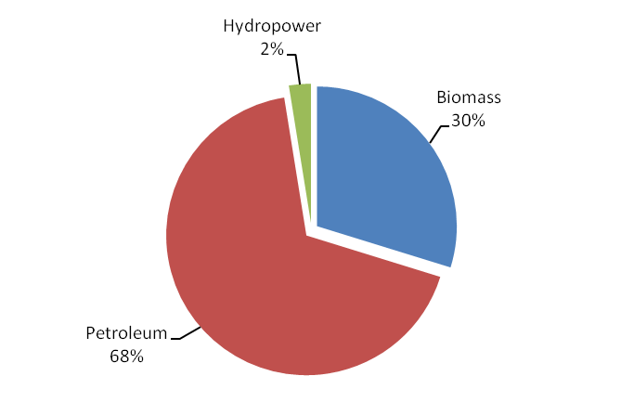
Figure 1: Main Sources of Energy Supply in Samoa, 2013
Source: Ministry of Finance, Samoa Energy Review Report 2013

- The Strategic Action Plan includes a goal of 20% of all energy services to be supplied by renewable energy resources by 2030. In 2012, the National Energy Policy and its associated plan were reviewed as the first step towards the development of the Samoa Energy Sector Plan 2012–2016 and its program of activities, which was launched in December 2012. The Energy Sector Plan aims at supporting delivery of the Strategy for the Development of Samoa (SDS) 2012-2016 which has the vision to improve the quality of life of all citizens of Samoa. RE and EE are the main components of the energy sector planning where the Ministry of Finance (MOF) plays a coordinating role. Various ministries and agencies such as the Ministry of Natural Resources and Environment (MNRE), the Scientific Research Organisation of Samoa (SROS) and EPC as well as NGOs and the private sector carry out implementation of the plan.

- The Energy Sector Plan sets a goal to reduce imported fossil fuels by 10% by 2016, with the following specific targets also by 2016: a 10% contribution of renewable energy to total energy consumption and 10% supply of renewable energy for energy services. In addition, an ambitious target to become 100% renewable energy (electricity) was formulated by GOS in support of RE to further strengthen and drive the energy sector vision for “Sustainable Energy” for Samoa. Samoa’s Intended Nationally Determined Contribution (INDC) published in September 2015 states that Samoa is committed to reducing its GHG emissions from the Electricity sub-sector through the adoption of a 100% Renewable energy target for electricity generation. This commitment targets on reaching the 100% renewable electricity generation target in 2025. As of 2016, no official reports on the progress in achieving the abovementioned goal and targets have been published by the GOS.

- The National Infrastructure Strategic Plan (NISP) 2008 – 2018 outlines the Government’s priorities and strategic directions for major initiatives in the economic infrastructure over the next 5–10 years. The four main initiatives identified in the Energy section of the NISP are: the Power Sector Expansion Project; a demand-side strategy; the development of clean energy resources through the establishment of a local Clean Energy Fund; the establishment of Samoa under the global Clean Development Scheme; and other renewable energy generation including large on-grid solar.

- The National Policy of Combating Climate Change 2007, and Greenhouse Gas Abatement Strategy 2008 – 2018 are also considered as relevant strategies as they refer to greenhouse gas mitigation strategies and objectives that involve energy, including RE and EE. In addition, there are at least two Acts that deal directly with grid-connected electricity generation and investments by independent power producers (IPPs). The Electric Power Corporation Act (1980) - governing activities of the electric power utility in Samoa; and ii) The Electricity Act (2010) - a legislative framework for regulating the electricity sector, the establishment of the post of the Electricity Regulator and the Office of the Regulator (OOTR), and for related matters. These two Acts were not prepared to support integration of RE IPPs in the electricity grid in Samoa, and specify overlapping roles and responsibilities of EPC and OOTR in planning and development of power generation in Samoa. For example, OOTR has a mandate to supervise and regulate licensing of the electricity sector, however tariff negotiation and PPA signing have generally been managed by EPC with little or, in some cases, no involvement from OOTR. GOS has recognized the constraints and revision of these two Acts is now under consideration.

Electricity Generation

- The Electric Power Corporation (EPC) is a wholly government-owned corporation and is responsible for all operating responsibilities for the power sector. The EPC Act (1980) and the EPC Amendment Act (2001) mandate EPC with the authority for generation, transmission, and distribution of electricity throughout Samoa. The utility operates as a separate entity and is defined as a public trading body under the Public Bodies Act (2001), with the principal objective of operating as a commercial business. The Electricity Act (2010) created an independent regulator to oversee the electricity sector, and also paves ways for Independent Power Producers (IPPs) to generate and sell electricity to EPC.

- Most of the electricity in Samoa, particularly for the main grids on the two main islands, Upolu and Savaii, is produced through diesel and hydropower generation. Note that the combined generation in these two main islands accounts for about 95% of the country’s generation capacity. Before 2014, the Upolu system was supplied by integrated hydro-diesel networks, while the Savaii system was nearly entirely diesel generation with a small fraction from a solar PV system in Salelologa. EPC has signed Power Purchase Agreements (PPAs) with few RE IPPs since 2011. However, the first few grid-connected variable RE power plants, including three grid-connected solar PV systems and two wind generators, introduced in Samoa in 2014 are owned by EPC. These are comprised of the following:

- Three solar PV systems funded by the Government of Japan, and installed at the EPC’s compound at Tanugamanono (150 kWp), Vaitele (246 kWp) and Salelologa (150 kWp). It is estimated that these three solar systems with the total capacity of 546 kWp generate about 800,000 kWh per year;

- Two wind turbines with 275 kW generators funded by the United Arab Emirates are located at Vailoa, Aleipata on Upolu Island. These wind energy generators produce around 300,000 kWh per year.

- In addition to abovementioned EPC-owned RE power generation, three solar based IPPs, Green Power Samoa, Solar for Samoa and Sun Pacific Energy, have added a combined installed capacity of 6.78 MWp to the grid and these solar farms have been supplying energy to the grid since May 2015. Utilizing coconut oil (CNO) for power generation has also been of interest as a potential source of indigenous RE among the Pacific island countries. During 2009 -2010, EPC had blended diesel with CNO in its diesel generators in Tanugamanono power station. The trial was ceased in 2011 with no records or report of the results.

- Although some grid-connected variable RE (i.e., solar PV and wind) power plants have been connected to the grid since 2014, the majority of installed generation capacity on Upolu island, as of May 2016, is still mainly conventional, with a main diesel power plant in Fiaga, the second diesel plant in Tanugamanono and five other hydro power plants (Alaoa, Fale ole Fee, Loto Samasoni, Lalomauga and Taelefaga) with a maximum rated capacity of approximately 42 MW. It should be highlighted that Loto Samasoni (1.9 MW) and Fale-ole-Fee (1.75 MW) hydro power plants are currently out-of-service due to damages sustained from Cyclone Evan, but EPC is planning to have them rehabilitated and taken back online in 2017. Grid-connected solar PV and Wind power plants, which are currently in operation, still represent a relatively low percentage of the total installed solar PV power generation capacity in Samoa (12 MW peak in total as of May 2016).

- Recent EPC quarterly reports for the fiscal year 2013/2014 and 2015/2016 show significant growth of solar energy-based electricity production in the total national power generation from 0.23% in 2013/2014 to 8.04% in 2015/2016 (see Table 1). Considering that, construction of a hydro power plant will take several years, the integration of more variable RE power generation units has demonstrated the effort to meet the country’s ambitious target of reducing greenhouse gas emissions and achieving 100% electricity generation through RE technologies by 2025. However, diesel electricity generation still accounts for the largest share in the total electricity generation in Samoa, almost 70% in 2015/2016 fiscal year, followed by hydro at about 24%.

Table 1: National Electricity Generation Mix in Samoa

Generation Source | 2012/2013 | 2013/2014 | 2015/2016
Diesel | 71.27% | 75.78% | 68.30%
Hydro | 28.72% | 23.99% | 23.45%
Solar | 0.01% | 0.23% | 8.04%
Wind | 0.00% | 0.00% | 0.21%

- Over the next few years, Samoa expects to see a substantial increase in installed grid-connected RE power generation, as about 30 MW of solar, 25 MW of wind turbines and bio-energy power plants will be connected to the grid by the end of 2017. Samoa also plans to add 4 more new hydro power plants to the grid, and about 16 MW of generation capacity will be completed through an IPP and EPC’s new hydro power plants and rehabilitation of existing power plants by the end of 2017. Shown in Table 2 are installed capacity of grid-connected variable RE power plants (non-hydro) in Upolu and Savaii until 2017, and the total available installed capacity as of May 2016.

Table 2: Installed Capacity of Grid-Connected Non-Hydro RE-based Power Plants in Upolu and Savaii

Technology | Available Capacity as of May 2016 (MW) | Power Development Plan until 2017 (MW)
Upolu
Solar | 6.45 | 15.30
Wind | 0.55 | 0.55
Bio-Energy | 0.00 | 12.00
Sub-Total Upolu | 7.00 | 27.85
Savaii
Solar | 0.23 | 2.23
Sub-Total Savaii | 0.23 | 2.23
Grand Total | 7.23 | 30.09
Source: Correspondence with EPC, June 2016

- It is forecast that the RE share (i.e., hydro and other RE-based power generation) in the overall national power generation mix may reach 55% by 2020. The Government of Samoa has set the target of 100% of RE by 2017; although realistically this target may not be met, it is possible that Samoa could reach 70% of RE share in the near future while maintaining least cost of power generation.

Electricity Demand

- The two largest islands (Upolu and Savaii) consume about 95% of the total electricity generation in Samoa. The 2011 Population Census shows that around 96% of households in Samoa are electrified. EPC’s customer base increased from 33,157 in 2011/2012 to 35,227 by the end of 2013/2014 fiscal year. It should be noted that most new connections are prepayment users (Cash Power), and many of EPC’s non-prepayment residential users have converted to prepayment users since 2009/2010. As a result, most of the EPC’s customers are now Cash Power users, and percentage share of prepayment meter users has been on the rise from 77% in 2011/2012 to 85% in 2013/2014. The EPC customer base in fiscal year 2013/2014 is shown in Figure 2.

- EPC reported annual electricity consumption of about 93 GWh per year in 2011/2012 and 2012/2013, and about 10% growth was seen from 2012/2013 to 2013/2014 in which the annual electricity consumption was reported at 106 GWh. The commercial sector is the largest end-use sector in Samoa, accounting for about 44% of the total consumption, followed by the residential sector, at about 28%. The remaining consumption comes from the public sector (government), industrial sector, educational institutions, religious organizations, etc. The electricity consumption by sector in 2009/2010 fiscal year are shown in Figure 3.

- Based on data from the operation reports of EPC, electricity demand profiles in Upolu and Savaii are different reflecting the different end-use sectors in these 2 islands. In Upolu, there are 2 electricity peak demands, i.e. late morning to noon peak and evening peak, as shown in Figure 4. Analysis of the load profile showed that the major contributors to daytime load are industrial (primarily base load) and commercial customers (primarily air-conditioning and lighting). The decrease in commercial sector activities in the afternoon (around 5pm) is replaced by the increase in the residential sector activities (e.g. lighting, cooling, cooking and entertainment) resulting in an evening peak around 7 pm.

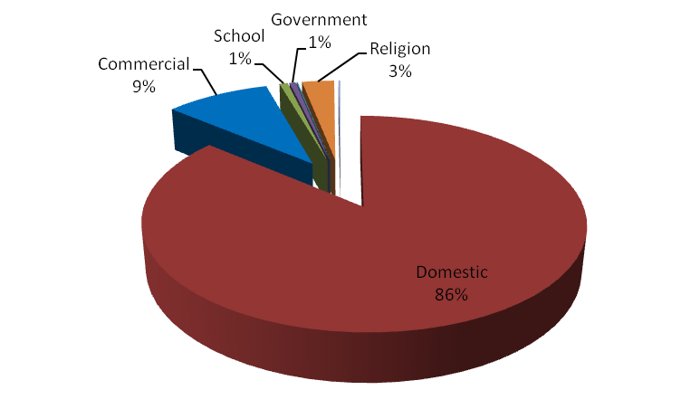

Source: EPC Annual Report 2013/2014
Figure 2: EPC Customer Base, 2013/2014

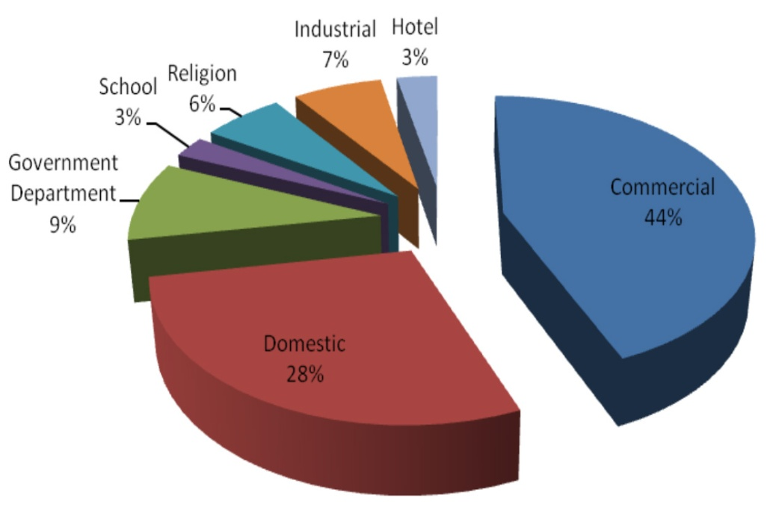

Source: Samoa Energy Review 2013, Ministry of Finance, Government of Samoa
Figure 3: Electricity Consumption by End-Use Sector

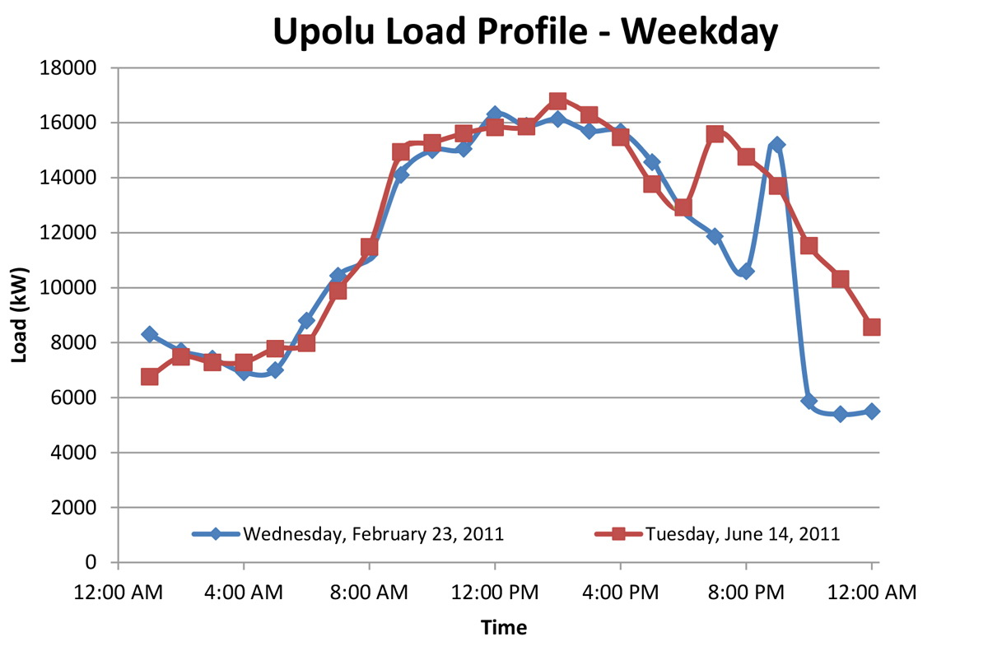
Source: PES Upolu KEMA Grid Study, EPC, 2013
Figure 4: Typical Load Profiles in Upolu

- It should be noted that there are minimal activities in the commercial sector in Upolu over the weekends (Saturday and Sunday) in comparison with the weekday. Considering this, the evening peak is very notable in the weekend demand profiles (see Figure 5).

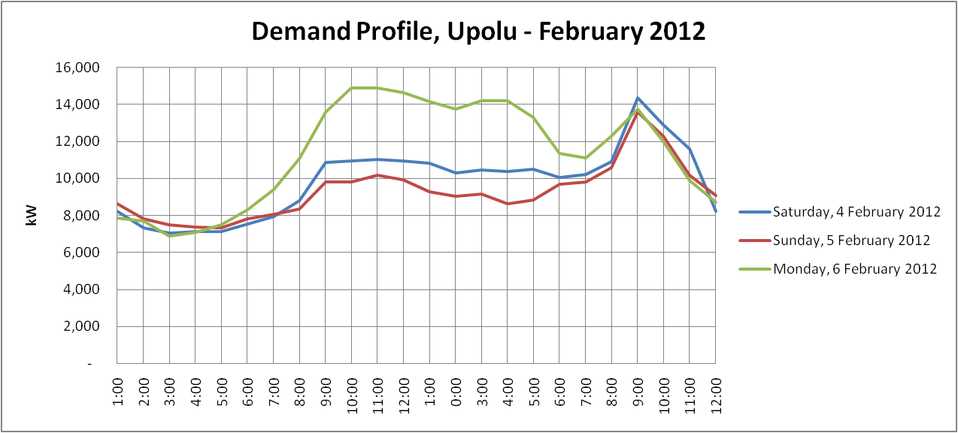
Source: EPC, 2012
Figure 5: Typical Load Profiles – Weekends and Weekday in Upolu

- For Savaii, there is only one salient peak demand in the evening representing the residential sector activity (primarily lighting, cooling/heating and cooking) during 7pm to 8pm (see Figure 6). For the load demand profile which is dominated by residential load, typically the weekdays and weekends load profiles are similar.

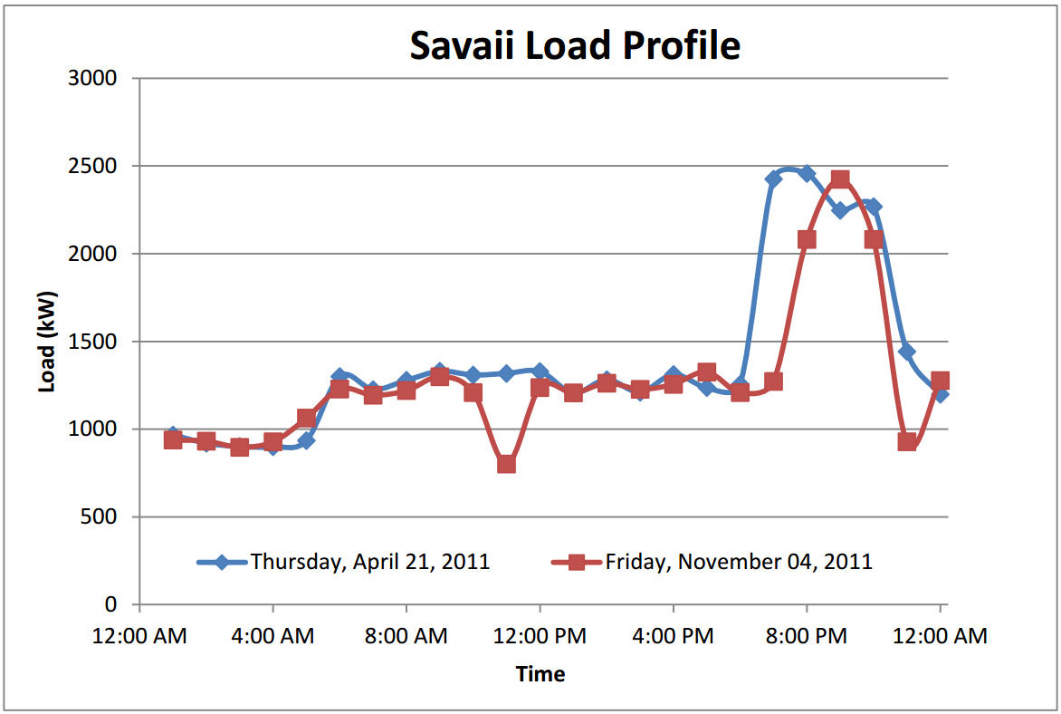
Source: PES Savaii KEMA Grid Study, EPC, 2013
Figure 6: Typical Load Profiles in Savaii

- The electricity tariff in Samoa is adjusted on a monthly/bimonthly basis in response to fluctuations of production costs caused by the rising/falling of fuel costs. As stipulated in the Electricity Act 2010, EPC is required to seek approval from the Office of the Regulator to implement retail rates charged to electricity consumers for the provision of electricity services. As of June 2016 tariffs for EPC are as follows: a) domestic consumers: 0-50 kWh = ST$ 0.59/kWh; 51-100 kWh = ST$ 0.74/kWh; and above 100 kWh = ST$ 0.79/kWh. For EPC non-domestic consumers the tariff is ST$ 0.79/kWh. All prepaid power purchases receive a 2% discount on the “usage charge” component of the tariff, and on average prepaid meter users pay ST$ 0.01 less per kWh than induction meter users.

Power System Performance

- Based on the latest EPC Annual Report for 2013/2014, the transmission and distribution (T&D) losses in the EPC system are estimated at about 15%. EPC has also installed a Supervisory Control And Data Acquisition (SCADA) system that links power plants and substations with the National Control Center.

- Samoa has experienced RE integration into the EPC’s grid since late 2014, and it has been reported that the existing installed capacity of about 7 MW solar PV and wind power generation (refer to Table 2) have caused system instability, specifically when the system load is low over the weekend. The immediate measures undertaken by EPC have been to run diesel generators in light load conditions to minimize system instability during variation of PV and wind power outputs, and also to temporarily disconnect the oversupplied solar PV plants from the grid. It should be noted that the latter measure has incurred some compensation payments from EPC to the Solar IPPs. EPC is already planning to install two Battery Energy Storage Systems (BESS), one on Upolu (4 MW) and one on Savaii (2 MW) to alleviate intermittency issues on both islands.

Renewable Energy Resources in Samoa

- According to the Samoa Energy Review reports published by MOF, other renewable energy resources that are presently utilized in Samoa, besides hydro power, solar and wind for electricity generation, are referenced as bio-energy. This includes: biomass (Firewood, coconut shells, coconut husks, plant waste residues, wood charcoal, etc.), liquid biofuels (coconut oil biofuels, biodiesel, and ethanol) and biogas. Information on these RE resources and potential assessments in Samoa is outdated. There were a few study reports on biofuel and biomass gasification published around 2009 and 2010. The latest feasibility study report on biogas was published in 2013. However, the “Energy Bill and the Development and Implementation of Sustainable Bioenergy in Samoa project funded by the EU-GIZ regional program on Adapting to Climate Change and Sustainable Energy (EU-GIZ ACSE) in collaboration with MOF is conducting an assessment of biomass resources in Samoa and the assessment report is expected to be published by 2016.

- Based on the available studies, the potential for biomass energy in Samoa includes agricultural residues, forestry residues, sawmill waste, coconut and municipal and other solid waste. Almost 100% of biomass utilization in Samoa is in the residential sector (99.70%), primarily for domestic cooking. Samoa has experienced a decrease of about 35% in biomass consumption from 54.3 ktoe in 2000 to 35.3 ktoe in 2013. Decreasing biomass consumption in Samoa is due to the closure of 3 sawmills including the only mill that used biomass to produce its own electricity, and discontinuation of copra production in 2006.

- The 2 main sources of biomass available in Samoa in sustainable and sufficiently large quantities include: wood biomass; and coconut shells and husks. The Samoa Trust Estates Corporation (STEC) plantation also has a large concentration of coconut shells and husk, and it was reported in August 2010 that the coconut processing produces around 45 tons (fresh) of husk and shell per week. Of this amount around 5 tons per weeks is being used for copra drying. The woody overgrowth biomass resource within the STEC plantation, which is made up of primarily invasive plant species, is estimated to be around 240,000 metric tons. These constitute 10 to 15 years of biomass resources for 500 kW gasifier. However, considering the other potential commercial uses of these biomass resources, replantation of the trees is required to sustain the continuous supply of biomass feed into the gasifier units.

- Other bioenergy-based electricity generation options in Samoa that have been identified include: 1) producing biodiesel from coconut oil (CNO), for both the electricity generation and transport sectors; and 2) blending coconut oil with diesel for direct injection into diesel engines. It should be noted that these two options have been implemented on a trial basis in Samoa but scaling-up could not be realized due to high market prices of CNO.

Productive and Social Uses of Renewable Energy

- Samoa does not have a long term strategy for the Productive Use of RE (PURE) and Social Use of RE (SURE) to support economic development of the country. The current Energy Sector Plan for 2012-2016 addresses key energy sources for end-users in the residential, commercial, industry and transportation sectors. However, the plan provides no details on PURE and SURE. Although financial and capacity building support for local entrepreneurs to startup businesses has been implemented by the Small Business Enterprise Centre (SBEC), the focus is rather generic, and RE has not been properly addressed. Utilization of RE for non-power applications has been demonstrated and promoted in Samoa by a local NGO, Youth with a Mission (YWAM) and the GEF-funded Pacific Islands Greenhouse Gas Abatement through Renewable Energy Project (PIGGAREP). YWAM has implemented capacity building activities for stakeholders in Samoa and other Pacific Island Countries (PICs). However there has been very few replication of biogas systems in Samoa to date. YWAM has just established a company called Biogas Energy Solutions Technology or B.E.S.T. in 2016 to offer products and services including training, and the design and installation of fixed dome biogas digesters made of brick and cement. YWAM expects that the new business unit will help fill the gap between knowledge transfer and actual implementation.

- 72.6% of households use an open fire as a cooking method in Savaii. Usage of open fires for cooking has decreased in urban areas; 64.1% Rest of Upolu, 51.1% Northwest Upolu and 21.1% Apia Urban area. Usage of wood stoves is not a common practice, and ranged only from 3.1% in Apia to 7.7% in Savaii. Although the use of fire wood does not pose a burden on household expenses, it has detrimental impacts on health and environment.

- It is clear that the growing percentage share of RE in the overall power generation mix has contributed to better energy security in Samoa. However, its contribution to economic development, particularly at the community level and in rural areas has not been evidenced. Nearly all Samoans are connected to the power grid, and only a small percentage is off-grid due to remoteness and the sparse population in those locations.

- Household expenses exceeded income in most areas of Samoa, except in Apia. The statistical data shows that rural households have subsistence farming and fishing that could sustain them on food but they are burden with expenses from modern living such as electricity, fuel, transportation, education, etc. Statistical data also shows that income from non-subsistence entrepreneur activities is minimal (0.9% in Savaii to 3.5% in Apia). The lack of entrepreneurship and business idea, particularly in rural Savaii, hinders their opportunities to generate incomes.

Demand-Side Management and Energy Efficiency in Samoa

- Voluntary and mandatory implementations of Demand-Side Management (DSM) and Energy Efficiency (EE) technologies/techniques have been carried out for decades in many countries around the world. Samoa also has experience in implementing various EE projects with supports from various international development agencies. A draft regulation to support implementation of mandatory energy standards and labeling programs was prepared through the Pacific Appliance Labelling and Standards (PALS) Program (PALS) that was implemented by SPC in 2012. Based on previous EE project implementation experiences in other countries, it is clear that successful EE implementation requires well-coordinated efforts among different agencies and authorities. For example, the implementation of mandatory energy labeling for refrigerators and freezers in Fiji is a coordinated effort between the Fiji Department of Energy and the Customs Department. In Samoa, energy efficiency standards and labeling implementation is expected to involve the Customs Department, Ministry of Finance, and EPC.

GHG Emissions from Electricity Sub-Sector

- On a global perspective, Samoa’s Greenhouse Gas (GHG) emissions are negligible as highlighted in its Second National Communication (SNC) to the UNFCC, and its second GHG Inventory (2007). The total GHG emissions for the year 2007 was estimated at 352,034 tCO_{2e} or about 0.0006% of 2004 global GHG emissions. Transportation and electricity generation are the two main sources of GHG emissions in Samoa, with the electricity sub-sector contributing 44,214 tCO_{2e} or around 13% of the total GHG emissions in 2007. In 2014, GHG emissions from the electricity sub-sector were estimated at around 55,065 tCO_{2e} or an increase of around 25% from 2007.

- Despite the low contribution to global GHG emissions, Samoa aims to reduce its GHG emissions and demonstrate to the global community the actions being undertaken by a small and vulnerable country to address climate change. Samoa is targeting the energy sector with a focus on the electricity sub-sector. 32% of electricity was generated from renewable energy sources in 2015/2016. According to Samoa Intended Nationally Determined Contribution (INDC) Report that was submitted to UNFCCC in September 2015, Samoa commits to generating 100% of its electricity from renewable energy sources by 2025. This is conditional on Samoa attaining this target in 2017 and receiving external assistance to maintain the contribution of renewable sources at 100% through to 2025. Assistance is required to reach this target, including human, technological and financial resources. Further economy‐wide emission reductions are conditional on Samoa receiving external financial assistance from the international community.

- In this context, the Government of Samoa recognizes biomass as an important RE resource that can help the Government to catalyze national and international support and finance to achieve effective and sustainable transformation of the electricity sub-sector in Samoa from a fossil fuel reliant generation mix to the RE-based power system.

Barrier Analysis

- Barriers that restrict widespread adoption and investment in RE in Samoa exist across a range of areas that need to be strategically addressed to facilitate marked progress. Key barriers include those related to: systematic and institutional coordination, financial, market, technical and informational barriers. These are discussed below in Table 3.

Table 3: Summary of Barriers hindering Improvement of Performance and Reliability of RE Power Systems in Samoa

Policy & Regulatory Barriers
Inconsistency of policies and regulatory frameworks related to RE development and implementation: The current policies and regulatory frameworks related to RE development and implementation, including but not limited to Samoa National Energy Policy (2007), the EPC Act (1980) and Electricity Act (2010), specify different sets of targets, overlapping roles and responsibilities among authorities involved in the electricity sub-sector in Samoa. The current application process for IPP in Samoa involves multiple agencies and authorities. In general, it takes more than one year to complete an IPP application process. These unclear and inconsistent policies and regulations on the development and implementation of RE-based power generation result in fragmented decision making process and involvements of many actors, thus hampering cohesion, effectiveness and progress of RE development in Samoa. One of the significant issues that needs to be addressed in the yet-to-be updated National Energy Policy (NEP) is the RE target that was set to be achieved by 2017. It was projected that by 2017, all of the electricity generated in the country would be from RE-based power generation (100% RE target). In reality, the share of RE in the country’s energy mix has fluctuated. In 2012/2013, the country’s power generation mix was 29% RE (primarily hydro); reduced to 24% in 2013/2014 (with a miniscule contribution from solar); and increased to 32% in 2015/2016 (with about 8% contribution from newly grid-connected solar farms). This continuous variation makes the renewable electricity target a challenge that likely cannot be met. In addition, there is limited RE resource assessment data to support the establishment of the national RE targets, and some RE resources, i.e. waste-to-energy, are not included in the target and plan. Without a realistic target, it is difficult to design policies and programs effectively.

Absence of regulatory frameworks to support EE implementation and enforcement: Preparation of regulatory frameworks to support implementation of minimum energy performance standards (MEPS) and energy labeling requirements for lighting products, refrigerating appliances (refrigerators and freezers) and air-conditioners in Samoa has been delayed for many years, and the regulation to support implementation of MEPS and labeling will be included in the new Energy Bill being developed by the project entitled “Energy Bill and the development and implementation of sustainable bioenergy in Samoa” funded by EU-GIZ ACSE, and implemented by MOF. It is envisioned that it could take several more years to complete the Energy Bill, and subsequent regulations to support implementation of EE in Samoa, and there is a need to introduce and maintain the momentum of EE implementation aligning with the new Energy Bill.

Limited policies for the provision of incentives/subsidies for communities & private sector for producing RE: Aside from the absence of cohesive RE and EE policies that can encourage end-users to embrace RE and EE initiatives, there are also limited incentives for the implementation of projects on the application of EE and/or RE technologies. There has been an amendment to the “manufacturing” duty tax exemption regulation whereby all equipment imported for RE projects are considered as “raw materials” for producing energy thereby making them all exempted to duty tax in Samoa. However no specific policy measures have been designed to incentivize development and implementation of RE and EE in Samoa, particularly in the areas of productive and social uses of RE.

Technical Barriers
Low performance of power systems in the major islands due to limited knowledge on planning and operating of variable RE resources: Integration of variable RE resources such as solar PV, wind and run-of-river hydro into the existing electricity grid is complex, and to facilitate high levels of RE integration will require careful planning to ensure not only lower optimal overall generation cost but also satisfactory electricity supply reliability. Given the small size of the Upolu power system (peak demand is around 21 MW), EPC has already experienced grid stability problems with existing connection of around 6 MW solar farms, especially during the weekends when daytime demands are lower than those during the weekdays. The total installed capacity of all grid-connected solar farms is expected to be more than 10 MW by the end of 2016, and it is envisioned that the current grid stability problems will be amplified when these additional solar farms connected to the grid unless substantial electricity storage such as batteries or pumped hydropower reservoirs become available. Current constraints in managing EPC’s electricity grid come from various reasons including limited knowledge on grid operation performance and impacts from variable RE integration, lack of power development planning, lack of stability requirements in grid connection code, lack of application of EE in the operation of power generation units and ancillary units, and lack of power generation dispatch & grid operation schemes.

Limited use of domestic biomass resources for energy production: Potential benefits of biomass energy resources have not yet been tapped for energy production (for power and non-power applications) in Samoa. This is mainly due to limited knowledge about the extent, quality and characteristics of the various biomass resources in the country, and the general lack of knowledge in biomass energy conversion technologies, and biogas technologies, as well as on the energy efficient design and operation of biomass-based energy production systems. There is also limited knowledge of the biofuel potential in the country. In addition, the application of grid-connected biomass-based power generation could offer a rational solution to the concern about grid instability.

Limited knowledge on selection and implementation of T&D technologies for effective management of a power grid with high variable RE integration: Although EPC has strengthened its capacity in operating the grid with high RE generation, current actions undertaken appear to be corrective measures, including running standby diesel generators and disconnecting oversupplied solar generation, rather than implementation of appropriate T&D technologies and preventive measures for grid stability. Note that, disconnecting oversupplied solar generation has incurred additional operating costs for EPC in compensating the solar IPPs for must-buy solar energy. The current scenario is due to limited knowledge in identification of available technologies for high RE system management and evaluation of their cost effectiveness.

Financial Barriers
Absence of accessible and affordable financing for electricity DSM and power/non-power RE applications: The banks and financial institutions in Samoa are generally not aware of the business potential in RE and EE investments, and are not interested in these initiatives, since RE and EE investments are often viewed as risky investments (mainly due to high initial costs of RE/EE technologies, and collateral issues).

Initial assessment during the project preparation phase indicates that high prevailing interest rate is one of the key barriers resulting to the increased cost of financing and prohibitive investments in energy efficiency measures. Lack of collateral is usually the cause why several loan applicants could not access business loans. This is because most of the lands in Samoa are customary lands and therefore cannot be sold or mortgaged.

Government and financial sector not providing financing for electricity saving and productive & social uses of RE: Financial supports for RE and EE initiatives is generally lacking from the government and private sector (banks/financial institutions) in Samoa. There are no other forms of financial incentives and affordable financing schemes for end-users to invest in RE and EE applications. This is attributed to limited government funds to support RE/ EE initiatives and inadequate private sector funds to support RE/ EE initiatives.

There are two credit guarantee facilities currently implemented in Samoa by SABS and SBEC. However there is no risk sharing/credit guarantee facility dedicated for RE and DSM/EE investments. The existing credit guarantee facilities in Samoa were designed to support investments in the small business and agricultural sector, and to date there is no utilization to support RE and DSM/EE investment. The initial assessment during the project preparation phase reveals good potential in developing and/or expanding the existing guarantee facilities to support RE and DSM/EE investments.

Market Barriers
Lack of demand for RE for productive and social uses: There are few installations of biogas systems in Samoa for heating, lighting and electricity generation. However these demonstrations primarily focus on reduction of household expenses rather than productive and social uses of RE. Also, some of these installations were not designed with energy efficiency in mind, such as in the energy efficient operation of the RE-powered devices. In addition, scaling-up of these demonstration efforts has encountered several hurdles including inconvenience in feedstock preparation and system maintenance, knowledge and willingness of households in operating and maintaining the systems, limited number of local service providers to support installation and after-sale services, and understanding in operating better businesses through integration of RE for productive and social uses. There is also generally a lack of appreciation and knowledge in economic and environmental benefits of using available RE resources and applicable RE technologies for productive and social uses among communities and households. These market-related barriers have undermined efforts in promoting RE for productive and social uses, and also contributed to the existence of the main financial barrier.

Information, Awareness and Capacity Barriers
Low level of awareness and adoption of RE and EE technology applications: Widespread application and practice of RE and EE technologies is still at a low level in Samoa. This is further aggravated by the limited training and in-country human resources available on RETs, and inadequate information about the magnitude and availability of available RE resources. People are generally not aware of EE appliances available in the local market. There is inadequate information sharing of technology implementation in RE projects in the country, and a lack of understanding and awareness on linkages between RE production, poverty reduction, and income generation (productive use). There is also a lack of promotional activities to address the low level of awareness on RE development and utilization in the country.

Limited technical knowledge and experience in energy development, planning and implementation: Human resources in relevant government agencies and authorities involved in energy development, planning and implementation appear to have limited technical knowledge and experience in RE. As a result, delivering outputs and targets related to RE as specified in the Energy Sector Plan (2012-2016) has not been effective. Note that development and planning for the productive and social uses of RE have not been included in the Country’s Energy Sector Plan, and power system reliability has not been properly addressed in the Power Development Plan.

Baseline Analysis

- There are a number of ongoing RE and EE related project activities supported by international donor agencies and the Government of Samoa. In addition, there are several planned IPP RE power generation units in Samoa. In addition, there are also planned projects involving system stabilization technologies such as battery and pump storage. However, the baseline analysis section will focus only on projects that could contribute to improvement of grid stability in Samoa.

Table 4: Summary of Baseline Project Activities

Baseline Project | Implementation Period | Available Budget | Baseline Activities | GEF Incremental
1. Energy Bill and the development and implementation of sustainable bioenergy in Samoa Project, MOF / EU-GIZ ACSE  The main beneficiary of this project is STEC, and the project aims at enabling STEC to convert waste biomass into a renewable energy. The 3 components of the project includes: i) the biomass assessment activities; (ii) the procurement of harvesting and processing equipment; and (iii) the conclusion of a Power Purchase Agreement between EPC and an IPP investor. SPC is currently assisting in the biomass assessment and harvesting planning work. In addition, an Energy Bill will be drafted to improve the legislative environment in the energy sector to better facilitate private sector investments and establish EE performance standards for energy using equipment and appliances in Samoa. | 2017 - 2019 | EUR 764,000 | - Biomass resource assessment  - Development of a plan for Biomass harvesting and supply for power generation  - Preparation of the Energy Bill  - Facilitation of private sector investment by improving the legislative environment for RE and EE | - Development of a biomass-gasification project  - Development of specific policies and regulations to incentivize project developers and end-users to implement RE and EE initiatives  - Enhancement of the capacity development of communities  - Development of community-based business models for the implementation of biomass power and non-power projects
2. Samoa Power Sector Expansion Project, EPC/ ADB/ AusAid/ JICA  The project consists of 28 subprojects, with the Fiaga Power Plant, being the biggest single subproject. The subprojects are divided between the islands of Upolu and Savaii between areas of Generation and Transmission. | 2017 - 2020 | US$  17,500,000 | - Installation and operation of a SCADA system  - Capacity enhancement for system-wide modeling and planning | - Utilization of the SCADA system for system reliability enhancement  - Capacity building for better utilization of the power system modeling
3. Samoa Renewable Energy Development and Power Sector Rehabilitation Project, GOS / ADB  The project is primarily funded by grants from ADB Special Fund for Disaster Response Facility with support from the Samoa Clean Energy Fund, the European Union, the New Zealand Government, EPC and the Government of Samoa, and it consists of repairing of 3 existing hydro stations and construction of 4 new hydro plants | 2017 - 2018 | US$ 10,488,000 | - Rehabilitation of 3 existing hydro power plants in Samasoni, Fale ole Fee and Alaoa  - Construction of 4 new hydro power plants in Tafitoala/Fausaga, Faleaseela, Fuluasou hydro and Taeelefaga (3rd 2MW generation unit) | - Development and facilitation of effective dispatching of power plants to ensure grid stability
4. Battery Energy Storage Systems (BESS) in Upolu and Savaii, EPC/ ADB  EPC with financial support from ADB is planning installation of: 6 MW BESS in Upolu with 7,000 kWh of energy storage, and voltage and reactive power regulation of 3.5 MVar; and 2 MW BESS in Savaii with 750 kWh energy storage. These BESS will enhance grid stability control in both major islands. | 2017 | US$ 8,956,200 | - Installation and commissioning of 4MW/ 2000kwh and 2MW/ 5000 kwh BESS in Fiaga power station on Upolu  - Installation and commissioning of 2MW/ 750kwh at Salelologa power station on Savaii | - Enhancement of power system reliability through coordination of power dispatching and grid control
5. Samoa AgriBusiness Support Project (SABS), GOS/ ADB  The SABS project is funded by ADB’s grant to create a financial scheme for projects with initial investment cost from ST$ 100,000 to 1 million through local commercial banks. The eligible project shall be sustainable agricultural projects using local raw materials and will contribute to export or import replacement. 50% of the project cost will be funded by the banks of which 50% will be guaranteed by ADB. ADB will also provide up to 25% of the project cost a supplemental seed capital at no interest payable in 7 years.  In addition to financing support, the project provides support in preparation of the business plan, other specialized technical support (e.g. product development and export promotion). Financial management support is also provided. | 2017 - 2018 | US$ 255,000 | - Operationalization of a financial scheme to support agro-business projects with potentials for RE resource utilization for power and non-power applications  - Capacity building for potential investors in business management and operation (e.g., preparation of the business plan, financial management, product development and export promotion) | - Development of additional financial support and improvement of project viability through integration of RE and EE  - Development of business ideas and activities that include productive and social uses
6. Samoa Agriculture Competitiveness Enhancement Project (SACEP), GOS/ WB  SACEP is financed by the World Bank and GOS, and aims to provide capital investments to strengthen the performance of the livestock, and fruit and vegetable sub-sectors in Samoa. The project provides maximum grant of ST$ 16,000 (US$7,000) to support capital investment for each beneficiary. To date, there are about 1,000 projects approved under SACEP, and all beneficiaries have to comply with the environmental requirements established by SACEP, including management of waste from livestock. | 2017 - 2018 | US$ 2,000,000 | - Operationalization of a subsidy scheme to support projects with potentials for waste-to-energy (pig farms, cattle farms and vegetable gardens) | - Development of additional financial support and improvement of project viability through integration of RE and EE  - Development of business ideas and activities with waste-to-energy applications
7. Pacific Technical and Vocational Education and Training in Sustainable Energy and Climate Change Adaptation (PacTVET), GOS/ USP/ EU  PacTVET is a component of the broader regional Adapting to Climate Change and Sustainable Energy (ACSE) Programme. The project builds on the recognition that energy security and climate change are major issues that are currently hindering the social, environmental and economic development of Pacific - African Caribbean and Pacific (P-ACP) countries. The project aims to enhance Pacific regional and national capacity and technical expertise to respond to climate change adaptation (CCA) and sustainable energy (SE) challenges. It is currently being implemented by the Secretariat of the Pacific Community (SPC) in partnership with the University of the South Pacific (USP). | 2017 - 2019 | EUR 6,000,000 | - Technical capacity building on sustainable energy | - Capacity building on policy and regulation and technical knowledge on RE/EE

Baseline Scenario

- The baseline scenario is a continuation of the present business as usual situation, which follows from existing government policy, activities, legislation and institutions/mandates in Samoa. The business-as-usual (BAU), scenario will most likely be characterized by the following:

- Regulatory frameworks for RE and EE development and implementation remain fragmented and ineffective.
- The generation and introduction of intermittent RE-based power generation units in the EPC grid will be continued without appropriate power system stabilization features. EPC has to run its diesel generators to ensure grid stability, and some RE power plants will be disconnected from the grid when the RE generation exceeding the demand, sometimes leading to additional costs for EPC.
- The system instability problem will persist due to limited in-country resources and capacity.
- The absence of policies and strategies to enhance capacity, build awareness, and develop new information/data generation continue to hinder the development of RE and EE. Information on productive and social uses of RE remains scattered and hard to access by potential investors. This will continue to hamper the market access and effectiveness.
- Difficulty to access financing for RE projects specifically at the community level, due to small project size to justify high transaction costs of the financial institutions, collateral based project financing modalities, lack of innovative financing schemes and an appropriate guarantee facility.

- The BAU outcome with respect to GHG emissions in the electricity sub-sector in Samoa is a gradually decrease from 55,065 tCO_{2e} in 2014 to approximately 34,178 tCO_{2e} in 2022 as the results of the ongoing and planned power generation projects. Due to limited capacity of the EPC’s grid to absorb additional RE-based power generation, percentages of RE electricity generation in the annual electricity generation in Samoa are projected to be slightly over 60% from 2020 onward, and the GHG emissions in the electricity sub-sector is then projected to increase to 36,615 tCO_{2e} in 2032.

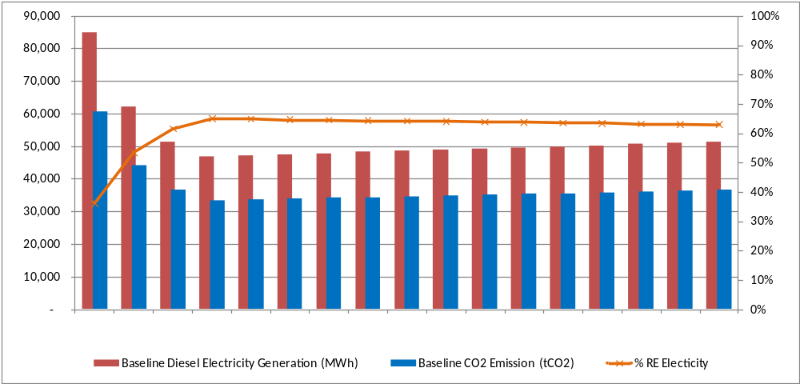
Figure 7: Projection of Diesel Electricity Generation and Corresponding CO2 Emission in the Baseline Scenario

Incremental Reasoning

- While there has been significant progress over the past decade in the development and implementation of RE and EE in Samoa and other PICs, the overall process of implementing RE and EE in Samoa is still slow. Although the recent integration of IPP-funded and operated solar PV power generation systems into the EPC’s grid has boosted up the % RE share in the total annual generation mix, it is estimated that % RE share without hydropower generation will be less than 15% by the end of 2016. This is due to the lack of awareness and knowledge on how different types of variable RE power plants would impact the electricity grid, clear and consistent policies and regulation to promote appropriate RE and EE technologies, and proper financial schemes for PURE, SURE and EE. The stakeholder consultations and meetings during the project preparation stage found that there have been limited efforts addressing these pertinent barriers hampering RE and EE promotions in Samoa.

- The baseline activities discussed in Table 4 are only expected to contribute marginally to the regulatory framework issues (i.e., the Energy Bill) particularly in the long-term, mainly because the Energy Bill is the high level regulatory framework which will not be effectively implemented without implementing rules and regulations. Although these baseline activities were initiated and tailored to suit the requirements of different stakeholders in Samoa, they were not specifically designed to be well coordinated and complement one another to minimize overlapping, and it is unclear if these will contribute synergistically in the achievement of the RE targets for Samoa.

- Without the GEF intervention actions that will remove barriers to promotion of RE for power and non-power applications and the widespread application of EE technologies in Samoa, it will likely take some years to achieve benefits in terms of % RE share in total electricity generation, energy savings, and GHG emission reductions. GEF incremental activities in this project are built on the baseline activities, and they will provide vital support to MNRE, MOF, EPC, STEC, communities and other stakeholders in effectively implementing RE and EE policy measures and promotional activities, while helping to set up financial scheme(s) and facilitate access to affordable financing, and greatly enhancing the level of awareness and knowledge of local communities and stakeholders on the benefits of RE, EE, PURE and SURE.

STRATEGY

Project rational and policy conformity

- Considering Samoa’s current circumstances, the country will not be able to realize the 100% RE electricity generation target. In fact, it remains unclear what amount of RE generation can feasibly be achieved without causing substantial negative impacts on reliability. The percentage of generation that can feasibly come from renewable sources will depend on substantial grid reliability improvements and/or additional investment in storage technologies. The proposed project endeavors to facilitate the realization of an alternative scenario which is a combination of the baseline efforts of the country and incremental activities that will bring the country towards the achievement of its realistic RE target.

- The proposed project is in line with the Government of Samoa (GOS) policies and measures to mitigate GHG emission, including but not limited to:

- Greenhouse Gas Abatement Strategy 2008 – 2018 - Stated objectives are “Reduced GHG emissions from the electricity sector”, “Reduced GHG emission from replacing fossil fuel with biofuel” and “Reduced GHG emissions through new sources of RE”.
- National Infrastructure Strategic Plan (NISP) 2011-2021 - The 4 main initiatives include: a demand-side strategy; the development of clean energy resources; the establishment of Samoa under the global CDM; and other RE generation including large on-grid solar.
- STEC Corporate Plan 2015-2017 - A relevant objectives is to “support the energy sector and implement developments for renewable energy in Samoa”. STEC intends to produce renewable energy from coconut oil and biomass, develop new forest plantations and protect the remaining upland native forest.

Alternative Scenario

- Complementing and supplementing the ongoing and planned efforts of the country to enhance the utilization of RE resources for power generation and reducing GHG emissions, the proposed GEF Project will facilitate the improved sustainability and cost-effectiveness of the utilization of indigenous renewable energy resources for energy production in Samoa. This takes a comprehensive holistic approach in addressing the identified policy and regulatory, financial, market, technical and informational barriers; as well as in expanding the operational and financial scope of the ongoing and planned RE projects in the country. The proposed project endeavors to facilitate the realization of an alternative scenario that will bring the country towards the realization of its %RE electricity target. This will directly contribute to the achievement of the goal of 20% of all energy services to be supplied by renewable energy resources by 2030 as mentioned in the Strategic Action Plan of the National Energy Policy.

- The project focus is on enhancing the sustainable and cost-effective utilization of indigenous RE resources for energy (power and non-power) production in Samoa. This will cover the following:

- Formulation and advocacy for the approval and effective enforcement of the national energy policy including the support policies, regulations and projects on the RE-based power generation investments in the country;
- Demonstration of the application of relevant technologies for ensuring power grid system protection and stability, optimum load dispatch of electricity produced from RE-based power generation assets; and application of base load RE-based power generation systems (e.g. biomass-based);
- Improving the availability/access to financial resources (local and foreign) for financing electricity system reliability, RE and electricity DSM projects, including the development of financing schemes and other financial instruments.
- Enhancing RE markets through the promotion and support of productive and social uses of RE in rural communities; and,
- Design and implementation of an improved advocacy and promotional program to improve awareness of RE/EE applications.

Innovativeness

- The proposed project features, among others, work towards the showcasing of the design, engineering, planning, financing, construction, commercial operation, and maintenance of a biomass gasification-based power generation facility. This will be the first time such technology will be utilized for power generation and supporting stability of electricity grids, and its commercial operation demonstrated not just in Samoa, but also in any of the PICs. The biomass gasification demonstration offers a unique opportunity to record all performance data and construct a full energy balance of such biomass-based power generation operations (fuel use in harvesting/processing and drying, thermal and electrical efficiency of gasifier). Furthermore the economic and environmental impacts of the operation will be fully documented to establish reference data for the deployment of this technology in the context of small island countries. This is also the first time in Samoa for development of financing schemes to lower risks associated with investments for RE and DSM/EE, and for development of appropriate business models for RE power and non-power applications for productive and social uses. With these crucial elements for RE and DSM/EE implementation been clearly addressed by relevant project outputs, Samoa will have instruments to mainstream its target of 100% RE electricity generation by 2025.

RESULTS AND PARTNERSHIPS

Expected Results

Project objectives, outcomes and outputs

- The objective of the proposed project is the improved sustainable and cost-effective utilization of indigenous renewable energy resources for energy production in Samoa. Considering Samoa’s current circumstances, the country would not be able to realize this aim with its current baseline efforts. The project comprises the following components:

- Component 1: Enhancement of Renewable Energy Policy Formulation and Implementation
- Component 2: RE-based Energy System Improvements
- Component 3: Financing of Initiatives for Electricity Saving, Productive and Social Uses of RE Electricity, and Electricity System Performance Improvement
- Component 4: Productive & Social Uses of RE
- Component 5: Enhancement of Awareness on the Applications and Benefits of RE/EE

- The realization of the outcome(s) of each of the abovementioned project components will collectively lead to greater implementation of RE and EE in Samoa. The achievement of these outcomes will be realized through the delivery of the expected project outputs that will be produced from the successful completion of the activities that will be carried out under the Project. Details on outcomes, outputs and activities of each component are discussed under the project activities section.

Component 1: Enhancement of Renewable Energy Policy Formulation and Implementation

- GEF incremental activities under Component 1 will supplement the baseline activities under the Energy Bill, and the development and implementation of sustainable bioenergy in Samoa project implemented by MOF and SPC. The successful implementation of the baseline and GEF incremental activities under this component will deliver the necessary outputs that will contribute to the realization of the expected outcome: “Enforcement of clear and consistent policies and regulations that are supportive of the development and implementation of RE-based power generation in support of national economic development”. The relevant outputs that will collectively bring about this outcome are summarized in Table 5.

Table 5: Summary of required outputs and activities under Component 1

Outputs | Activities
Output 1.1: Established and enforced clear and consistent RE policy and legal frameworks for RE (power and non-power) development and implementation | - Activity 1.1.1: Conduct review of EPC Act 1980 and Electricity Act 2010 and prepare a clear and consistent regulatory framework on development and implementation of RE-based power generation.  - Activity 1.1.2: Conduct review of RE resource assessments, undertake outstanding RE resource assessments and potential studies and propose revised RE targets for the national RE policy. This also includes the assessment of the national %RE electricity target (magnitude and schedule), and the proposed (for approval) plan of action to realize the target.  - Activity 1.1.3: Formulate a clear RE policy for both power and non-power development and implementation, as well as the development and enforcement of standards, policies, and regulations on the participation of the private sector in all aspects of RE electricity development.  - Activity 1.1.4: Establishment of a One-Stop Service for RE Development and Implementation to facilitate implementation and enforcement of RE policy and legal frameworks.
Output 1.2: Comprehensive energy integrated development plans formulated by skilled and capable government development planners. | - Activity 1.2.1: Establish institutional and operational frameworks to support national energy development, planning and implementation  - Activity 1.2.2: Establish and operationalize a task force to integrate power system reliability in the Power Development Plan  - Activity 1.2.3: Develop and implement a comprehensive training program for relevant agencies and responsible personnel in national energy development, planning and implementation
Output 1.3: Formulated and approved EE implementation regulations to promote EE | - Activity 1.3.1: Review regional and international experience in institutionalization and enforcement of EE regulations  - Activity 1.3.2: Develop draft regulations for promotion and implementation of EE in Samoa under the umbrella of the Energy Bill  - Activity 1.3.3: Establish an inter-ministerial collaborative for implementation and enforcement of EE regulations
Output 1.4: Formulated and approved policy measures to incentivize communities and private sector for RE production | - Activity 1.4.1: Conduct cost and benefit analysis of applicable RETs at the national and community levels.  - Activity 1.4.2: Develop draft policy instruments to incentivize RE investments at the national and community levels.  - Activity 1.4.3: Conduct stakeholder consultation and coordinate with the relevant government agencies for adoption and implementation.

Output 1.1: Established and enforced clear and consistent RE policy and legal frameworks for RE (power and non-power) development and implementation - This output is expected to be realized from the implementation of several activities that are designed to build policy and regulatory platforms for the future implementation of RE power and non-power projects in Samoa. These include updating regulatory frameworks, conducting resource assessment and drafting revised RE policy with realistic targets and setting up a One-Stop Service (OSS) to support RE developers and investors in implementation of power and non-power projects.

Activity 1.1.1: Conduct review of EPC Act 1980 and Electricity Act 2010 and prepare a clear and consistent regulatory framework on development and implementation of RE-based power generation

- This activity involves the conduct of comprehensive review of the EPC Act 1980 and the Electricity Act 2010 in coordination with EPC and OOTR to determine available and appropriate options applicable under existing and upcoming regulatory frameworks in Samoa (including the Energy Bill under preparation by MOF with support from EU-GIZ ACSE) to establish effective process to promote integration of RE IPPs into EPC’s grids. In addition, review of relevant international experience on the development of regulatory requirements and implementation of government support programs to promote grid-connected RE-based power generation will also be conducted to supplement the finding from the review of the relevant national legal frameworks. Following the policy review assessments and through a stakeholder consultation process, recommendations for GOS to establish a clear and consistent policy and regulatory framework. The results of the assessments will be used as inputs for coming up with the policies and policy measures and instruments for example to incentivize communities and the private sector in utilizing RE for energy production.

- The Office of the Attorney General Office of Samoa will take the lead in preparing the revised regulatory framework based on the above recommendations and technical inputs and implementation experience from relevant agencies and authorities in Samoa, and the experts engaged by the IMPRESS project. The revised regulation framework will be reviewed and concluded through a consultation process, and presented to GOS for approval.

Activity 1.1.2: Conduct review of RE resource assessments, undertake outstanding RE resource assessments and potential studies and propose revised RE targets for the national RE policy

- This activity involves the expansion of the coverage of the ongoing MOF/ EU-GIZ ACSE assessment, which focuses on available RE resources owned by STEC to include other RE resources in Samoa, such as waste-to-energy potential using thermal technologies (e.g. incineration, gasification, and pyrolysis) for Municipality Solid Waste (MSW) and non-thermal technologies (e.g. biogas, fermentation) for waste from piggeries and other organic sources. The assessment will include the evaluation of both technical potential (available RE resources) and economic potential (the long term financial sustainability of RE resources) in Samoa, and lessons learned from previous RE projects in Samoa.

- Considering that root crops such as taro and yam are common agricultural products in Samoa, and these crops have the potential for ethanol production for the transportation sector, the assessment will also discuss biofuel potential. Although there are only a couple of taro plantations at medium scale (around 5,000 plants per plantation) for Apia markets and small plantations for household consumption, the assessment should also evaluate the existing potential, and the cost/benefits of plantations scaling up for energy production.

- During the course of the assessment, consultation with key stakeholders including but not limited to MNRE, Ministry of Agriculture and Fisheries (MAF), and municipalities will be regularly conducted to ensure that the findings truly reflect the most current situation in Samoa. Following the RE resource assessment, a mapping of economic potential of RE resources with the energy demand projected by different agencies (i.e. electricity demand projection by EPC, non-power RE demand projection by MNRE, forecast of overall energy demand by MOF) will be conducted. Historical energy consumption data will also be reviewed to validate these projections.

- Based on the results from the RE resource assessment and the potentials mapping, short- and long-term RE targets for power (electricity), heat and fuel in Samoa will be developed in collaboration with EPC and MNRE. Finalization of the RE targets will be in consultation with all key stakeholders prior to submission to NECC for acknowledgement and inclusion in the relevant national energy policies and planning.

Activity 1.1.3: Formulate a clear RE policy for power and non-power development and implementation

- Based on the resource assessment and the revised RE targets, a review of the existing RE policy and related measures will be conducted to identify possible improvements corresponding with the new Energy Bill and the regulatory frameworks recommended by Activity 1.1.1. A clear policy to support development and implementation of RE for power and non-power to meet the required targets will be formulated. The policy will be reviewed through a consultation process with stakeholders before finalizing and forwarding to NECC for final review and approval. This activity will also involve the design of a framework for monitoring and reporting RE resource supply and consumption in Samoa, and formulation of the detailed action plans on PURE and SURE development and implementation in Samoa. The detailed action plans on PURE and SURE will be proposed for integration into the new Energy Sector Plan for 2017-2021 in regular NECC meetings during the IMPRESS project period. It should be noted that development of PURE and SURE action plans will also consider the results of relevant activities under Component 4 and 5.

Activity 1.1.4: Establishment of a One-Stop Service for RE Development and Implementation to facilitate implementation and enforcement of RE policy and legal frameworks

- This activity is mainly on the establishment of a One-Stop Service (OSS) to support RE developers and investors for power and non-power applications. The OSS will be created as an integral part of the RE Division (REF) of the MNRE, and its main function will be to coordinate with various agencies and authorities (e.g., OOTR, EPC, MFA, MOF) involved in development and implementation of RE projects in Samoa, and provide advisory services and implementation supports for developers and investors in the following areas: business registration and license; development consent; electricity generation license; PPA; and financial arrangement. The OSS’s initial operation will be supported directly by the IMPRESS PMU, as part of the capacity building for the RED/MNRE in the provision of advisory services and implementation support by the OSS as specified in the existing regulations and will be defined in the future revisions carried out under Activity 1.1.1.

- In addition, a website will be developed to serve as a “virtual home” for the OSS. The OSS website will be integrated with database, communication tools and user management system which will enable the OSS to effectively facilitate implementation of RE policy and legal frameworks. The OSS website will also be designed to support monitoring and reporting of RE resource supply and consumption in Samoa. An information technology and database expert will be engaged to assist in design, development, operation and maintenance of the OSS website. Following the conclusion of the IMPRESS project, management and operation of the OSS concerning RE for power and non-power application projects will be transferred to the RED/MNRE or whatever GOS agency will be designated based on the revised regulatory framework and the RE policy prepared by Activity 1.1.1 and 1.1.3 respectively.

GEF support is required for the technical assistance in conducting review of relevant national regulatory frameworks and international experience in promoting on-grid and off-grid RE-based power generation; preparing recommendations for GOS to establish clear and consistent regulatory frameworks in Samoa; drafting the RE policy; preparing detailed action plans for PURE and SURE; and designing, developing and maintaining the OSS website. GEF support is also required for software and hardware necessary for the website operation; and organization of stakeholder consultation meetings.

Output 1.2: Comprehensive energy integrated development plans formulated by skilled and capable government development planners - This output will be realized from the implementation of activities that will facilitate coordination and improve knowledge and skills of relevant national agencies and authorities in preparation of the national energy development, planning and implementation. The sustainability and effectiveness of the output will be assured through direct involvement of personnel in responsible agencies/authorities in delivery of national energy development, planning and implementation.

Activity 1.2.1: Establish institutional and operational frameworks to support national energy development, planning and implementation

- Although NECC was established to support the national energy development, planning and implementation in Samoa, preparation of a development plan and an implementation plan is still the responsibility of the key agencies with limited contribution from other agencies involved. This activity involves the development of an institutional framework for national energy development, planning and implementation in Samoa, and provision of support for the operationalization of the proposed institutional arrangement during the course of project implementation period. The proposed institutional and operational frameworks will involve MNRE, MOF and EPC as the core agencies. Other agencies and institutions will also be engaged however limited contribution will be expected.

- Agreements from all core and non-core agencies will be prepared and endorsement from NECC on the proposed institutional and operational frameworks to support national energy development, planning and implementation will be sought before the execution phase of the frameworks. Regular meetings of responsible personnel from the core agencies will be organized to monitor progress of training and planning activities and key achievements will be reported to the regular NECC meetings.

Activity 1.2.2: Establish and operationalize a task force to integrate power system reliability in the Power Development Plan

- The power system reliability is a critical component in the overall power system development and planning. The continued adoption of variable power generation, such as solar and wind, will require good knowledge and understanding in the overall system's reliability and possible measures to minimize negative impacts from these intermittent power supplies. This activity entails the establishment of a task force to analyze the current and projected power system reliability issues in Samoa, and develop appropriate measures to improve power system reliability in the long-term. The proposed power system reliability improvement measures will be integrated into the Samoa national power development plan under the overall framework prepared by Activity 1.2.1.

- The task force members will mainly comprise technical and operational staff from EPC and staff involved in power system planning from relevant agencies, such as OOTR. Members of the technical advisory committee under the PMU will also participate in the task force on an ad-hoc basis as required. The development of the power system reliability improvement measures will involve the conduct of comprehensive investigations of the power system reliability issue, as well as in the actual operation of the EPC power system (generation, transmission and distribution), and the conduct of comprehensive reviews of technologies and approaches that could be utilized to address the power system reliability issues in Samoa. EPC will take the lead in the operationalization of the task force. This will also ensure that consideration of power system reliability is integrated into the national power development plan, and all levels of policy and planning related to RE and EE in Samoa.

Activity 1.2.3: Develop and implement a comprehensive training program for relevant agencies and responsible personnel in national energy development, planning and implementation

- Based on the frameworks developed in Activity 1.2.1, a comprehensive training program to enhance capacity of both core and non-core agencies in energy development, planning and implementation will be developed. A training needs assessment will be conducted prior to the design of the training program which could involve different training strategies including but not limited to class room training for basic and intermediate levels, hands on workshops for advanced technical training (e.g. training workshops on national energy balance assessment and energy planning, including national electricity development and infrastructure planning, a training workshop to enhance skills in utilization of the DIgSILENT energy modeling procured by EPC), field trips or study visits for operationalization knowledge and lessons learned.

- The training program will be intensive during the first and second year of the IMPRESS project to build up capacity of the stakeholders. Continuing education and ad-hoc training courses, as well as field visits will be organized and conducted throughout the project period. The evaluation of the training program will be carried out in 2 stages, firstly through immediate quantitative and qualitative evaluation after the training activities, and secondly the impact evaluation of energy development, planning and implementation delivered by trainees from the core agencies involved. The impact evaluation will be carried out before closing of the IMPRESS project.

GEF support is required for the technical assistance in developing the institutional framework for national energy development, planning and implementation in Samoa; operationalizing the proposed institutional arrangement; coordinating with EPC in operationalizing the task force to integrate power system reliability in the Power Development Plan; and designing, implementing and evaluating the comprehensive training program. GEF support is also required for production of training tools and materials and organization of training workshops.

Output 1.3: Formulated and approved EE implementation regulations to promote EE - This output is expected to be realized from the implementation of several activities that facilitate the development of EE regulations under the umbrella of the Energy Bill and the establishment of institutional frameworks to support implementation and enforcement of the EE regulations.

Activity 1.3.1: Review regional and international experience in institutionalization and enforcement of EE regulations

- This activity involves the conduct of a comprehensive review of regional and international experience in implementation and enforcement of EE regulations for different end-use sectors in small economies like Samoa. It involves the review of the best institutional set up for different EE policy measures appropriate for different end-use sectors in Samoa, including but not limited to energy standards and labeling (S&L) for electrical appliances and lighting products in residential and small commercial sector, EE building codes and energy audit and EE targets for intensive energy users. In addition, policy support activities, strategies and incentives that can be considered to enhance the effectiveness of the EE implementation and enforcement for different end-use sectors will also be included in the review. Findings from the review will serve as a guideline for development of draft regulations for promotion and implementation of EE in Samoa under the umbrella of the Energy Bill.

Activity 1.3.2: Develop draft regulations for promotion and implementation of EE in Samoa under the umbrella of the Energy Bill

- This activity entails the development of draft regulations on the promotion and implementation of EE in Samoa based on the review conducted in Activity 1.3.1. The draft regulations will be prepared through consultation with stakeholders and will be implemented/enforced under the umbrella of the new Energy Bill that is currently being prepared by MOF/ EU-GIZ ACSE. Priority EE regulations to be developed will be identified and finalized with stakeholders, and the tentative list of the priority regulations would include but not limited to:

- Requirements for Minimum Energy Performance Standards (MEPS) and energy labeling for electrical appliances and lighting products;
- Compliance regimes for energy labeling and MEPS including monitoring, verification and enforcement;
- EE requirements for building and construction;
- Requirements for energy consumption monitoring and evaluation, energy auditing and EE improvement and targets in large/intensive energy users.

Note that provisions for voluntary implementation can be included in the regulations, as it is quite common for a country to initially implement EE requirements as a voluntary scheme before transitioning to a mandatory scheme in a later stage.

- Following the preparation of the draft regulations, work on securing the endorsement of these draft regulations will be carried out. This will be from the management of each involved ministry and from the NECC. Lobbying and coordination work will be done for each responsible ministry/agency to secure the approval by the GOS.

Activity 1.3.3: Establish an inter-ministerial collaborative for implementation and enforcement of EE regulations

- This activity involves work on the establishment of an inter-ministerial working group and relevant action plans to support implementation and enforcement of the approved regulations. The working group will support NECC in implementation and enforcement of approved EE regulations, and its members will include operational staff from involved ministries. Coordination and promotional meetings of the working group will be organized and conducted to ensure progressing of the implementation and enforcement as planned. Any specific requirements on capacity building and awareness for key stakeholders and general public to support the implementation and enforcement are coordinated and implemented through activities under Component 5.

GEF support is required for the technical assistance in reviewing regional and international experience in implementation and enforcement of EE regulations; identifying and finalizing the priority list of EE regulations; drafting the regulations; and supporting and coordinating with responsible ministries/agencies for approval and implementation of the EE regulations. GEF support is also required for organization of consultation meetings and workshops.

Output 1.4: Formulated and approved policy measures to incentivize communities and private sector for RE production - This output is expected to be realized from the implementation of several activities that facilitate the development and implementation policy measures for RE production.

Activity 1.4.1: Conduct cost and benefit analysis of applicable RETs at the national and community levels

- This activity involves the conduct of an analysis of macro- and micro-level economic benefits of applicable RETs and PURE/SURE in Samoa. The analysis will evaluate social and economic benefits of different RETs, linkages to climate change initiatives and potential for scaling up in both power and non-power applications. A review of the policy measures employed for the promotion of RE in other countries (developed and developing), particularly on incentives programs will also be carried out. The analysis study will provide recommendations on policy measures with appropriate scope to promote RE in the Samoa in the long term.

Activity 1.4.2: Develop draft policy instruments to incentivize RE investments at the national and community levels

- Based on the recommendations developed in Activity 1.4.1, at least two (2) fiscal policy instruments (e.g. rebates/subsidies, tax incentive) and two (2) non-fiscal policy instruments (e.g. special land uses for biomass productions) for RE projects will be identified and evaluated, and the detailed design for each policy instrument will be developed. Cost and benefit analyses will be conducted to understand economic justifications for each policy instrument. Following the confirmation of the economic viability of the proposed policy instruments, a more detailed action plan for their implementation will be prepared.

Activity 1.4.3: Conduct stakeholder consultation and coordinate with the relevant government agencies for adoption and implementation

- This activity involves the conduct of a series of formal and informal meetings with relevant Ministries, including but not limited to MNRE, MOF, MAF, MCIL and MWCSD, on the promotion of the formulated policies to familiarize them with the aim of removing financial and non-financial barriers to the widespread application of RETs in Samoa. These meetings are primarily aimed at building knowledge and support for the proposed policy measures. Coordination with the relevant government agencies will be done to obtain approvals from NECC and GOS. The implementation phase of these policies will include promotion through the OSS and its website developed under Activity 1.1.4.

GEF support is required for the technical assistance in in conducting the analysis of macro- and micro-level economic benefits of applicable RETs and PURE/SURE in Samoa; developing detailed design and conducting cost/benefit analysis of policy; and coordinating with relevant government agencies for approval and implementation of the policy instruments. GEF support is also required for organization of consultation meetings and workshops.

Component 2: RE-based Energy System Improvements

- Component 2 will address the power grid instability problems that currently hinder the cost effective integration of RE power generation into the power system. The expected outcomes of this component are: 1) Enhanced operating performance and reliability of RE power systems (generation and distribution) in the major islands in support of national economic development; 2) Increased application of biomass-based energy for power and non-power uses in order to create a consistently available RE power source to reduce dependence on imported petrol and to cope with the intermittent availability of wind, solar, and hydroelectric power; and 3) Increased application of RE-based power system performance and reliability enhancement technologies. Outputs under this component will be delivered through implementation of baseline activities implemented primarily by EPC, and GEF incremental activities which will identify the cost-effective RE-based power generation technologies that are feasible in Samoa, including technologies for enhancing the electricity system performance and reliability, demonstrate the application biomass energy production for power and non-power uses, and demonstrate the application of RE-based power system performance and reliability enhancement technologies. The respective outputs of the outcomes under Component 2 are summarized in Table 6.

Table 6: Summary of required outputs and activities under Component 2

Outputs | Activities
Outcome 2.1: Enhanced operating performance and reliability of RE power systems (generation and distribution) in major islands
Output 2.1.1: Completed power system profile and analysis of grid performance and power quality | - Activity 2.1.1.1: Conduct a comprehensive review of previous system studies and conduct proper metering and data collection for a whole year  - Activity 2.1.1.2: Conduct a detailed analysis of power supply and demand and recommend characteristics of power plants required to improved grid performance and power quality  - Activity 2.1.1.3: Recommend an appropriate RE project portfolio including smart grid control systems and optimum power dispatch for maximized grid reliability
Output 2.1.2: Completed assessment of the various available biomass energy resources in Samoa, including biomass energy resource production business model | - Activity 2.1.2.1: Assess quantity and characteristics of various available biomass energy resources in Samoa  - Activity 2.1.2.2: Analyze physical and chemical properties of priority biomass feedstock in Samoa  - Activity 2.1.2.3: Assess biomass feedstock supply and potential for power and non-power applications  - Activity 2.1.2.4: Analyze social and economic benefits and costs for communities along the supply chain and possible environmental impacts  - Activity 2.1.2.5: Assess and recommend suitable business models for sustainable biomass resource (i.e., any sustainably available biomass) production, harvesting, processing and supply for biomass-based power and non-power uses in Samoa
Output 2.1.3: Applicable cost-effective RE-based power generation technologies that are feasible in Samoa, including technologies for enhancing the electricity system performance and reliability identified | - Activity 2.1.3.1: Evaluate applicable cost-effective RE-based power generation technologies that are feasible in Samoa, including technologies for enhancing the electricity system performance and reliability  - Activity 2.1.3.2: Develop RE grid connection codes to specify technical, safety and reliability requirements for RE power plants and grid equipment
Output 2.1.4: Completed designs and implementation plans for the application of technologies for enhancing electricity system stability and energy performance | - Activity 2.1.4.1: Prepare detailed engineering designs and implementation plans for the application of technologies for enhancing electricity system stability and energy performance  - Activity 2.1.4.2: Design and implement a capacity building program for EPC personnel for enhancement of electricity system stability and energy performance  - Activity 2.1.4.3: Implementation of feasible applicable technologies for enhancing electricity system stability and energy performance
Output 2.1.5: Published information on performance and impact on each implemented RE technology application and demonstration | - Activity 2.1.5.1: Document and disseminate information on performance and impact on each implemented RE technology application and demonstration
Outcome 2.2: Increased application of biomass-based energy for power and non-power uses
Output 2.2.1: Completed preliminary engineering designs and implementation plans for biomass-based energy for power and non-power uses demonstrations | - Activity 2.2.1.1: Validate the conceptual designs and confirm the implementation plans with the selected demonstration hosts  - Activity 2.2.1.2: Finalize preliminary engineering designs for biomass-based technology demonstration projects for power and non-power use
Output 2.2.2: Operational biomass production facility for biomass-based power generation | - Activity 2.2.2.1: Assist selection of qualified contractor(s) for a biomass production facility for biomass-based power generation  - Activity 2.2.2.2: Prepare detailed engineering designs for a biomass production facility for biomass-based power generation  - Activity 2.2.2.3: Install, commission and operate a biomass production facility for biomass-based power generation
Output 2.2.3: Operational biomass-based power generation demonstrations | - Activity 2.2.3.1: Negotiate PPA, acquire relevant permits, and EIA (if required) for power generation demonstrations  - Activity 2.2.3.2: Assist selection of qualified contractor(s) for biomass-based power generation demonstrations  - Activity 2.2.3.3: Prepare detailed engineering designs for biomass-based power generation  - Activity 2.2.3.4: Install, commission and operate a biomass production facility for biomass-based power generation
Output 2.2.4: Operational biomass energy technology demonstrations for non-power applications in selected communities | - Activity 2.2.4.1: Assist selection of qualified contractor(s) for biomass energy technology demonstrations for non-power applications in selected communities  - Activity 2.2.4.2: Prepare detailed engineering designs for biomass energy technology demonstrations for non-power applications in selected communities  - Activity 2.2.4.3: Install and commission biomass energy technology demonstrations for non-power applications in selected communities
Output 2.2.5: Documented operating and energy performances of demonstrations | - Activity 2.2.5.1: Conduct monitoring and evaluation, and prepare annual reports on the operating and energy performances of the demonstrations
Output 2.2.6: Technically capable and qualified personnel for managing, operating and maintaining the demo units/facilities | - Activity 2.2.6.1: Design and implement a capacity building program for personnel of biomass energy systems for power and non-power applications
Outcome 2.3: Increased application of power system performance and reliability enhancement technologies
Output 2.3.1: Detailed designs and specifications for demonstrations for power system performance and grid system reliability enhancement | - Activity 2.3.1.1: Evaluate and confirm EPC’s substations/feeders for implementation of power system performance and grid system reliability enhancement projects  - Activity 2.3.1.2: Prepare detailed engineering design of power dispatch and grid stabilization technologies demonstrations
Output 1.2.3: Operational demonstrations of power system stabilization technologies in the EPC power grid system | - Activity 2.3.2.1: Assist selection of qualified contractor(s) for supply and implementation of power system stabilization technologies in selected EPC’s substations/feeders  - Activity 2.3.2.2: Install and commission power system stabilization technologies in selected EPC’s substations/feeders
Output 2.3.3: Documented operating and energy performances of demonstrations | - Activity 2.3.3.1: Conduct monitoring and evaluation, and prepare annual reports on the operation, energy performance and impacts of the power stabilization technology demonstration
Output 2.3.4: Approved plans for the replication and/or scale up of the demos on minimizing/abating potential system instability in the EPC power grid system | - Activity 2.3.4.1: Prepare system stabilization technology replication plans for minimizing/abating potential system instability in the other EPC systems based on demonstration results

Outcome 2.1: Enhanced operating performance and reliability of RE power systems (generation and distribution) in major islands

Output 2.1.1: Completed power system profile and analysis of grid performance and power quality - This output is expected to be realized from the implementation of several activities that enable EPC and Samoa to understand their power system performance, RE power generation portfolio, and necessary characteristics of power plants for improved grid performance and power quality.

Activity 2.1.1.1: Conduct a comprehensive review of previous system studies and conduct proper metering and data collection for a whole year

- There have been studies on the Samoa’s power system stabilities including the IRENA’s Grid Stability Assessment for the Upolu Island - Samoa conducted in 2015, and two other outdated studies for Upolu and Savaii conducted by KEMA in 2013. These studies provide initial information on the existing power system and grid stability problems. However, to gain better understanding and to update the system status including new IPPs and recent demand growth, comprehensive metering and records of power generation and demand profiles are required. The metering shall separate each generation type (hydro, solar, wind, diesel), and measure demand and power quality indicators (voltage, frequency) of all major feeders. The recording frequency of 15 minutes for the whole year period is recommended to produce good profiles of power generation and demand in different seasons and time of day. This activity will coordinate with EPC and retrieve all relevant recent measurements over the past 12 months from the EPC’s SCADA system.

Activity 2.1.1.2: Conduct a detailed analysis of power supply and demand and recommend characteristics of power plants required to improved grid performance and power quality

- Based on the data retrieved from the previous activity, detailed analysis of power supply and demand profiles and power quality indicators will be carried out. The analysis will identify the causes of grid instability and power imbalances. The result of the analysis will define the characteristics of the RE biomass power plants, such as start-up time, response time and capacity turn down, required for improvement of grid performance. The energy modeling software procured by EPC will be utilized to support the analysis as appropriate.

Activity 2.1.1.3: Recommend an appropriate RE project portfolio including smart grid control systems and optimum power dispatch for maximized grid reliability

- Findings from Activity 2.1.1.2 will be reviewed and recommendation on the mix of RE generation together with control systems for optimal management of grid and proper power dispatch will be made. The primary focus will be on the applications of smart grid technologies and more stable RE biomass generation to cope with variable RE power generation from solar, wind and run-off river hydro in Samoa. Among the projects in the recommended RE project portfolio will be implemented as demonstrations. These shall include the biomass-based power plant and grid control.

GEF support is required for the technical assistance in compiling data from EPC’s SCADA system and conducting additional measurements as needed; conducting detailed analysis of the power system profiles (both demand and supply); and preparing recommendations on appropriate RE portfolios and control systems.

Output 2.1.2: Completed assessment of the various available biomass energy resources in Samoa, including biomass energy resource production business model - This output is expected to be realized from the implementation of several activities that are designed to determine available and accessible biomass feedstock, and viable business models to utilize the available potential for power and non-power applications in Samoa.

Activity 2.1.2.1: Assess quantity and characteristics of various available biomass energy resources in Samoa

- This activity involves review of quantity and characteristics of biomass resources in Samoa prepared by the Energy Bill and the development and implementation of sustainable bioenergy in Samoa project, and the RE resource assessment conducted under Component 1, and then identify priority types of biomass, including invading species in the forest area, vegetation, plantation, agricultural and industrial activities on Upolu and Savaii, that could serve as the potential resources for biomass power and non-power application in Samoa. Selection criteria of priority types of biomass resources would include but not limited to quantity, continuous availability, high usage potential and impact on net emissions. Assessment of available quantity shall consider harvesting period and seasonal impacts, and the available quantity shall also be categorized into tree and non-tree species, together with provision of their physical characteristics including shapes, sizes, and densities. The assessment results will form the inventory of available biomass feedstock for energy production in Samoa.

Activity 2.1.2.2: Analyze physical and chemical properties of priority biomass feedstock in Samoa

- This activity involves the conduct of analysis and laboratory testing of various properties of the priority types of biomass resources identified under Activity 2.1.2.1, which were not included in the EU-GIZ ASCE funded project. Samples of the priority biomass resources will be collected and sent for laboratory testing at the SROS facility to analyze physical and chemical properties. The biomass properties required from testing include:

- Physical properties including shapes, sizes, impurity and density;
- Proximate analysis of %fixed carbon, %ash, %moisture, %volatile matter;
- Ultimate analysis of %ash, %moisture, %Carbon, %Hydrogen, %Oxygen, %Sulfur;
- Heating values including as-received high and low heating values.

- The physical properties and proximate analysis are important for selecting appropriate biomass energy conversion technologies, especially for power generation. The ultimate analysis is for combustion and material validation. The heating values are necessary for estimation of the energy availability in biomass feedstock.

Activity 2.1.2.3: Assess biomass feedstock supply and potential for power and non-power applications

- Based on the laboratory test results, a detailed evaluation and assessment of production of biomass feedstock supply for energy production will be carried out. Areas of detailed evaluation and assessment shall include identification of potential areas for biomass production facilities, logistical management from biomass resources, harvesting seasons and stock management, existing usages and current market, and the existing market price. The assessment shall cover biomass from all potential sources including plantation of energy crops, by-products and wastes from agricultural farming and industry.

Activity 2.1.2.4: Analyze social and economic benefits and costs for communities along the supply chain and possible environmental impacts

- Production of biomass feedstock for energy use may create some impacts on existing communities and environments. This activity involves the analysis of the social, economic and environmental aspects of the biomass feedstock supply chain, covering the biomass plantation, harvesting, processing and production. This is to ensure that the new biomass supply chains will be beneficial to the communities and will not lead to pollution, unmanageable wastes or misuse of natural resources i.e. invasion of natural forest for biomass plantation, etc. A monitoring scheme will be developed as part of the analytical study to ensure that the new biomass supply chains will be beneficial to the communities and will not lead to pollution, unmanageable wastes or misuse of natural resources, i.e., invasion of natural forest for biomass plantation, etc. Such scheme will be incorporated in a biomass resource assessment (e.g., annual supply and use) and harvesting plan that will be developed for the MERD to ensure that the biomass supply chain is sustainable and that no negative impacts are generated in the ecosystem. The monthly volumes of organic waste materials that are generated and are used as energy resource will also be monitored. The safe and sustainable use of such materials will also buffer any potential increase in the demand for biomass resources for energy production.

Activity 2.1.2.5: Assess and recommend suitable business models for sustainable biomass resource production, harvesting, processing and supply for biomass-based power and non-power uses in Samoa

- This activity involves the study and design of various options for sustainable business models to supply biomass power and non-power energy uses. The business models shall address all key stakeholders, their benefits and possible interest in participation. It should also enable new biomass market and provide recommendations on how the new business could be developed and maintained. The business models shall recommend proper biomass pricing structure and explore alternatives of public-private partnership to secure feedstock intake. Governmental support in the form of technical advice, capacity building and financial incentives may also be considered to assist the startups.

GEF support is required for the technical assistance in conducting additional biomass resource assessment and property testing which are not part of the EU-GIZ ASCE funded project; conducting detailed assessment of biomass feedstock supply and potential; conducting analysis and assessment of social and economic benefits and costs for communities along the supply chain and possible environmental impacts; and developing business models for sustainable biomass resource production, harvesting, processing and supply in Samoa.

Output 2.1.3: Applicable cost-effective RE-based power generation technologies that are feasible in Samoa, including technologies for enhancing the electricity system performance and reliability identified - This output is expected to be realized from the implementation of several activities that are designed to identify cost-effective RE-base power generation technologies and comprehensive technical requirements for connecting these feasible power generation technologies to the power system (grid connection code).

Activity 2.1.3.1: Evaluate applicable cost-effective RE-based power generation technologies that are feasible in Samoa, including technologies for enhancing the electricity system performance and reliability

- This activity involves the technical and economic evaluation of applicable technologies for power generation from biomass and for grid performance and reliability enhancement. The evaluation will be based on findings from activities under Output 2.1.2, and the main objective is to utilize more stable biomass power generation and power grid technology e.g. smart grid to stabilize the power fluctuation from unstable RE power plants (solar, wind, hydro), and then increase % RE share in the overall power generation mix.

- The evaluation on biomass power generation technologies shall include two main areas: (1) Direct combustion of biomass utilizing boiler and steam turbine to generate electricity; and (2) Pyrolysis or gasification of biomass to produce the combustible gas to drive the engine-driven electricity generator. The evaluation shall consider all factors and criteria that would impact selection of the applicable technologies, including:

- Sizes and capacity best suited the availability of biomass feedstock;
- Generation characteristics including capacity turndown startup and response time to help leverage the grid power profile;
- Efficiency in the conversion of biomass to electricity;
- Operation complexity and controllability;
- Reliability and maintenance requirements;
- Costs of investment, operation and maintenance.

- Evaluation of applicable grid enhancement technologies will focus on utilization of the smart grid concept to manage the RE power grid which include utilization of state-of-the-art technologies to perform real-time monitoring of power generation profiles and other operating parameters, and automated dispatching of suitable types of power generation and load control to balance power supply and demand.

Activity 2.1.3.2: Develop RE grid connection codes to specify technical, safety and reliability requirements for RE power plants and grid equipment

- Based on the applicable cost-effective RE technologies and applicable grid enhancement technologies identified in the previous activity, RE grid connection codes will be developed in addition to the existing EPC’s grid codes. The RE grid connection codes will specify the following requirements to maintain power quality, operability and grid integrity.

- Characteristics of RE power plants with variation and disturbances limit.
- Protection system required for the RE power plant and related equipment.
- Configuration and parameter settings of the protection systems.
- Communication and coordination between the RE power plant, substations and system operator.

GEF support is required for the technical assistance in conducting evaluation of applicable cost-effective RE-based power generation technologies to support power system performance and reliability enhancement for Samoa; and developing RE grid connection codes in Samoa.

Output 2.1.4: Completed designs and implementation plans for the application of technologies for enhancing electricity system stability and energy performance - This output is expected to be realized from the implementation of several activities that facilitate EPC to implement relevant baseline activities and demonstration projects to enhance power system stability and energy performance.

Activity 2.1.4.1: Prepare detailed engineering designs and implementation plans for the application of technologies for enhancing electricity system stability and energy performance

- This activity involves the preparation of engineering designs of the application of RE-based power generation and grid enhancement technologies identified in Activity 2.1.3.1. The designs will specify appropriate technology components, their functions, and how these components will integrate to the current power grid with consideration of upcoming generation and grid development scenarios. The engineering studies that will be carried out to support the designs will compare different alternatives with budget, and cost/benefit analysis, and recommend the most feasible design for implementation.

- Following the preparation of the engineering designs, an implementation plan will be developed to provide an implementation strategy of the assessed feasible technologies, relevant baseline projects and demonstration projects and define required activities, responsibilities, timeframe and resources for each project phase. It should be noted that this activity will involve EPC and concerned stakeholders to provide inputs to the engineering designs and implementation plans. Implementation of the proposed feasible technologies shall be based on the “Engineering, Procurement and Construction” contracting model and the final detailed engineering designs of the selected technologies will be responsible by the contractor. The experience and lesson learned from the demonstration projects will later be incorporated to the implementation plan once the outcomes are available. The proposed implementation plan shall be referenced in the national power development plan to be prepared with support from the IMPRESS project.

Activity 2.1.4.2: Design and implement a capacity building program for EPC personnel for enhancement of electricity system stability and energy performance

- This activity involves the design and implementation of a capacity building program to prepare the EPC personnel for the operation and maintenance of implemented RE-based power generation and grid stability technologies and optimum load dispatch. The capacity building will include classroom and on-the-job trainings from the technical experts and suppliers and will also incorporate knowledge and lesson learned from the demonstration projects. The following topics are recommended for the capacity building program.

Grid operation with the new implemented technologies:
- Understanding of the new technology components and their roles in the grid operation.
- RE power plant characteristics (solar, wind, hydro, biogas, biomass) and their roles in the grid operation.
- RE grid operation and dispatching strategies for optimum performance.
- Management and control of RE grid stability and reliability.

Maintenance of the new implemented technologies:
- Configuration of the new technology components.
- Preventive and breakdown maintenance of the new technology components.

- The capacity building program will be a multi-year program. The implementation of on-the-job training activities will address all key technical elements of power system stability and energy performance, including: detailed engineering designs, equipment procurement and installation, reprogramming of the SCADA system to accommodate optimum load dispatch, commissioning and operation. Implementation timeline of these on-the-job activities will be in line with the prepared implementation plan of the demonstrations (Output 2.3.1).

Activity 2.1.4.3: Implementation of feasible applicable technologies for enhancing electricity system stability and energy performance

- This activity involves implementation of various technologies in relevant baseline projects for enhancing electricity system stability and energy performance according to the implementation plan by EPC and related stakeholders. The potential activities will include capacity building and technical assistance in developing and implementing the utility’s system management, which is aimed at improving system reliability. Depending on the current condition of the EPC system installations, the activities of the program may include conduct of field observations and data analysis to determine the best locations to implement the system reliability improvements. The integrated activities are expected to work together to assist EPC in accomplishing its projected SAIDI and SAIFI goals. The monitoring and verification (M&V) of the performance of these system improvements will be conducted in parallel to each technology implementation to measure the grid stability and energy performances before and after the operation of the implemented technologies.

GEF support is required for the technical assistance in preparing the engineering designs and implementation plan the application of technologies for enhancing electricity system stability and energy performance; designing and implementing the capacity building program for EPC personnel; and implementing M&V activities of relevant baseline projects.

Output 2.1.5: Published information on performance and impact on each implemented RE technology application and demonstration - This output is expected to be realized from the implementation of several activities that facilitate the compilation of operational and performance data from the demonstration projects, the analysis and evaluation of results of the demonstration projects and dissemination to concerned stakeholders.

Activity 2.1.5.1: Document and disseminate information on performance and impact on each implemented RE technology application and demonstration

- This activity entails the documentation of the results of all implemented demonstrations under Component 2 (Outcome 2.2 and 2.3) and other RE projects for power and non-power applications implemented under Component 3 and 4. The preparation of a profile for each application and demonstration summarizing operating performance, impacts and lessons learned from the implementation. The following contents are recommended for the profiles.

- Rationale on selection of the technology to solve the grid problem and to promote PURE and SURE;
- Working principle of the technologies;
- Impacts on grid performance by comparing pre- and post-implementation, using indicators e.g. variations of voltage and frequency, SAIFI, SAIDI, etc.;
- Impacts on economic development and employment;
- Problems found and solved during the implementation;
- Recommendation for improvement and replication.

- Under this activity, the dissemination of the profiles of all the demonstration projects to all concerned stakeholders and the target beneficiaries will be facilitated. The primary channels for the dissemination will include the OSS website and all communication and outreach activities to be designed and implemented under the IMPRESS project.

GEF support is required for the technical assistance in preparing summary profiles for all pilot projects and coordinating dissemination activities.

Outcome 2.2: Increased application of biomass-based energy for power and non-power uses

Output 2.2.1: Completed preliminary engineering designs and implementation plans for biomass-based energy for power and non-power uses demonstrations - This output is a package of detailed engineering designs and implementation plans for RE power and non-power application projects including technical specifications and other supporting information for the procurement phase. This output will be realized through validation of the conceptual designs and engagement of RE technology experts for preparation of the procurement documents.

Activity 2.2.1.1: Validate the conceptual designs and confirm the implementation plans with the selected demonstration hosts

- The conceptual designs of these demonstration projects were carried out during the project preparation phase, and these are presented in Annex K, and the confirmed co-financing commitments for the demonstrations are shown in Annex L. This activity entails coordination work with STEC, Sisters of the Poor, Salua village on Manono island, and Sa’asa’ai village, Tapu’ele’ele village, Asau village and Fa’ala Palauli village on Savaii to validate the conceptual designs and develop a detailed plan for implementation of pilot demonstration of biomass-based technologies for power and non-power applications.

- Following the validation of the conceptual designs and business plans for each demonstration project, the implementation plan will be developed highlighting timelines and responsibilities of different stakeholders in financial arrangement, preliminary engineering designs, equipment procurement, construction, commissioning, training and operation supports. The implementation plan for each project will also address the activities and indicators to monitor the performance whether it meets project design objectives.

Activity 2.2.1.2: Finalize preliminary engineering designs for biomass-based technology demonstration projects for power and non-power use

- The preliminary engineering designs for each demonstration project will be carried out by the international and national experts (including but not limited to RE technology expert, biomass gasification expert, electrical and mechanical engineers) together with comprehensive technical and economic evaluations, and preparation of M&V protocol. It should be noted that the preliminary engineering designs will be used to support the procurement of contractor/s for each demonstration project. Contractual arrangements with the selected contractor/s shall be based on the “Engineering, Procurement and Construction” contracting model and the final detailed engineering designs of the selected technologies will be responsible by the contractor, including those for civil, mechanical, electrical and instrument works. After completion and approval of the preliminary engineering designs, the demonstration hosts will be assisted in preparing all necessary steps that will enable successful procurements of the contractors, including but not limited to preparing selection and evaluation criteria and short listing of potential suppliers/service providers.

GEF support is required for the technical assistance in validating conceptual designs and preparing the preliminary engineering designs and implementation plans for RE power and non-power demonstration projects; preparing the detailed engineering designs, conducting techno-economic evaluation; preparing the M&V protocol and plan; and preparing necessary documents for procurement.

Output 2.2.2: Operational biomass production facility for biomass-based power generation - This output will be realized from the implementation of several activities that facilitate procurement, installation, commissioning and operation of a biomass production facility which will provide feedstock for the biomass gasification power plant.

Activity 2.2.2.1: Assist selection of qualified contractor(s) for a biomass production facility for biomass-based power generation

- Based on the implementation plans, preliminary engineering designs and the agreed procurement protocols (Output 2.2.1), STEC will be assisted in the selection of qualified contractor/s based on an “Engineering, Procurement and Construction” contracting model. The selected contractor/s will be responsible for finalization of detailed engineering designs, procurement of equipment/technologies, construct and commission of the biomass processing and production facility to prepare feedstock for the biomass-based power generation plant. The biomass processing consists of cutting, chipping, and drying of biomass to the required sizes and moisture content. The facility will also include storage and conveyor systems to manage the inventory and feeding of the processed biomass to the power plant. The supply contract for all equipment and systems including but not limited to cutting, chipping, drying, storage and material transfer (e.g., conveyor systems), shall be bundled with necessary training and preventive maintenance from the technology suppliers.

Activity 2.2.2.2: Prepare detailed engineering designs for a biomass production facility for biomass-based power generation

- The selected supplier(s) will be responsible for preparation of all detailed engineering designs for all civil, mechanical and electrical works required for the biomass production facility. Draft detailed engineering designs will be reviewed and approved by the RE technology experts, the demonstration project hosts, and the PMU to ensure that the proposed designs by the supplier(s) are able to meet the requirements specified in the preliminary engineering designs and the proposed M&V protocol can be applied. After approval of the final detailed engineering design, the selected supplier(s) will proceed with the procurement of all equipment, systems (cutting, chipping, drying, storage and conveyor) and services (e.g., civil and mechanical works) for the biomass production facility.

Activity 2.2.2.3: Install, commission and operate a biomass production facility for biomass-based power generation

- Prior to delivery of equipment and the cutting, chipping, drying, storage and conveyor systems to the project site, all civil, mechanical and electrical preparatory works will be carried out by the selected supplier(s). Following the delivery of equipment and the cutting, chipping, drying, storage and conveyor systems to the project site, the selected supplier(s) will install and commission these. Once completed, the facility will be tested together with the biomass power generation demonstration project. The implementation arrangement of the biomass production facility will depend on the contractual arrangement between the selected system supplier(s) and STEC.

GEF support is required for the technical assistance in supporting STEC to select qualified contractor(s) to prepared detailed engineering designs, procure all required goods and services, install, commission and operate the biomass production facility. GEF support is also needed for the costs of equipment and other systems required by the demo biomass production facility.

Output 2.2.3: Operational biomass-based power generation demonstrations - This output will be realized from implementation of several activities that facilitate procurement, installation, commissioning and operation of a demonstration project of biomass-based power generation with connection to the EPC’s grid.

Activity 2.2.3.1: Negotiate PPA, acquire relevant permits, and EIA (if required) for power generation demonstrations

- The biomass-based power generation demonstration unit will be connected to the EPC’s grid to supplement shortfall from other variable RE supplies (primarily solar farms) and to enhance reliability performance of the grid. This activity involves assisting the demonstration host of the biomass-based power generation project (i.e. STEC) in the application for relevant permits from the relevant government authorities that will enable transmission of the electricity generated from the biomass-based power generation demo facility to the EPC’s grid. Implementation of this activity will also serve as a pilot test of the OSS established under Component 1.

Activity 2.2.3.2: Assist selection of qualified contractor(s) for biomass-based power generation demonstrations

- Based on the preliminary engineering designs and implementation plans (Output 2.2.1), STEC will be assisted in the selection of qualified contractor/s based on an “Engineering, Procurement and Construction” contracting model. The selected contractor/s will be responsible for finalization of detailed engineering designs, procurement of equipment/technologies, construct and commission of the biomass-based power generation plant. The biomass gasification power plant consists of two lines of 250 kW biomass gasifiers and gas engine generators, and the power plant shall be installed near the biomass production facility (Output 2.2.2). The selection of qualified supplier(s) will consider the commercially available gasification technology that suits well with the characteristics of biomass available in Samoa and also the characteristics of the feedstock (e.g., size, moisture) to be produced by the biomass production facility. The supply contract for all equipment (gasifiers, gas engines) and systems (cooling, filtering, etc.) shall be bundled with necessary training and preventive maintenance from the technology suppliers.

Activity 2.2.3.3: Prepare detailed engineering designs for biomass-based power generation demonstrations

- The selected biomass gasification technology supplier(s) will be responsible for preparation of all detailed engineering designs for all civil, mechanical, electrical and instrument works required for the biomass gasification power plant. Draft detailed engineering designs will be reviewed and approved by the RE technology and biomass gasification experts, the demonstration project hosts, and the PMU to ensure that the proposed designs by the supplier(s) are able to meet the requirements specified in the preliminary engineering designs and the proposed M&V protocol can be applied. After approval of the final detailed engineering design, the selected supplier(s) will proceed with the procurement of all equipment, systems (cooling, filtering, etc.) and services (e.g., civil and mechanical works) for the biomass gasification power plant.

Activity 2.2.3.4: Install, commission and operate biomass-based power generation demonstrations

- Prior to delivery of equipment to the project site, all civil, mechanical and electrical preparatory works will be carried out by the selected supplier(s). Following the delivery of equipment, the selected supplier(s) will install and commission all equipment and systems. Once completed, the facility will be performance tested together with the biomass production facility to ensure their operational integration and performing to the design. The implementation arrangement of the biomass production facility will depend on the contractual arrangement between the selected system supplier(s) and STEC.

GEF support is required for the technical assistance in supporting STEC to finalize PPA with GOS and to select qualified contractor(s) to prepare detailed engineering designs, install, commission and operate the biomass-based power generation facility. GEF support is also needed for the costs of equipment and other systems required by the biomass-based power generation facility.

Output 2.2.4: Operational biomass energy technology demonstrations for non-power applications in selected communities - This output will be realized from implementation of several activities that facilitate procurement, installation, commissioning and operation of demonstration projects biomass energy technology demonstrations for non-power applications in selected communities.

Activity 2.2.4.1: Assist selection of qualified contractor(s) for biomass energy technology demonstrations for non-power applications in selected communities

- Based on the preliminary engineering designs and implementation plans (Output 2.2.1), each selected community will be assisted in the selection of qualified contractor/s based on an “Engineering, Procurement and Construction” contracting model. The selected contractor/s will be responsible for finalization of detailed engineering designs, procurement of equipment/technologies, construct and commission of small-scale biogas systems for non-power applications. Selection of an appropriate biogas technology (e.g., fixed dome, modular plastic digester or plug flow) for each community will also be carried at this stage. The “Engineering, Procurement and Construction” contract for the biogas systems shall be bundled with necessary training and maintenance from the technology suppliers.

Activity 2.2.4.2: Prepare detailed engineering designs for biomass energy technology demonstrations for non-power applications in selected communities

- Draft detailed engineering designs for all civil and mechanical works required for the selected biogas system for each community shall be reviewed and approved by the RE technology experts, the demonstration project hosts, and the PMU to ensure that the proposed designs by the supplier(s) are able to meet the requirements specified in the preliminary engineering designs and the proposed M&V protocol can be applied. After approval of the final detailed engineering design, the selected contractor(s) will proceed with the procurement of all goods and services required to complete installation, commissioning and operation of the biogas systems.

Activity 2.2.4.3: Install and commission biomass energy technology demonstrations for non-power applications in selected communities

- Prior to delivery of equipment to the project site in each community, all civil, and mechanical preparatory works will be carried out. The selected contractor(s) will installation and commission the proposed biogas systems. After completion of the commissioning and test-run period, the demonstration projects will be operated by the selected communities.

GEF support is required for the technical assistance in procuring qualified contractor(s) to prepare detailed engineering design, install, and commission and operate the biomass energy technology demonstrations for non-power applications in selected communities. GEF support is also needed for the costs of equipment and other systems required by the demonstration projects;

Output 2.2.5: Documented operating and energy performances of demonstrations - This output is expected to be realized from the implementation of several activities that facilitate the compilation, documentation, publication and dissemination of the operating and energy performances results of the demonstration projects.

Activity 2.2.5.1: Conduct monitoring and evaluation, and prepare annual reports on the operating and energy performances of the demonstrations

- This activity involves preparation of detailed case studies based on data from monitoring and evaluation to be conducted in each demonstration project. The monitoring and evaluation activities for each demonstration project will be conducted on an annual basis with preparation of an annual report. Actual operational performances of the demonstration facilities will be continuously monitored and reported. However, the preparation of the detailed case study for a particular demonstration project will commence only when enough verified results on success indicators such as energy generation, operating cost, GHG emission reductions, economics benefits, jobs creation are obtained. Wherever possible, comparison with similar RE-based energy generation projects in other countries will be included in the case studies.

GEF support is required for the technical assistance in conducting monitoring and evaluation of demonstration project performance, preparing annual reports and detailed case studies.

Output 2.2.6: Technically capable and qualified personnel for managing, operating and maintaining the demo units/facilities - This output is expected to be realized from the conduct of training programs for technical and operation personnel of each demonstration project.

Activity 2.2.6.1: Design and implement a capacity building program for personnel of biomass energy systems for power and non-power applications

- This activity involves the design and implement a capacity building program involving on-the-job training activities for each demonstration project and organization of a seminar/workshop to specifically discuss and promote the results of the demonstration projects. It is envisaged that the capacity building program for demonstration project personnel will be a multi-year program, and implementation of on-the-job training activities will address all key elements of each demonstration project, including: financial arrangements, detailed engineering designs, equipment procurement, construction, commissioning and operation. The following topics will be covered in the capacity building program:

- Understanding of the design of each biomass energy technologies for power and non-power uses demonstrations.
- Operation and maintenance of the demonstrated biomass production facility.
- Operation and maintenance of the demonstrated biomass power plant.

Implementation timeline of these on-the-job activities including refresher courses each year will be in line with the implementation plan prepared under Output 2.2.1.

- A seminar/workshop to discuss and promote the results of all demonstration projects will be organized after completion of M&V activities of all the demonstration projects. In the seminar/workshop, the demonstration hosts will present the demonstration project they have implemented highlighting key findings and lessons learned, and their respective recommendations for implementation of RE for power and non-power in Samoa. Personnel from other demonstration projects and other stakeholders involved in development implementation of RE for power and non-power in Samoa will be the main target audiences of this seminar/workshop.

GEF support is required for the technical assistance in facilitating on-the-job training activities. GEF support is also required for organization of seminars/workshops to discuss and promote the results of the demonstration projects.

Outcome 2.3: Increased application of power system performance and reliability enhancement technologies

Output 2.3.1: Detailed designs and specifications for power system performance and grid system reliability enhancement - This output is a package of engineering designs and implementation plans for power system performance and grid system reliability enhancement demonstration, which among others, will address the instability problems attributed to the integration of more RE-based power generation into the existing grid. This activity also includes establishing the technical specifications of the required hardware and other supporting information for the procurement of these items. This output will be realized from a selection of EPC’s substation/feeders, finalization of the system designs and engagement of power system experts for preparation of the procurement documents.

Activity 2.3.1.1: Evaluate and confirm EPC’s substations/feeders for implementation of power system performance and grid system reliability enhancement projects

- This activity will involve coordination work with EPC to confirm the current set up and condition of the Lafaga feeder, and the list of major loads at the new airport. The conceptual design prepared during the project development will be reviewed and modified as necessary. The implementation plan and financial arrangement for the RE-based demonstration project for power system performance and reliability enhancement will be developed using the similar structure as outlined in Output 2.2.1.

Activity 2.3.1.2: Prepare detailed engineering design of power dispatch and grid stabilization technologies demonstrations

- Based on the validated conceptual design, detailed engineering design of power dispatch and grid stabilization technologies will be conducted. The design may include but not necessarily limited to: installation of Energy Management System (EMS) at the new Faleolo airport to provide demand response to the grid condition; communication systems between the EMS and the EPC SCADA; and a control and monitoring system that will enable regulation of active and reactive power flow from the new gasification power plant and adjust the demand of the airport’s major loads to improve the balance of power supply-demand and grid stability.

- The detailed engineering designs and technical specifications for procurement will be carried out by power system experts together with preparation of M&V protocol. The detailed engineering designs and technical specifications will be reviewed and approved by EPC, and EPC will then be assisted in all necessary steps that will enable successful procurements of the chosen equipment and systems, including but not limited to short listing of potential suppliers, and developing criteria for evaluation and selection of qualified equipment and systems.

GEF support is required for the technical assistance in detailed engineering designs and preparation of the implementation plans for the power system performance and grid system reliability enhancement demonstrations; preparing the detailed engineering designs, conducting techno-economic evaluation; preparing the M&V protocol and plan; and preparing necessary documents for procurement.

Output 2.3.2: Operational demonstrations of power system stabilization technologies in the EPC power grid system - This output will be realized from implementation of the activities that facilitate procurement, installation, commissioning and operation of a demonstration project on power system stabilization technologies in the EPC power grid system.

Activity 2.3.2.1: Assist selection of qualified contractor(s) for supply and implementation of power system stabilization technologies in selected EPC’s substations/feeders

- Based on the detailed engineering design and technical specification (Output 2.3.1), EPC will be supported in procurement of qualified contractor(s) to install and commission power system stabilization technologies in the selected EPC power grid system (i.e., the Lafaga feeder). The selected contractor(s) will be responsible for refining the detailed engineering designs to ensure compatibility with their proposed technologies and communication protocols. The final detailed engineering design will also include specifications and layouts for all civil, mechanical and electrical works required. The supply contract for all equipment and control systems shall be bundled with necessary training and maintenance from the technology suppliers.

Activity 2.3.2.2: Install and commission power system stabilization technologies in selected EPC’s substations/feeders

- Prior to delivery of equipment to the project site, all civil, mechanical and electrical preparatory works will be carried out by the selected contractor(s). Following the delivery of equipment, the selected contractor(s) will install and commission all equipment and systems. Once completed, the equipment and systems will be tested together with the biomass gasification power plant and other supply/demand systems in the selected feeder. After the installation and commissioning, the selected contractor(s) will operate the power system stabilization technologies and provide advisory services as well as on-the-job training and to EPC’s personnel to ensure effective operation of the system.

GEF support is required for the technical assistance in supporting EPC to select qualified contractor(s) to revise/finalize detailed engineering designs, install, and commission and operate the power system stabilization technologies. GEF support is also needed for the incremental costs of equipment and other systems required by the demonstration project.

Output 2.3.3: Documented operating and energy performances of demonstrations - This output is expected to be realized from the implementation of the activities that facilitates the compilation of operating and energy performances results of the power system stabilization demonstration project.

Activity 2.3.3.1: Conduct monitoring and evaluation, and prepare annual reports on the operation, energy performance and impacts of the power stabilization technology demonstration

- This activity involves preparation of a detailed case study based on data from monitoring and evaluation activities which will be conducted on an annual basis with preparation of an annual report. The preparation of the case study for this particular demonstration project will commence when there are already sufficient meaningful results on the energy performance and impacts of the power stabilization technology demonstration. The detailed case study shall summarize good practices and lessons learned to substantiate any deviations from the target results of the demonstration project, as well as recommendations to improve the results. Comparison with similar power system stabilization scheme implementations in other countries (particularly SIDS) will be included in the case studies.

GEF support is required for the technical assistance in conducting monitoring and evaluation of demonstration project performance, preparing annual reports and a detailed case study.

Output 2.3.4: Approved plans for the replication and/or scale up of the demos on minimizing/abating potential system instability in the EPC power grid system - This output will be realized from implementation of the activities that facilitate preparation of the replication plan for appropriate power system stabilization technologies for all EPC systems.

Activity 2.3.4.1: Prepare system stabilization technology replication plan for minimizing/abating potential system instability in the other EPC systems based on demonstration results

- Based on the results from the demonstration project, a replication plan will be prepared for EPC to enhance reliability of its power system through implementation of various stabilization technologies and smart grid systems. The replication will be developed in close consultation with the EPC’s technical personnel, and the plan will be submitted for approval by the EPC management.

GEF support is required for the technical assistance in preparation of the replication plan.

Component 3: Financing of Initiatives for Electricity Saving, Productive and Social Uses of RE Electricity, and Electricity System Performance Improvement

- The expected outcomes of this component are “Improved availability of, and access to, financing for electricity DSM, power/non-power RE-application and electricity system performance improvement projects”, and “GOS and financial sector providing financing for EE and productive & social uses of RE”. These two outcomes will be achieved with the delivery of various outputs which will be produced in collaboration with relevant baseline activities (e.g. the guarantee facility for Samoan businesses being managed by SBEC). It should be noted that the consultations during project formulation stage with the government, local financial sector and RE investors revealed that most large-scale RE IPPs operating in the country have been able to access local financial institutions (FIs) in financing large-scale RE IPP projects in Samoa. The local banks in Samoa already have consumer lending schemes in place however they are not focusing on RE and EE. On the other hand, the consultation has underlined the imperative of the government and local financial sector to be more proactive in providing financial support to unleash the optimum potential for RE (including for PURE and SURE applications) and EE in Samoa. There is a keen interest and commitment from the local financial sector in championing this cause and taking a lead in implementing effective financial support for RE and EE in Samoa.

- Considering this, the primary focus of the financing support would be to enhance the existing consumer lending schemes to support small-scale investments in RE and EE. This would also include support for early adopters of best available EE technologies in combination with renewable applications (e.g. solar PV lighting and solar water heaters used for space heating). Incremental GEF assistance is required for TA in the design and development of financing models, capacity building and communication activities, and assistance for complying with the government permitting requirements for the establishment and operationalization of the financing schemes that can lower risks associated with investments in RE and EE in Samoa. The respective project activities and outputs of the outcomes under Component 3 are summarized in Table 7. The incremental GEF funding is also required for the facilitation of the operationalization of the financing schemes by the partner banks and financial institutions.

Table 7: Summary of expected outputs and activities under Component 3

Outputs | Activities
Outcome 3.1: Improved availability of, and access to, financing for electricity DSM, RE-based power generation and electricity system performance improvement projects
Output 3.1.1: Feasible financing models and schemes designed and developed to serve as incentives for RE and Demand Side Management (DSM)/EE projects | - Activity 3.1.1.1: Review national and international experiences in design, establishment and operation of an effective financial scheme to promote RE and DSM/EE investment projects  - Activity 3.1.1.2: Design and develop suitable financial scheme(s) for RE and DSM/EE projects  - Activity 3.1.1.3: Develop an operations manual on the feasible financial scheme  - Activity 3.1.1.4: Develop the necessary templates and draft agreements with stakeholders to establish/set up the financial scheme  - Activity 3.1.1.5: Develop a sustainable follow-up plan for the financial scheme(s) at EOP
Output 3.1.2: Completed capacity buildings for the local banks and financial institutions (FIs) on financing RE and DSM/EE projects including those on PURE and SURE | - Activity 3.1.2.1: Design and conduct a promotional program on RE and DSM/EE investments for banks and financial institutions (FIs)  - Activity 3.1.2.2: Design and implement a capacity building program on RE and DSM/EE investments for FIs.
Output 3.1.3: Actual RE and DSM/EE investments by end-users, project developers and investors | - Activity 3.1.3.1: Design and implement a promotional campaign for potential investors of RE/ EE initiatives and potential beneficiaries of the financing scheme(s)  - Activity 3.1.3.2: Assist potential financing beneficiaries in the development and implementation of RE and DSM/EE investment projects
Outcome 3.2: GOS and financial sector providing financing for EE, and productive & social uses of RE
Output 3.2.1: Established and operationalized government financing scheme(s) for feasible RE and DSM/EE technologies application projects | - Activity 3.2.1.1: Assist the partner bank/financial institutions (FIs) in complying with the government permitting requirements for the establishment and operationalization of the financing schemes  - Activity 3.2.1.2: Finalize agreements with relevant stakeholders to establish the financial scheme(s)  - Activity 3.2.1.3: Develop and implement a plan to promote the loan uptakes, and the generation of the pipeline of projects for possible financing
Output 3.2.2: DSM/EE and RET application projects financed either through the established financing scheme or by private sector investment | - Activity 3.2.2.1: Assist potential financing beneficiaries in accessing established financial scheme(s) and concluding financial agreements with FIs; and where necessary, assist also the project proponents in the design of their projects to ensure these are technically feasible and bankable.  - Activity 3.2.2.2: Regular tracking of the operation of the implemented DSM/EE and RET projects, and evaluation of their performance (energy utilization, operational and economic), including proper documentation and reporting of performance evaluations.  - Activity 3.2.2.3: Evaluation of the overall performance of the financing schemes, including the formulation of recommendations on their continuance or enhancement.

Outcome 3.1: Improved availability of, and access to, financing for electricity DSM, power/non-power RE application and electricity system performance improvement projects

Output 3.1.1: Feasible financing models and schemes designed and developed to serve as incentives for RE and DSM/EE projects - This output is a set of feasible financing schemes that incentivize investments in RE and DSM/EE projects in Samoa. It will be delivered through the following activities.

Activity 3.1.1.1: Review national and international experiences in design, establishment and operation of an effective financial scheme to promote RE and DSM/EE investment projects

- This activity involves review of national and international experiences on possible schemes that could be adopted for the promotion and implementation of RE and DSM/EE projects. These may include, but not necessarily limited to, the financial scheme that promote socio-economic development implemented by SABS, SACEP and SBEC. Similar financial support policies for RE and DSM/EE found in other countries, like those implemented in Palau and Tonga for promotion of EE in housing and residential sector will also be reviewed.

- The abovementioned review will be conducted from the perspectives of both FIs and borrowers. The focus of the review will be on potential RE and DSM/EE projects which have not been able to access affordable financial support, or have not been feasible due to the high cost of financing. The review will also include any new financing tools/products to be introduced by local FIs and donors during implementation period of the IMPRESS project. Findings from the review will be used to develop detailed designs of suitable financial scheme(s) for RE and DSM/EE investments in Samoa.

Activity 3.1.1.2: Design and develop suitable financial scheme(s) for RE and DSM/EE projects

- Drawing from the results of Activity 3.1.1.1 and considering the prevailing financial barriers in Samoa, the design and development of suitable financial scheme(s) will be conducted. Such schemes will address the barriers to investments in RE and DSM/EE technologies and leverage with existing socio-economic development financing schemes in the country. GEF fund allocated for this component will be used to establish the selected financial scheme(s). Based on the PPG exercise findings, a risk sharing scheme, such as a partial credit guarantee or a co-financing scheme and financial scheme(s) to promote replacement of old and inefficient large appliances such as refrigerators with energy efficient models, could serve as potential financing instruments to support RE/ EE investment in Samoa.

- During the project inception, a detailed assessment will be conducted to validate the above financial schemes. Economic justifications for each financial scheme will be evaluated, and stakeholder consultation meetings will be organized to discuss and endorse selection of the most suitable financial scheme(s). This exercise will be conducted in close cooperation with relevant ministries (such as MNRE and MOF), local FIs, and RE (including PURE and SURE) and DSM/EE project developers and technology suppliers. Cost and benefit analyses at the macro level will also be conducted to understand economic justifications for each policy recommended. Following the confirmation on economic justifications, a stakeholder consultation meeting will be organized to discuss and endorse selection of the most suitable financial scheme.

- Upon selection of suitable financial scheme(s), the design of the scheme will be developed. This will include the identifying financing arrangements, funds flow, mode of delivery, the investment project eligibility criteria and priority listing, financing beneficiaries eligibility criteria, funding coverage, maximum loan size, interest rates, fees./charges if any, financing terms, documentary requirements, required institutional structures, key players and their roles in the scheme. The concept designs of the financing scheme and the GEF incremental fund that will be utilized are provided in Annex L.

Activity 3.1.1.3: Develop an operations manual on the feasible financial scheme(s)

- A comprehensive design of the operating manual of the designed and approved financial scheme(s) will be prepared. It will include, among others: clear delineation of the roles of each stakeholder in the scheme, the description of the scheme, and the guidelines on the management and operation of the scheme.

Activity 3.1.1.4: Develop the necessary templates and draft agreements with stakeholders to establish/ set up the financial scheme(s)

- Following completion of the detailed design and operating manuals, the financial institution(s) FI(s) where the financial scheme(s) shall actually reside will be identified, and Memorandum of Understanding (MOU) will be signed between the IMPRESS project and the FI(s). Development of templates and draft agreements necessary for establishment/ setting up of the financial scheme(s) will be carried out in parallel with the formulation and conclusion of the MOU(s).

Activity 3.1.1.5: Develop sustainable follow-up plan(s) for the financial scheme(s) at EOP

- Depending on the financial scheme(s) adopted by the local FI(s), the appropriate sustainable follow-up plan(s) will be developed as necessary in accordance with the strategies developed under Activity 3.1.1.3. The sustainable follow-up plan(s) will be developed based on the experience from operationalization of the financing scheme(s) under Outcome 3.2 (Activity 3.2.2.3), and the development work should commence. Finalization and adoption of the sustainable follow-up plan(s) will be carried out in consultation with MNRE, MOF and the local FI(s) to ensure that the financial scheme(s) can be sustained after the project closing.

GEF support is required for the technical assistance in conducting review of national and international experience in design, establishment and operation of an effective financial scheme to promote RE and DSM/EE investment projects; designing and developing suitable financial scheme(s) and the sustainable follow-up plan(s) in consultation with relevant stakeholders; developing an operation manual and necessary templates; and drafting agreements for setting up the financial scheme(s). GEF support is also required for organization of consultation meetings.

Output 3.1.2: Completed capacity buildings for the local banks and financial institutions (FIs) on financing RE and DSM/EE projects including those on PURE and SURE - This output is expected to be realized from the implementation of several activities that will enhance awareness and knowledge of local banks and FIs in potential investments in RE (including PURE and SURE in rural communities) and DSM/EE projects in Samoa.

Activity 3.1.2.1: Design and conduct a promotional program on RE and DSM/EE investments for banks and financial institutions (FIs)

- This activity will be carried out in conjunction with Activity 3.1.1.4. A promotional program will be designed and implemented to build awareness and interest from local banks and FIs. The communication strategies will primarily include direct communication activities including but not limited to workshops and focus group meetings that can effectively convey details of the proposed financial scheme(s) and solicit inputs for the improvement of the designs and operations to make them more supportive to the promotion of RE and DSM/EE in Samoa. The layman’s versions of relevant promotional materials on RE and DSM/EE will be designed and developed for non-technical personnel (e.g. managers and staff from the local banks and FIs) as appropriate. The full listing of these tools and promotional materials will also be made available through the OSS website. In addition to the local banks and FIs, and key agencies (e.g. MNRE and MOF), interested RE and DSM/EE project developers and investors will be invited to participate in the workshops and meetings. Assessment of training and capacity building needs of stakeholders invited will be carried out as part of the promotional activities, and the results will used for design and implementation of a capacity building program for banks, FIs and potential investors.

Activity 3.1.2.2: Design and implement a capacity building program on RE and DSM/EE investments for financial institutions (FIs)

- Based on the training/capacity building needs assessment conducted in Activity 3.1.2.1, A capacity building program focusing on the selected financial scheme(s) and potential RE and DSM/EE technologies/applications that would possibly be financed will be designed. Development of training materials and monitoring and evaluation schemes will be part of the overall design of the capacity building program. The primary target group of trainees will be the local banks and FIs that sign MOU(s) with the project and implementation of the capacity building program can be commenced when participation agreements with the local banks and FIs are finalized. Potential investors (community level businesses), RE and DSM/EE suppliers and other local FIs will also be invited to join to enhance their knowledge and interest in financing RE and DSM/EE in Samoa. The endorsed financial scheme(s) (Output 3.1.1) will also be referenced in the capacity building programs under Component 5.

GEF support is required for the technical assistance in designing and implementing a promotional program on RE and DSM/EE investment opportunity in Samoa for the local banks and FIs; assessing capacity building needs of the local banks and FIs in the areas of RE and DSM/EE; and designing and implementing a capacity building program for the local banks and FIs. GEF support is also required for production of promotional and training materials and organization of meetings and training workshops.

Output 3.1.3: Actual RE and DSM/EE investments by end-users, project developers and investors - This output is expected to be realized from the implementation of promotional activities that will create awareness and knowledge of potential investors of RE (including PURE and SURE in rural communities) and DSM/EE projects in Samoa, and assistance for potential beneficiaries in identifying actual investment projects and qualifying for financial supports.

Activity 3.1.3.1: Design and implement a promotional campaign for potential investors of RE DSM/EE initiatives and potential beneficiaries of the financing scheme(s)

- A promotional campaign will be designed to promote the financial scheme(s) and participating FI(s) to potential investors of RE (including PURE and SURE) and DSM/EE initiatives and other potential beneficiaries throughout Samoa. The activity will develop a package of promotional materials which will be disseminated through the campaign activities, and also through the participating FI(s) and the OSS website established under Component 1. The campaign activities will be implemented in collaboration with the ongoing communication activities being implemented by SABS, SACEP and SBEC, as meetings being regularly conducted by these ongoing projects in each community.

Activity 3.1.3.2: Assist potential financing beneficiaries in the development and implementation of RE and DSM/EE investment projects

- In parallel with the design and implementation of the financial scheme(s), a technical assistance program will be developed and implemented to assist potential beneficiaries to identify RE and DSM/EE investments and to gain access to financial supports provided by the participating FIs. The technical assistance program will be designed based on findings from the training activities that deliver Output 3.1.2 and it will supplement the capacity building activities on business planning and operation, as well as financial and accounting management being implemented by SBEC and SABS. The core components of the technical assistance program would also include techno-economic pre-feasibility study and pre-qualification for the financial scheme(s) for the potential beneficiaries. Signing up for the technical assistance program will be designed on a first-come, first-served basis with requirements to complete technical assistance activities within a given timeframe. Identification of potential beneficiaries to be served by the technical assistance program will be determined during the design phase in consultation with stakeholders and also based on findings on potential PURE and SURE projects from Component 4.

GEF support is required for the technical assistance in designing and implementing a promotional campaign for potential investors; and designing and implementing an assistance program for potential beneficiaries. GEF support is also required for production of promotional and training materials and organization of meetings.

Outcome 3.2: GOS and financial sector providing financing for EE, and productive & social uses of RE

Output 3.2.1: Established and operationalized government financing scheme(s) for feasible RE and DSM/EE technologies application projects - This output is expected to be realized from the implementation of several activities that will operationalize the established financial scheme(s) with the local banks and FI(s) in Samoa.

Activity 3.2.1.1: Assist the partner bank/financial institutions (FIs) in complying with the government permitting requirements for the establishment and operationalization of the financing schemes

- This activity involves evaluating all the government requirements for the approval of the establishment and operationalization of the designed financing schemes. Based on the evaluation results, the necessary assistance to the partner banks/FIs for complying with such requirements will be facilitated.

Activity 3.2.1.2: Finalize agreements with relevant stakeholders to establish the financial scheme(s)

- This activity involves the finalization of agreement(s) between GOS (i.e. MNRE and MOF) and the local FIs that agree to participate in the agreed and funded financial schemes. These agreement(s) will define roles and responsibilities among the key players participating the financial scheme(s). It will also kick off the operationalization phase of the proposed financial schemes. Following the signing of the agreement(s), a project liaison person from the PMO will be appointed to coordinate with the partner banks/FIs on the operation of the financial schemes.

Activity 3.2.1.3: Develop and implement a plan to promote the loan uptakes, and the generation of the pipeline of projects for possible financing

- This activity involves collaboration with the local banks and FI(s) in the development of an implementation plan to promote the loan uptakes. The implementation plan for each FI will take into consideration capacity building, promotional campaign and technical assistance activities that will be implemented under Outcome 3.1. The implementation plan will also include a monitoring and evaluation component which monitors effectiveness of the financial scheme(s) in supporting RE and DSM/EE investments in Samoa on an annual basis. Implementation of tasks and activities outlined in the plan including the monitoring and evaluation activities will be carried out in collaboration with each FI, and findings from each annual review will be used to modify the implementation plan in the following years as necessary.

GEF support is required for the technical assistance in finalizing the agreements between GOS and the local FI(s) for execution of the financial scheme(s); and designing and implementing the plan to promote the loan uptakes.

Output 3.2.2: DSM/EE and RET application projects financed either through the established financing scheme or by private sector investment - This output is expected to be realized from the implementation of several activities that will operationalize the established financial scheme(s) with the local banks and FI(s) in Samoa.

Activity 3.2.2.1: Assist potential financing beneficiaries in accessing established financial scheme(s) and concluding financial agreements with FIs; and where necessary, assist also the project proponents in the design of their projects to ensure these are technically feasible and bankable.

- Potential financing beneficiaries for RET applications and DSM/EE investments will be identified through review and collaboration with SBEC and baseline activities, including but not necessarily limited to the SABS and SACEP projects. These potential financing beneficiaries will be reviewed and mapped against the relevant outputs produced by Component 4, and then prioritized by its implementation and replication potential before detailed discussion on possible technical and financial supports provided by the project.

- Ad-hoc technical assistance scheme will be designed and implemented for proponents of high potential RE and DSM/EE projects, to assist them in meeting the requirements for obtaining financial support under the financing scheme. This will be from the start of the application for financial support until financial closure with the selected FI. The ad-hoc one-to-one coaching will be provided for preparation of the application and supporting documents to meet the eligibility criteria of the financial scheme. The ad-hoc technical assistance activities will indirectly serve as a capacity building program for the FI to understand characteristics of RE and DSM/EE investments. In addition, and in line with the assistance to securing financial support, the project proponents will be assisted (if requested) in the design of their projects to make them more technically feasible and bankable.

Activity 3.2.2.2: Regular tracking of the operation of the implemented DSM/EE and RET projects, and evaluation of their performance (energy utilization, operational and economic).

- This involves the development of a monitoring plan for the implemented DSM/EE and RET projects. The regular tracking of the operation of these projects will be done including the evaluation in regards the energy utilization efficiency and energy savings generated, as well as the operational and economic performances. The proper documentation and reporting of the performance evaluations will also be done.

Activity 3.2.2.3: Evaluation of the overall performance of the financing schemes, including the formulation of recommendations for their continuance or enhancement.

- This involves the conduct of a survey among the owners/implementers of the DSM/EE and RET projects about the usefulness/relevance of the financing schemes. The survey results including the results from Activity 3.2.2.2 will be used in evaluating the overall performance of the financing schemes. Depending on the evaluation results, recommendations for the continuance or modification of the financing schemes will be formulated and used in the development of the sustainable follow-up plan(s) for the financial scheme(s) in Activity 3.1.1.5.

GEF support is required for the technical assistance in securing financial support from the financing schemes, as well as in the evaluation of the performance of the different DSM/EE and RET projects that will be supported through the financial scheme, and in the evaluation of the overall performance of the financing scheme(s).

Component 4: Productive & Social Uses of RE

- This component will enhance RE markets through the promotion and support of productive and social uses of RE at the community level with the expected outcome - “Increased demand and utilization of RE for productive and social uses”. Realization of this outcome will be through the delivery of multiple outputs and successful completion of activities that will be implemented in collaboration with various key stakeholders, including but not necessarily limited to SBEC, MWCSD, SROS, YWAM, NUS and USP, to promote new business ideas focusing on PURE and SURE. Successful implementation of the project activities will create jobs for the unemployed population, increase incomes and reduce expenses on fuel for households and businesses that will eventually lead to economic development of the country. The lists of outputs and activities under Component 4 are summarized in Table 8.

Table 8: Summary of required outputs and activities under Component 4

Outputs | Activities
Output 4.1: Completed feasibility studies of new business ideas for productive and social uses of RE | - Activity 4.1.1: Conduct a feasibility study of RE electricity for productive and social uses  - Activity 4.1.2: Conduct a feasibility study of non-power RE for productive and social uses  - Activity 4.1.3: Conduct a feasibility study of RET service providers
Output 4.2: Established appropriate business models for RE power and non-power applications for productive and social uses | - Activity 4.2.1: Assess capacity and available resources of potential communities, entrepreneurs and social institutions for development of business models  - Activity 4.2.2: Develop appropriate business models and replication plan for potential communities, entrepreneurs and social institutions
Output 4.3: Established and operationalized business(es) involving productive and social uses of RE | - Activity 4.3.1: Train potential communities, entrepreneurs and social institutions on productive use of RE in both products and services  - Activity 4.3.2: Assist private entrepreneurs during the start-up and operation of business(es)  - Activity 4.3.3: Monitor and evaluate business operation performance of the private entrepreneurs  - Activity 4.3.4: Develop communication materials on successes and lessons learned for information dissemination

Output 4.1: Completed feasibility studies of new business ideas for productive and social uses of RE- This output is expected to be realized from the implementation of the feasibility studies that will recommend a set of new business ideas in the 3 following areas: RE power, RE non-power (biogas and efficient cook stove) and RET service providers. The feasibility studies will review impacts of RE on the whole value chain of the production or manufacturing of products (see Figure 8). Each value chain will be studied in detail (i.e. stakeholder, value, role, effectiveness and gaps). In the case of community based products, multiple value chains (e.g. farmers, processors and distributors) may be the same entity and thus the majority of economic value will remain in the community.

Figure 8: PURE Product Value Chain

Activity 4.1.1: Conduct a feasibility study of RE electricity for productive and social uses

- This activity involves the conduct of a feasibility study on development and installation of different setting up of RE electricity systems (e.g. stand-alone, grid-connected, small-scale, medium-scale, etc.) with the main focus on their benefits on PURE for income generation and job creation. Other benefits, such as possible contributions of these RE electricity systems to DSM strategies (e.g. load shifting) will be included in the scope of study as appropriate. The feasibility study will also review of data in the manufacturing and agricultural sectors in Samoa, including those reports produced by SBS to understand quantity of production, in-country consumption as well as import and export and possibility and impact of RE electricity in enhancing competitiveness of the sectors.

- Field surveys will be conducted to address any data gaps identified during the previous data reviews. Findings from the field surveys will be analyzed and feasibility in creating new businesses and enhancing existing businesses will be determined. The primary focus of the feasibility study will be on utilization of RE electricity for income generation activities by businesses in the food and beverage sector since these activities can be implemented by micro and small enterprises that include household level entrepreneurs. Other possible electricity-based activities related to PURE would include refrigeration of agricultural and marine products, small production of local ice cream, ice making, fruit juice, etc.

Activity 4.1.2: Conduct a feasibility study of non-power RE for productive and social uses

- This activity involves identification of new business opportunities for use of non-power RE, mainly biogas and biomass, for income generation and job creation. Banana and taro chips are commonly available in the Samoan market but these products are usually processed using open-fire biomass or LPG cook stoves. Considering this, the main focus of the feasibility study will be on the utilization potential of non-power RE in processing local agricultural products such as frying, drying, or baking for local and potentially export markets. In collaboration with SROS work on inventing new products that offer varieties to customers and thus add value to the products will be carried out. Pat of this activity is also the exploration of the potential expansion of plantations to respond to any possible increased demand of particular agricultural products.

- Examples of relevant non-power RE applications to be covered by the feasibility study include biogas for cooking, solar-dried agricultural products, and other applications to be considered in the study may include but are not limited to the following:

- Potential processing using non-power RE, i.e. roasted chips (banana, taro, coconut) using hot air oven, and fried chips using biogas or biomass;
- Potential product development - improved flavor (salted, chocolate coated, barbecue, etc.), packaging designs.

Activity 4.1.3: Conduct a feasibility study of RET service providers

- While the previous activities focus on the demand side of RE, this activity will focus on developing supply side, i.e., Renewable Energy Technology (RET) service providers. Based on discussion with key stakeholders and village visits during the project design stage, RE technologies that have good potential for PURE business development are those that utilize biogas and biomass energy resources. The feasibility study on the biomass energy technology service provision will focus on biomass for household cooking and thermal processes in rural industries (e.g., crop drying, metal working). Biomass supply for electricity generation is included in Component 2. The feasibility study will cover business potential, market size, and value chains.

- The feasibility study of biogas technology service provision will include importing ready-made biogas units and will explore other opportunities to support entrepreneurs who would be interested in starting biogas service provision in addition to the newly established biogas company by YWAM (Biogas Energy Solutions Technology - B.E.S.T). The feasibility study will also include cost comparison, economic benefits, system operation and lifetime, customers’ preference and behavior, and value chains of difference types of biogas digesters.

Also under this activity the possibility of introducing efficient cook stoves in household and small enterprises will be carried out. The technical and financial capacity of relevant local stakeholders, including the existing cook stove producers, in designing and making efficient cook stoves in Samoa will be assessed. A survey of sources and availability of suitable clay for cook stove making will also be done, as well as the assessment of the feasibility of charcoal making at commercial scale. A market survey will be conducted for potential of these products (efficient cook stove and charcoal), market size, customers’ expectation and willingness to pay.

GEF support is required for the technical assistance in conducting the feasibility studies of RE power, RE non-power (biogas and efficient cook stove) and RET service providers for productive and social uses in Samoa.

Output 4.2: Established appropriate business models for RE power and non-power for productive and social uses - This output is expected to be realized from activities which will be implemented in coordination with the existing business development entities in Samoa such as SBEC and Women in Business Development Inc.

Activity 4.2.1: Assess capacity and available resources of potential communities, entrepreneurs and social institutions for development of business models

- This activity involved the conduct of an assessment of capacity and available resources of the potential implementers of RE power and non-power applications for productive and social uses (i.e. communities, entrepreneurs and social institutions) identified in the feasibility studies in Output 4.1 and the surveys conducted under Output 5.3. The assessment will determine generic profiles of these potential implementers based on capacity and available resources, and then prioritize into different groups representing potential, e.g. high, medium and low, for RE power and non-power project development. Findings from the assessment will serve as the main inputs for the project to develop appropriate business models and replication plans for these potential implementers.

Activity 4.2.2: Develop appropriate business models and replication plans for potential communities, entrepreneurs and social institutions

- Based on the results from the feasibility studies (Output 4.1), capacity and resource assessment (Activity 4.2.1), and the pilot projects implemented under Component 2, appropriate business models will be developed for each group of potential implementers (i.e. communities, entrepreneurs and social institutions). Main considerations of the business models would include key partners, key activities, key resources, value prepositions, customer relationships, channels, customer segmentation, cost structure, and revenue stream. The proposed business models will be built on the three pillars of sustainable development, i.e. economic, social and environment. New business startups often face key challenges in financial and technical resources. Therefore the business models in this activity will ensure that it involves key partners in the models; for example, SROS for product development, SBEC for financial scheme and business matching, Women in Business Development Inc. for entrepreneurship building, MWCSD for channel to reach communities.

- The replication plan to be prepared under this activity will be based on the proposed business models for all groups of potential implementers. The replication plan will include the development of Key Performance Indices (KPIs) for monitoring and evaluation of the operating performance and progress of the PURE/ SURE businesses, and will provide the primary target groups for implementation of supporting activities under Output 4.3. The replication plan will also propose activities should be implemented after completion of the IMPRESS project. The approval of the replication plan together with the proposed business models will be carried out through a consultation process with relevant stakeholders including the potential implementers.

GEF support is required for the technical assistance in conducting the assessment of capacity and available resources of the potential implementers of power and non-power applications for PURE and SURE; and developing appropriate business models and replication plans for the potential implementers.

Output 4.3: Established and operationalized business(es) involving productive and social uses of RE - This output is expected to be realized from the implementation of several activities that will operationalize the established business(es) in the areas of productive and social uses of RE in Samoa.

Activity 4.3.1: Train potential communities, entrepreneurs and social institutions on productive use of RE in both products and services

- This activity involves the design and implementation of technical training for the potential implementers (i.e. communities, entrepreneurs, social institutions) in accordance with the approved replication plan (designed by Activity 4.2.2). Possible technical training courses identified during the project design stage are summarized in Table 9. Experienced and suitable in-country organizations, such as YWAM, will be contracted to provide training service for biogas installation and operation and maintenance training. SROS is the potential trainers for production of food, snack or beverage products that they have developed. Other trainers may be solicited if there are topics that the identified trainers cannot provide. For trainers in efficient cook stove and charcoal, international experts will be acquired.

Table 9: Possible Technical Training Course for PURE and SURE

Training courses | Target trainees | Potential Trainers
Biogas system design and installation | - Plumbers and masons  - Representatives from potential implementers | YWAM
Biogas Operation and Maintenance | - Representatives from potential implementers | YWAM
Food/beverage/snack processing | - Representatives from potential communities  - Entrepreneurs (e.g. existing businesses) | SROS or other experts
Efficient cook stove | - Entrepreneurs (e.g. existing cook stove manufacturers/suppliers) | TBA
Charcoal | - Entrepreneurs (e.g. existing charcoal producers) | TBA

- The above possible training courses will be mapped out by the potential implementers in accordance with their PURE/SURE business operation and capacity building needs as identified in the feasibility studies, and then a complete work plan of the training courses will be prepared. This will include details on technical and financial resources required, potential external resource speakers, training tools and materials (including utilization of relevant outputs produced by other outcomes and components under the project), and appropriate Monitoring and Evaluation (M&E).

- Following the conclusion of the work plan, all relevant training materials and training tools will be developed, and the training courses will be conducted as per the work plan. If applicable, implementation of the technical training will be carried in conjunction with the financial training in Output 3.1.3 which will also facilitate the potential implementers to access to financial scheme(s). Each training course will be evaluated based on the establish M&E schemes. A training and evaluation report for each training course will be prepared and consolidated to form part of archives of training materials of the One-Stop-Service.

Activity 4.3.2: Assist entrepreneurs during the start-up and operation of PURE/SURE businesses.

- This activity involves the provision of support to the potential communities/ entrepreneurs/ institutions during the start-up phase of the PURE/SURE businesses to ensure that these will take-off successfully and can be sustained. Various parameters pertaining to the business operation, including but not limited to, material cost, market testing, marketing channels, product testing, etc., will be reviewed and the business strategy will be refined if needed. This activity will also support the potential communities/ entrepreneurs/ institutions in reviewing their accounting and financial situation whether they have sufficient margin for business operation and growth. It is envisaged that some businesses should be started up by year 3 of the project and the coaching can be implemented during the first year of the business operation.

Activity 4.3.3: Monitor and evaluate business operation performance of the private entrepreneurs

- This activity involves the monitoring and evaluation of the operating performance and progress of the PURE/SURE businesses based on 2 sets of Key Performance Indices (KPIs. The first set of KPIs will be to evaluate the vitality of businesses. The assessment includes reviewing the progress of business, core activities, business efficiencies, financial position, competitors, customers and market analysis, and strategic review of business goals. An external business evaluator will be hired for the evaluation.

- The second set of the KPI is for monitoring and evaluation (M&E) against PURE/SURE targets which aim to support community, rural economic development, job creation, and the environment. Formulation of the KPIs for PURE/SURE will be carried out during the development of appropriate business models and replication plans (Output 4.2). Examples of the KPIs for PURE businesses are shown in Table 10.

Table 10: Examples of Key Performance Indicators for PURE Businesses

PURE Aspect | KPI
Usage of RE | Amount of RE power (electricity) or RE non-power (biogas, biomass, solar thermal)
Job creation | Number of local jobs created
Income generation | Amount of money generated for community / entrepreneur
Economic benefit | Total income generated along the value chain of the businesses
Environment | Avoided waste leakage to environment by using biogas plant (solid waste and animal waste)  Reduced carbon emission from use of efficient of cook stove  Reduced amount of fire wood in cooking
Energy | Reduced amount of LPG from using of biogas
Gender Equity | Number of women-owned/operated PURE businesses

- In addition to the KPIs, the PURE businesses will be evaluated for sustainability and replicability. Based primarily upon types of businesses to be implemented during the project implementation period, the sustainability can be evaluated from the business performance and projection of the business growth and operation, while the replicability can be estimated from the number of potential communities, entrepreneurs and institutions, such as number of household with piggeries (biogas), number of household using fire wood (efficient cook stove) together with extrapolation of SBEC clients in PURE businesses and loan performance, number of schools and social initiations with number of piggeries and people (solid waste) for estimation of the biogas production.

Activity 4.3.4: Develop communication materials on successes and lessons learned for information dissemination

- This activity involves the design and development of communication materials to strategically benefit PURE and SURE in communities, entrepreneurs and institutions. Dissemination of these materials will be undertaken by relevant activities under Component 5. The materials will be developed for 2 target groups.

- Potential communities, entrepreneurs and institutions in Samoa: the materials will be developed in both Samoan and English with attractive design in a form of booklet or pamphlet. The booklet will explain benefits of PURE and SURE, business ideas, steps of business set up, contact information for access to financial scheme and trainings. Successful stories with quotes from the communities, entrepreneurs and institutions will be highlighted. This will be in printed materials for distribution.
- Governments, development agencies, and general public: A full report on the activity from feasibility studies to successes and lesson learned will be included in the report. Information from M&E activity will also be included. This will be available in printed copies and electronic version for download.

GEF support is required for the technical assistance in developing and implementing technical training courses for potential implementers; providing supports for business(es) during initial start-up and operation; developing KPIs and implementing M&E activities; designing communication materials for PURE and SURE. GEF support is also required for production of communication materials.

Component 5: Enhancement of Awareness on the Applications and Benefits of RE/EE

- This component aims at addressing the barriers related to insufficient level of awareness on the applications and benefits of RE/EE among various groups of stakeholders in public sector, private sector, end-use sector and academia. The identified barriers include limited training and in-country human resources available on RETs, inadequate information about the magnitude and availability of available RE resources, inadequate information sharing of technology implementation in RE/EE projects in the country, and lack of understanding and awareness on productive and social uses of energy. The expected outcome from this component is “Improved awareness about RE and EE technology applications to support national economic development” which will be realized from implementation of activities designed to address the identified barriers. The proposed activities and respective outputs under Component 5 are summarized in Table 11.

Table 11: Summary of required outputs and activities under Component 5

Outputs | Activities
Output 5.1: Completed capacity development on RET (design, engineering, financing, construction, operation & maintenance) for schools and universities | - Activity 5.1.1: Develop RE and DSM/EE courses (design, engineering, financing, construction, operation and maintenance and optimum power dispatch) including training course materials for schools and universities  - Activity 5.1.2: Organize and conduct stakeholder meetings to support submission of documentations for endorsement and adoption of training courses by relevant authorities  - Activity 5.1.3: Conduct training of trainers for RE and DSM/EE courses and prepare implementation plan  - Activity 5.1.4: Implementation of training courses and conduct training course evaluations, and impact evaluation a year later.  - Activity 5.1.5: Develop a sustainable follow-up plan for the RE/EE technologies capacity development program for schools and universities.
Output 5.2: Established operational information network for the promotion, dissemination and information sharing of RE and DSM/EE technology, policy measures, incentives and financial schemes | - Activity 5.2.1: Organize and conduct stakeholder meetings to form a network/association to promote and dissemination of knowledge of RE and DSM/EE  - Activity 5.2.2: Establish and operationalize the information network for RE and DSM/EE promotion and information sharing  - Activity 5.2.3: Coordinate network regular meetings for information sharing and network interventions on the draft of national RE target, policy incentives and measures for RE and DSM/EE and Energy Bills
Output 5.3: Completed promotional activities of communities, entrepreneurs, institutions and local government authorities on RE and DSM/EE technologies, applications and policy planning | - Activity 5.3.1: Conduct surveys and assessments of RE/EE awareness levels in target groups (communities, entrepreneurs, institutions, and local government authorities)  - Activity 5.3.2: Develop and implement awareness and training workshops on RE, DSM/EE and PURE/SURE for communities and local authorities  - Activity 5.3.3: Design and implement communication campaigns to increase awareness on RE, DSM/EE and PURE/SURE

Output 5.1: Completed capacity development on RET (design, engineering, financing, construction, operation and maintenance and optimum power dispatch) for schools and universities - This output will be delivered through additional supporting activities that will be carried out in collaboration with PacTVET, NUS, USP, the Ministry of Education, Sports and Culture (MESC) and Samoa Qualifications Authority (SQA).

Activity 5.1.1: Develop RE and DSM/EE courses (design, engineering, financing, construction, operation and maintenance and optimum power dispatch) including training course materials for schools and universities

- Major concerns of RE and DSM/EE courses development include the lack of qualified lecturers and insufficient number of students if these are offered as a regular degree program. Considering this, this activity involves development of ad-hoc short-term training courses (which is categorized as non-formal learning in the SQA accreditation system). The training courses will cover both RE and DSM/EE technologies which are feasible for Samoa, including but not necessarily limited to solar, biogas, biomass, energy efficient lighting and energy efficient cooling and heating. The students enrolling in the training courses should have prerequisite courses in basic electrical or mechanical engineering.

- The training courses will be designed with practical learning and possible on-the-job trainings. During the design phase of the training course, review of various online courses related to RE and DSM/EE will be conducted, and the curriculum development will be carried out in close consultations with relevant stakeholders, such as PacTVET, NUS, USP, SQA, and MESC. The graduates of these training courses will not only be able to support the RE/EE industry, but they should also be able to initiate new RE and DSM/EE businesses. Therefore, financial and economics of RE and DSM/EE will be integrated in the training courses. The training curriculum design would involve the following key steps:

- Consultation of PacTVET to update of their RE and DSM/EE training courses
- Review of available online RE and DSM/EE courses
- Identify key partners in hosting the training program and signing of MOU
- Design of training curriculum and identify tools, materials and other resources required for the training

- The training courses will be institutionalized through USP and NUS. Both of the institutes express their interest in collaboration with the IMPRESS project during the project preparation phase. It should be noted that USP has an existing Vocational Training Centre in Samoa that can host the program. In addition, the USP staffs in Suva campus, Fiji, would be able to contribute to course design and training.

- For the school level, basic knowledge of RE and DSM/EE technologies can be integrated into existing science subjects. This activity will consult MESC for possible integration of RE/ EE learning units. These supplementary learning units for the existing science subjects will be developed focusing on basic knowledge of RE and DSM/EE technologies. Considering that implementation of the school program on RE and DSM/EE technologies at the national level will require significant resources and strong commitment from MESC, the IMPRESS project will collaborate with MESC to pilot the proposed school program and lessons learned from the pilot phase will be used for the nationwide rollout.

- Apart of the regular courses on RE and DSM/EE technologies, a course on optimum power dispatch will be designed together with the EPC as a follow-up program for capacity development of the energy sector in the optimum load dispatch to ensure stability of the power systems. This is to ensure that the knowledge and skills gained from “Activity 2.1.4.2 on the operation and maintenance of implemented RE-based power generation and grid stability technologies and optimum load dispatch will be sustained.

- Following completion of the training course design, a consultation with representatives from the education sector as well as RE/EE industry who are potential employers such as IPPs, EPC, and RE service providers will be conducted. Specific group discussion sessions will be included in the consultation to ensure the training courses will be able to address practical requirements from the industry. Findings from the discussions will be used to conclude the training design for universities and schools.

Activity 5.1.2: Organize stakeholder meetings to support submission of documentations for endorsement and adoption of training courses by relevant authorities

- This activity involves collaboration with PacTVET, NUS and USP and facilitation of the endorsement and adoption of the training courses by relevant authorities in Samoa (i.e. SQA and MESC). This activity will provide support in preparation of necessary documentation, organization of focus group/round table meetings, provision of technical clarifications, and additional improvement/refinement of the training courses to ensure that these training courses will be officially recognized in Samoa, and a platform for their sustainability is established.

Activity 5.1.3: Conduct training of trainers for RE and DSM/EE courses and prepare implementation plan

- This activity involves development and implementation of training of trainers (TOT) programs which will comprise basic modules on RE and EE technologies for science teachers, and more advanced modules for trainers of the training courses. All training modules will be based on the courses developed in Activity 5.1.1.

- As for the pilot phase of the school program, selection of participating schools, planning and organization of the TOT programs, and preparation of training materials for science teachers will be undertaken collaboration with MESC. Feedback from the TOT activities will be used to further improve the TOT programs for science teachers and will support the preparation of an implementation plan for the pilot phase of the school program. Preparation of educational materials for students will be undertaken following the procedures and protocols of MESC.

- For the training courses to be organized by USP and NUS, RE/ EE experts in the corresponding field of RE and EE (e.g. solar, biogas, biomass, refrigeration, etc.) will be engaged by the project to provide the TOT programs for nominated personnel from USP and NUS. Co-trainers invited from the local RE/ EE industry will be part of the TOT programs to ensure that specific hands on experience and practical considerations on operation, maintenance and troubleshooting which are unique to Samoa and the Pacific islands are properly communicated.

- The training and demonstration kits for RE/EE technologies, systems and applications could be housed at either USP or NUS. To ensure that the participants of the TOT programs understand and the necessary skills are successfully developed, it is expected that formal tests (examination papers) and informal tests (quizzes, peer-review, supervisor’s assignments) will be conducted. Following the completion of the TOT programs, an implementation and evaluation plan for the training courses at USP and/or NUS will be prepared and finalized.

Activity 5.1.4: Implementation of training courses and conduct training course evaluations, and impact evaluation a year later.

- The required training materials will be produced for the pilot school program, the training courses at USP and NUS, and the awareness and training workshops on RE, DSM/EE and PURE/SURE for communities and local authorities. The training activities are carried out per the approved plans. Monitoring and evaluation materials will also be prepared as integral part of the training materials. All arrangements for the logistics of the training activities will be organized and coordinated in collaboration with MESC, USP and NUS in advance of each training event.

- The pilot school program, the training courses at USP/ NUS, and the awareness and training workshops on RE, DSM/EE and PURE/SURE for communities and local authorities will be evaluated. The evaluations will be carried out with both the perspectives of the students/trainees and the trainers. A report incorporating all training materials and curriculum as well as the evaluation for each training activity will be prepared. The documentation of each training event is consolidated to form part of the IMPRESS M&E reports.

- Based on the results of evaluation, the nationwide rolling out plan for the school program will be developed in consultation with MESC. Lessons learned from the USP/NUS training courses, as well as from and the awareness and training workshops on RE, DSM/EE and PURE/SURE for communities and local authorities will be used to determine the structure of future capacity development programs on RE/EE technologies in Samoa, e.g., if the training should be evolved as an annual regular training courses or remain as an ad-hoc training courses every 3-5 years. This activity will also evaluate if the first batch of trainees who would have gain experiences by then could become trainers in the future training.

Activity 5.1.5: Develop a sustainable follow-up plan for the RE/EE technologies capacity development program for schools and universities.

- Based on the results of the evaluations in Activity 5.1.4, the appropriate sustainable follow-up plan for the RE/EE technologies capacity development program will be developed. The sustainable follow-up plan will be developed based on the experience from implementation of the training courses in Activities 5.1.4, 5.3.2 and 5.3.3. The finalization and adoption of the sustainable follow-up plan will be carried out in consultation with MNRE, MOF and USP/NUS, and local governments to ensure that such capacity development program for the education sector can be sustained after the project closing.

GEF support is required for the technical assistance in designing, developing and implementing training courses for universities, schools and trainers; providing supports for endorsement and adoption of training courses; conducting M&E activities for training courses; and preparing the implementation plan. GEF support is also required for production of training tools and demonstration kits for training courses and organization of stakeholder consultation meetings.

Output 5.2: Established operational information network for the promotion, dissemination and information sharing of RE and DSM/EE technology, policy measures, incentives and financial schemes - This output will be delivered through implementation of several activities that establish and operationalize an information sharing network which will serve as a platform for all stakeholders to exchange experiences, support government policy and effectively disseminate RE and DSM/EE information.

Activity 5.2.1: Organize stakeholder meetings to form a network/association for the promotion and dissemination of knowledge of RE and DSM/EE

- This activity involves organization of stakeholder meetings of RE/EE industry e.g. EPC, IPPs, MNRE, MOF, MCIL, NUS, USP, and community representatives to form a network for information exchange of RE and DSM/EE policies, regulations, technologies, and applications. In this network, private sectors, academics, end-users, and other members of civil societies will have opportunities to learn and be involved in policy planning and exchange of knowledge and experiences. The stakeholder meetings will inform potential network members on the objectives of the network formation and its benefits. Opinions from stakeholders on the structure of collaboration/association (informal network versus focal association) will be sought and conclusions from the meetings will be prepared.

Activity 5.2.2: Establish and operationalize the information network for RE and DSM/EE promotion and information sharing

- Based on the conclusions from the stakeholder meetings in Activity 5.2.1, all the necessary elements to design of network structure, activities, work plan and a platform to serve communication and information sharing through the OSS website established under Component 1 will be developed. These development works will be carried out in consultation with stakeholders. Information sharing on important matters related to RE and DSM/EE in Samoa would include government policy and planning, new and innovative RE and DSM/EE technologies that applicable to the Pacific context, and RE and DSM/EE business opportunities in Samoa. In addition, this activity will also support the established network to organize and conduct information workshops on RE and DSM/EE technologies and applications in communities to enhance awareness and knowledge on the productive and social uses of RE. Reports and promotion materials from Output 4.3 on PURE/SURE business opportunities will be disseminated to the target groups of communities, entrepreneurs and policy makers in Samoa and the Pacific Island countries as required. The replication plan for PURE and SURE will serve as a guidance for the established network to promote and scale up PURE/SURE businesses in Samoa.

Activity 5.2.3: Coordinate and conduct network regular meetings for information sharing and network interventions on the draft of national RE target, policy incentives and measures for RE and DSM/EE and Energy Bills

- In addition to active information dissemination activities, annual ad-hoc seminar/business exchange meetings will be organized as appropriate during the course of project implementation. This would also include organization of trips to RE and DSM/EE project sites in Samoa. Collaboration with professional networks, industry associations in Samoa will be explored to evaluate if the sustainable links can be established and prolonged following the conclusion of the IMPRESS project.

- The established network members from private and public sectors would also have contributions to the national energy planning and the draft of Energy Bills. The national energy planning and Energy Bills are generally drafted with little inputs from the private sector. The network will empower private sector to participate in the national energy policy incentives and measures. The network will solicit the relevant authorities for having public hearing of the Energy Bill.

GEF support is required for the technical assistance in establishing and operationalizing a network/association to promote and dissemination of knowledge of RE and DSM/EE. GEF support is required for organization of meetings and in-country study visits.

Output 5.3: Completed promotional activities of communities, entrepreneurs, institutions and local government authorities on RE and DSM/EE technologies, applications and energy planning - RE has been primarily promoted for energy security, clean sources of fuel, and greenhouse gas emission reduction in Samoa and other PICs. However, it has often been overlooked for its potential in economic development. Moreover, most of PURE projects often focused on RE power while RE non-power have been neglected. This output will be realized from the design and implementation of awareness and training activities to induce more RE, DSM/EE, PURE and SURE for economic development and improved livelihood.

Activity 5.3.1: Conduct surveys and assessments of RE/EE awareness levels in target groups (communities, entrepreneurs, institutions, and government authorities)

- This activity involves the conduct of surveys on the level of awareness (at the beginning and the end of the project) of RE, EE and PURE/SURE in the 2 target groups: (1) entrepreneurs, communities and social institutions; and (2) national and local authorities. The surveys will primarily focus on level of awareness of RE/EE and PURE/SURE, and findings from the awareness surveys will support design and implementation of the communication activities. Training needs assessments of national and local authorities on RE/EE and PURE/SURE will be conducted to support design and implementation of capacity building activities. Specifically for the first target group, additional surveys on capacity and available resources for implementation of PURE and SURE will also be conducted, and the results will be used for development of the business models for implementation of RE power and non-power projects in Samoa.

- The survey activities will be based on sampling-based quantitative and qualitative surveys, and different sets of questionnaires for different groups of respondents will be developed to serve as the guidelines for collecting data. It should be noted that the Samoan community has a strong sense of ownership, and there are village councils that comprise representatives from each household. The council holds a meeting once a month. The village rules that are set by the council are agreed to and followed strictly by the communities. Women have a separate committee and are represented in the village council meeting when there are issues that involve them. Considering this, questionnaires will be distributed to each household in selected communities. Collaboration with community representatives, e.g. village mayors, will be done for the distribution and collection of the questionnaires. In addition, face-to-face interviews will be conducted on a sampling basis.

- MWCSD is the main authority for community development. It is also their mandate in the Strategy for the Development of Samoa (2012-2016). Primary discussion with MWCSD showed that they need capacity building in order to carry their tasks in community development. For entrepreneurs (B.E.S.T. and others) and institutions, data collection activities will focus on current operation, skills required, available resources, capacity building needs and other resources required to operate RE power and non-power for productive and social uses. It is envisioned that the whole population size of potential entrepreneurs and social institutions will be much smaller compared with the potential communities. Hence larger sample sizes can be selected, and face-to-face discussions can be used for the data collection phase.

- The surveys will cover the following topics: Awareness of RE/EE, PURE/SURE, EE and preferred communication channels; Income and expenses; Education level; Expenses on fuel and electricity; Unemployed members of communities; Food sources and supply, management of food surplus and shortage; Agricultural plantation and products; Capacity building needs/ problems of the village/ household (e.g. insufficient fund for education of children, not enough fund for healthcare, lack of skills for jobs, no jobs in the village, etc.).

- Following the data collection phase, analysis of awareness levels on RE, EE and PURE/SURE as well as effective communication channels (TV, radio, newspaper, pamphlets, community meeting, etc.) will be undertaken and the results will be used for design of awareness program in Activity 5.3.4. Capacity building needs assessment will support designing of a capacity building program for relevant authorities. Data on capacity and available resources for implementation of PURE and SURE will be reviewed and analyzed in Activity 4.2.1.

Activity 5.3.2: Develop and implement awareness and training workshops on RE, DSM/EE and PURE/SURE for communities and local authorities

- Based on the surveys and assessment conducted by Activity 5.3.1, knowledge gaps and training needs for communities and relevant authorities will be identified and evaluated. The relevant authorities include MWCSD as the primary beneficiary and other ministries such as MNRE, MCIL, and local authorities. A series of training workshops will be developed together with a complete work plan, resources required, and appropriate Monitoring and Evaluation (M&E) frameworks. The training workshops will include classroom lectures, exercises, and field visits/activities, designed to increase awareness and knowledge on RE, DSM/EE, PURE and SURE. These training events will also target local authorities throughout the country. The initial outline of the training workshops would include but not limited to.

- Basic understanding of RE and DSM/EE technologies
- What are PURE and SURE?
- PURE and SURE and economic development
- Example of PURE and USRE projects (power and non-power)
- Steps to develop PURE and SURE projects (Community involvement, financial schemes, access to technical support, roles of stakeholders in PURE and SURE, etc.)
- PURE and SURE project planning and implementation

- Following the completion of the training program and work plan, all relevant training materials and training tools will be developed, and training activities will be conducted as per the work plan. The capacity building program will be evaluated based on the establish M&E schemes, and an evaluation report including level of knowledge and understanding in RE, DSM/EE and PURE/SURE will be prepared and consolidated to form part of archives of training materials of the OSS website.

Activity 5.3.3: Design and implement communication campaigns to increase awareness on RE, DSM/EE and PURE/SURE

- This activity involves formulation and implementation of awareness campaigns to enhance public awareness on RE, EE and PURE/SURE. It will involve determination of profiles and characteristics of target audiences (including specific demographics of primary target audiences within the communities, e.g. age and gender), key messages and appropriate communication channels, based on findings from Activity 5.3.1.

- The campaign design and production of marketing and promotional materials will be tailored to suit the profiles of the target audiences, and it is anticipated that the communication strategies will involve organization of focused outreach activities, e.g. a series of onsite marketing events to inform and introduce the concept and implementation of RE, DSM/EE and PURE/SURE, and available supports from the IMPRESS project. However, cost and benefits of large scale/mass media communications will also be explored and be utilized in this activity as needed. A post campaign survey will be conducted before the end-of-project to determine how well the campaigns have impacted the public awareness on RE, DSM/EE and PURE/SURE in Samoa.

GEF support is required for the technical assistance in conducting surveys and assessments of awareness, knowledge, capacity building needs in implementation of RE, EE and PURE/SURE among entrepreneurs, communities, social institutions, and national and local authorities; developing and implementing training workshops for communities and authorities; designing and implementing the communication campaigns; and evaluating training and promotional activities. GEF support is required for organization of workshops, production of training, marketing and promotional materials and cost of large scale/mass media communications.

- The following are the key outcome success indicators and targets of IMPRESS by the end of this 5-year project:

- GHG emissions in the electricity sub-sector in Samoa decrease from 55,065 tCO2e in 2014 to approximately 36,700 tCO2e in 2022
- % RE share in annual generation mix will increase from 36% in 2016 to 62% in 2022
- The estimated cumulative direct and direct post project CO2 emission reductions that can collectively be attributed to the project are shown in the table below.

Table 12: Global Benefits of the IMPRESS Project

 | Cumulative Diesel Generation Savings (MWh) | Cumulative CO2 Emission Reductions (tCO2e)
Direct Savings | 35,423 | 25,267
Direct Post Project | 45,001 | 32,099
Consequential (Bottom-up) | 160,847 | 114,732
Consequential (Top-down) | 400,000 | 285,320

- Global and national benefits are described below:

- Global Benefits: The project is forecast to facilitate and influence actions that will result in the reduction of GHG emissions from the electricity sub-sector and the electricity sub-sector by about 6% as compared to a the GHG emissions in a business-as-usual scenario by end-of-project.

- National Benefits: The project will greatly benefit Samoa, which is one of the small, isolated, and remote Pacific island countries with limited skilled manpower and capacity in the energy sector. Among all countries globally, the Pacific Island Countries are by far the most petroleum fuel dependent for their electricity generation. The full potential for the use of the country’s indigenous RE resources (particularly biomass energy), potential for fossil fuel and fossil fuel cost savings, and associated local benefits (e.g., improved energy services, and increased income generation activities, etc.) will be facilitated under the project.

- During the project inception and conclusion of the implementation work plan, an output level Monitoring & Evaluation framework will be developed, and appropriate indicators for each output, for example energy savings achieved by demonstration projects, number of buildings participating in the information disclosure program, number of training sessions and trainees, etc. Based on the M&E framework, an Annual Targets Table will be prepared, which will be used to monitor progress of achieving the targets for each indicator, and for purposes of annual project implementation review.

Country Ownership

- Samoa is a small island developing state in the Pacific that is highly vulnerable to the impacts of climate change, and it is only responsible for an insignificant amount of global greenhouse gas emissions. However, Samoa is committed to combating and addressing issues associated with climate change including adaptation and mitigation measures in order to demonstrate to the world that all nations can take responsibility for a low-carbon future. Samoa submitted its Samoa’s Second National Communication to the United Nations Framework Convention on Climate Change (UNFCCC) in 2007, and also submitted Intended Nationally Determined Contribution (INDC) and information to facilitate the clarity, transparency and understanding of the contribution in September 2015.

- It is clearly highlighted in the INDC report that the Energy Sector with a focus on the Electricity sub sector is the main target sector for GHG emission reduction, and Samoa aims to achieve 100% electricity generation from RE by 2025. Assistance required to reach this target include human, technological and financial resources. Further economy‐wide emissions reductions are conditional on Samoa receiving external financial assistance from the international community.

- This project does not only directly respond to the requirements highlighted in the INDC report, but also complement the SDS, the Samoa Energy Sector Plan and the Energy Bill being planned and implemented by GOS. MNRE is the designated executing agency for this GEF-funded project, and also the key agency for RE development and implementation in Samoa.

- During the project design/development, numerous stakeholders’ discussion and consultation activities, aside from the consultation workshop, were conducted to discuss the issues and concerns (i.e. barriers) regarding development and implementation of RE/EE policy measures, application of RE technologies for power and non-power generation, and productive and social uses, application of EE technologies, financial schemes and awareness and knowledge. The consultation workshop came up the consensually agreed project goal and objectives, outcomes, outputs and activities that are proposed to be carried out under the project, including the project implementation and management arrangements.

- It should be noted that under Component 2 of the project, the GEF will fund the incremental costs of the demonstrations. The rest of the demo costs will be shouldered by partners’ cash and in-kind contributions. Commitments in matching the project’s technical assistance and incremental cost support with available in-country resources and funds clearly demonstrate project ownership by the building industry, which will benefit from the removal of the identified barriers to RE and EE promotions in Samoa.

Partnerships

- The principles of partnerships will be adopted in the implementation of the project. MNRE, as the Implementing Partner, will enter into agreements with national government agencies, appropriate research and development institutes, consultants, NGOs, and universities in the implementation of selected outputs and activities. Key related implementing partners at the central government level would include MNRE, and MOF.

- The IMPRESS project will develop partnerships with all GEF and non-GEF funded projects of various stakeholders that are related to the development and utilization of feasible renewable energy resources and application of energy efficiency technologies for achieving the RE/EE targets in Samoa. This arrangement will harness potential synergies, complementarities and building on best practices and lessons learned and sharing of logistics costs while covering also for the country’s outer islands. These projects include ongoing and planned baseline RE and EE projects implemented by different ministries and organizations in Samoa.

- The establishment and realization of working linkages and co-financing arrangements among the implementing partners will build on their respective achievements and provide for consultation, planning and decision making through coordination mechanisms, stakeholder meetings and technical workshops towards achieving RE/EE energy savings and GHG reduction goals during and beyond the project implementation.

Stakeholder engagement

- During project preparation, stakeholder engagement was undertaken in order to identify key stakeholders, assess their interests in the project and define their roles and responsibilities in project implementation. The primary government agencies with mandates to promote RE and EE in Samoa are MNRE and MOF. In addition to the two primary agencies, other concerned stakeholders as discussed in below will be involved in the project implementation.

Table 13: Key Stakeholders and their Confirmed Roles

Stakeholders | Roles
Ministry of Natural Resources and Environment (MNRE) | Responsible for communication and coordination with office of the GEF OFP and UNDP on project management, implementation and monitoring; liaison with relevant national government agencies, authorities in local communities; in-charge of project management and implementation;  Renewable Energy Division (RED) – Provision of data/information on relevant RE resource research and feasibility studies, national energy plans, national energy balance, policies, regulations and energy targets, including ongoing and planned energy projects;  Planning and Urban Management Agency (PUMA) – Provision guidance and information on the energy project compliance with environmental regulations;  Forestry Division – Provision of support in assessment of biomass potential in Samoa.
Ministry of Finance (MOF) | Provision of data/information concerning relevant financial/fiscal policies and plans in the area of energy;  Energy Policy Coordination and Management Division (EPCMD) – Provision of information on the formulation and implementation of the Energy Sector Plan, including relevant policies and programs, including that relevant to the Petroleum Act;  Economic Policy and Planning Division (EPPD) – Provision of assistance to all sectors for integration of the Energy Sector Plan and ensuring alignment with the Strategy for the Development of Samoa (SDS);  Aid Coordination and Debt Management Division – Coordination with all other aids to ensure integrated approach toward meeting the objectives of the IMPRESS project and the national development.
Ministry of Works, Transport and Infrastructure (MWTI) | Provision of advice to ensure consistency of the IMPRESS project with the National Infrastructure Strategic Plan (NISP) 2011 – 2021, specifically in reducing Samoa's reliance on fossil fuels.
Ministry of Women, Communities and Social Development (MWCSD) | Provision of information and advice on the productive and social applications that can be supported by RE (e.g. biogas for heating, lighting and electricity generation);  Provision of advice on the design of RE market sustainability interventions;  Provision of assistance in the promotion of the proposed project activities that will focus on communities;  Provision of advice in the formulation of RE policies that are supportive of sustainable economic development initiatives for communities.
Ministry of Commerce Industry and Labour (MCIL) | Provision of support and technical advice for local entrepreneurs in the design and establishment of businesses making use of RE;  Provision of advice on development of financing models and schemes to finance electricity saving initiatives, productive and social uses of RE;  Provision of support and assistance in implementation of awareness on sustainable RET investments.
National Energy Coordinating Committee (NECC) | Review and approval of relevant outputs produced by the IMPRESS project for integration into energy policies, initiatives, targets as well as the Energy Sector Plan.
Samoa Trust Estates Corporation (STEC) | Provision of pertinent data/information on biomass resources and management for the final design of the biomass-gasification demonstration project;  Ensuring sufficient feedstock of biomass for sustainable operation of the biomass-gasification demonstration project;  Coordination with MNRE and EPC on the design, planning, engineering, financing, and commercial operation of the biomass-gasification demonstration project.
Electric Power Corporation (EPC) | Provision of pertinent data/information about its electric system expansion program and power plants necessary for the detailed design of the reliability enhancement project;  Coordination with MNRE and STEC on the design, planning, engineering, and commercial operation of the various RE-based power generation projects that will be subsumed into the project, including those on improved electricity system performance and reliability;  Provision of coordination and support in capacity building and awareness activities.
Scientific Research Organization of Samoa (SROS) | Provision of data/information and technical advice on biomass properties for the detailed design of biomass gasification demonstration projects, and productive and social uses of RE.
Office of the Regulator (OOTR) | Provision of advice on the work currently being done and being planned to do in regards to the setting and review of electricity tariffs, electricity service quality standards, issuance of licenses, and advice on consumer protection.
Banks and Financial institutions - National Bank of Samoa  Development Bank of Samoa (DBS), Samoa Commercial Bank (SCB), ANZ Bank, Bank of South Pacific (BSP) | Provision of financial services and awareness activities that would enable investments in RE for power and non-power applications and for productive and social uses in Samoa.
Small Business Enterprise Centre (SBEC) | Provision of guarantee schemes and training that would enable investments in RE for power and non-power applications and for productive and social uses in Samoa.
Industry Associations and Chambers - Chamber of Commerce (COC), Women in Business Development Samoa (WIBDS), Samoa Association of Manufacturers and Exporters (SAME) | Provision of support in implementation of training activities to its members as well as coordination of trade marketing events, and implementation of awareness campaign related activities
Youth with a Mission (YWAM) | Provision of support in identification, development and implementation of biomass energy technology demonstrations for non-power applications in selected communities.  Collaboration for capacity building and awareness activities in promoting sustainable RET applications in support of national economic development
Education Institutions/Universities (NUS and USP) | Collaboration in RE knowledge management and capacity building activities through development and possible integration of project experience in RE/EE-related curricular, and training programs
Rural community citizens in the villages | Provision of information on the availability and supply of biomass resources; on the productive and social uses that can be supported by RE; advise on the design of RE market sustainability interventions
Development partners and donors (ADB, NZMFAT, IUCN, EU) | Provision of technical, economic and financial data/information on ongoing and planned RE (power and non-power) projects that are being supported in Samoa. Specific data/information provision on biomass energy technology applications in other PICs/SIDS
UNDP | As a GEF implementing Agency, responsible for the provision of technical, operational and management support throughout the project implementation phase. Assistance provided also includes other development assistance provided by UNDP directly to the Government of Samoa and in collaboration with developing partners in the region.

Mainstreaming gender

- The project will contribute to the strengthening and enhancement of the involvement of women in multiple areas, including design and development policy and regulatory frameworks, operation of biomass production and gasification facilities, income generation through PURE and SURE, development and implementation of capacity building and awareness programs. Although there are no specific activities addressing gender equality issues implementation of RE-based energy productions and application in Samoa and interest of some works involved will be primarily from men due to the nature of the works (e.g. clearing of bush and chopping down trees), the project is designed in such a way that gender equality considerations are embedded in the business models and activities. This is to equally engage men and women in the decision making process during project implementation, and female staff will be more involved in possible areas such as biomass plantation and feedstock preparation activities.

South-South and Triangular Cooperation (SSTrC)

- The project will tap the vast experience of some developing countries in development and implementation of RE-based energy policies and projects, particularly among the PICs in the Pacific region and potential RE-based technologies suppliers/contractors from China and India, in the development and utilization of feasible renewable energy resources and application of energy efficiency technologies. RE-based energy projects have become attractive and interesting to several countries, especially those with the factors that could potentially lead to the development of RE/EE industry in cooperation with World Bank, EU, IUCN and other bilateral/multilateral cooperation with other donor agencies. Samoa has signed a number of agreements on bilateral, regional, interregional and multilateral bases in different levels of cooperation, including technology and knowledge transfer, research and development, and trade and investments. The project will foster cooperation in the exchange of experiences (failures and success) and the support for the implementation of national and regional RE/EE policies for the development and application of RE/EE technologies that involves the concerns and opportunities in this development area towards sustainable results.

FEASIBILITY

Cost efficiency and effectiveness

- The IMPRESS project will facilitate the country’s efforts in achieving its commitment to have 100% RE electricity generation with the use of locally available RE resources to displace petroleum and applying EE techniques to lower power demand levels. Though relatively small in terms of economic market sizes in introducing the proven RE technologies, with the complete replacement of diesel by 2025, the country will improve its balance of payments as the RE potentials are tapped maximally. Furthermore, easy access to cost effective energy supply and services for productive and social uses at the community and household levels will definitely improve socio-economic status of the people and opportunities to enhance livelihood and adaptation to adverse effects of climate change.

- The direct GHG reductions expected from this Project are 57,366 tCO₂ cumulative to 2032, 10 years after Project completion.

Risk Management

- While all possible efforts have been made to ensure the effective design and implementation of the project activities in the project design phase, there are inevitably some unavoidable residual risks that will have to be carefully monitored and managed during the project to ensure its success. To address these risks, the project has to establish effective means to monitor and to the extent possible mitigate these risks. Mitigation measures include active and continuous involvement in project activities and decisions of the groups of people that might pose a risk to the project implementation and sustainability. Generally speaking, the project management will try to establish win-win situations so that all parties can unite behind the results of the project activities.

- The major risk to the success of the project is continued political commitments toward RE and EE and continued stable economic growth in Samoa. The first major risk is seen in the form of government’s commitments in the establishment of policy and regulatory frameworks, and supporting activities, such as EPC’s investment in BESS and power system infrastructure, financial and business operation training implemented by SBEC, and financial support for the local agro industry. Although the second is heavily influenced by global, regional and in-country developments that are outside the influence of the project, the first can be mitigated to a certain extent by the project itself. This is done by making an effort to involve GOS and its institutions in the activities. In the project, GOS will be directly involved through MNRE, MOF, as well as other government institutions and state enterprises. The project management will also endeavor to get the backing from high level political players by involving them in public events, give high level briefings and listen to their advice on how best to proceed with the more politically sensitive activities in the project.

- Inasmuch as this project is relatively new to Samoa, it is deemed necessary to address potential risks associated with the biomass fuel supply. Hence, to address the risk of intermittent supply of biomass feedstock and additional transportation cost of biomass impacting negatively on the viability of biomass-based power generation, the sizing and specifications of the proposed power plant shall be based on the biomass feedstock owned by STEC. The conceptual design of the proposed demo biomass gasification power plant will take into account sufficient contingency to ensure sustainable operation of the power plant based on the STEC’s plantation. In regards, the risk of insufficient or poor handling of feedstock for biomass-based power generation, this will be mitigated by ensuring that a suitable feedstock preparation process is a part of the procurement, and the contractor will build capacity of STEC’s personnel in harvesting and processing of the company’s biomass feedstock. Thinking forward, the potential replication of the demo bio-gasification power plants may utilize different biomass resource. To address this potential risk, the IMPRESS project includes activities on biomass energy resource assessment and biomass harvesting plan to ensure that the biomass supply chain is sustainable and that no negative impacts are generated in the ecosystem. Organic waste materials that have to be properly disposed-off will also be included in the assessment. Each potential biomass resource will be characterized as to their thermal, physical and chemical properties, including the annual supply, supply chain, and potential impacts (positive and negative) to the environment of their use. The recommended biomass feedstock for future biomass-based power generation units will be those that are sustainable and could include biomass waste materials (e.g., agricultural waste).

- The investigation into the potential risk of a need for more biomass to fuel increasing demand for electricity through the upscaling efforts shows that this is something that can be mitigated by proper planning of biomass harvesting and processing, use of agro-forestry waste, and increased utilization of other alternative non-vegetation organic materials (e.g., animal waste). Moreover, analyses done in regards biomass resource utilization indicate that chances of land use change due to the use of biomass resources for energy production is slim. For example, the utilization of agricultural or forest wastes/residues does not result in land use change, inasmuch as the use of woody biomass does not. Investing in forestry and woodland partly to produce feedstock for biomass energy generation does not lead to land use change because a woodland is not being replaced by a non-woodland. For the sake of fuel supply security, the biomass-based energy generation units will have to be located as much as possible within the vicinity of the biomass fuel source. The design of the entire value chain of the biomass-based energy systems shall take into account documented reports on the environmental impacts of the deployment and operation of these facilities in the context of small island countries in their design, engineering, installation and operation.

- The key risks to the project implementation and the realization of outcomes will be monitored throughout the implementation of the Project. The Project Result Framework includes a detailed overview of critical assumptions anticipated during project preparation. An initial risk assessment, also used to inform the project design, was prepared during project preparation and is detailed in the Offline Risk Log in Annex H - Risk Analysis. This Risk Log will serve as a management tool and will be reviewed and updated during the project inception and implementation.

- As per standard UNDP requirements, the Project Manager will monitor risks quarterly and report on the status of risks to the UNDP Country Office. The UNDP Country Office will record progress in the UNDP ATLAS risk log. Risks will be reported as critical when the impact and probability are high (i.e. when impact is rated as 5, and when impact is rated as 4 and probability is rated at 3 or higher). Management responses to critical risks will also be reported to the GEF in the annual PIR.

# | Description | Type | Impact &  Probability | Mitigation Measures | Owner | Status
1 | Change in the GOS administration and policy on RE and EE | Policy | P = 1  I = 4 | Increasing RE shares in the total electricity generation mix and increasing EE have been identified as the priority actions to reduce GHG emissions from the electricity sub-sector in Samoa as clearly highlighted in INDC. The change of GOS administration is unlikely to impact the policy to support renewable energy. | Project Manager | No Change
2 | The project activities are affected by natural disasters, and potential adverse climate events | Environment | P= 3  I = 5 | The potential occurrences of natural disasters and adverse climate change will be considered during the design of the infrastructure related activities (i.e. demonstration). Proper engineering and construction design, codes and practices that ensure structural integrity and climate resilience of the installation will be applied. | Project Manager | No Change
3 | Demonstration projects are delayed due to environmental and socio-cultural issues | Environment | P = 1  I = 4 | All the necessary legal, environmental and socio-cultural requirements for the implementation will be taken into account in the design, planning and implementation of demonstration project. | Project Manager | No Change
4 | Limited capacities of project personnel and technical experts for project management and implementation | Institutional | P = 1  I = 4 | MNRE will put in place a solid project management unit (PMU) to ensure sufficient project management personnel and technical advisers to ensure effective project management and implementation. PMU will coordinate with UNDP and non-UNDP projects to ensure synergy in implementing baseline and GEF incremental activities. UNDP Samoa and BRH can support GOS if requested. Systematic approach will also be applied to address weakness in institutional capacities. This includes a) implementation of capacity building programs; b) setting up robust knowledge management system to ensure that project can be implemented continuously in case of change of personnel and/or experts. | Project Manager | No Change
5 | Lack of knowledge and expertise in the design, installation, operation and management of biomass gasification power plant | Technical | P = 3  I = 3 | STEC will take majority of the ownership of the proposed biomass gasification power plant. The procurement of the proposed power plant will be based on the Engineering, Procurement and Construction contract. The scope of the contract will also particularly emphasize on capacity building for STEC and recruiting of necessary technical personnel. | Project Manager | No Change
6 | Intermittent supply of biomass feedstock and additional transportation cost of biomass impacting viability of the biomass power plant | Technical | P = 2  I = 4 | Sizing of the proposed power plant is based on the feedstock owned by STEC. The conceptual design of the proposed biomass gasification power plant has taken into account sufficient contingency to ensure sustainable operation of the power plant based on the STEC’s plantation. | Project Manager | No Change
7 | Insufficient or poor handling of feedstock for biomass power generation | Technical | P = 2  I = 4 | The feedstock preparation process is a part of the procurement, and the contractor will build capacity of STEC’s personnel in harvesting and processing of the company’s biomass feedstock. | Project Manager | No Change
8 | Potential replication of the demo bio-gasification power plant may utilize different biomass resource. | Environment | P = 2  I = 4 | Biomass resource assessment (e.g., thermal, physical and chemical properties, annual supply, supply chain, and potential impacts (positive and negative) to the environment of their use) and biomass harvesting planning are among the project activities to ensure that the biomass supply chain is sustainable and that no negative impacts are generated in the ecosystem. | Project Manager | No Change
9 | Poor or fail operation of biogas systems | Technical | P = 2  I = 4 | The mitigation strategy has taken into account the level of skills, social and behavior of the systems owners and operators. The main feedstock which is pig manure requires little time and labor in loading of feedstock to mitigate the operating problems. | Project Manager | No Change
10 | No PPA for the biomass gasification demonstration project due to delays in approval process and tariff negotiation | Financial | P = 2  I = 4 | NECC, which is chaired by the Prime Minister, will be kept informed in the progress of the design and implementation of the proposed biomass gasification power plant. Results of relevant techno-economic analyses will be briefed to facilitate tariff negotiations between STEC and EPC. | Project Manager | No Change
11 | EPC scaling down its involvement and contribution due to its poor financial performance | Financial | P = 1  I = 4 | EPC has been implementing a new electricity tariff and rate structure since May 2014 to assist with its loan repayments. EPC is also reengineering its business operation through new electricity tariff and rate structure and outsourcing. | Project Manager | Decreasing

Social and environmental safeguards

- The Samoa situation may have some social and environmental factors that could also affect the implementation of and benefits from the project, similar to other PICs. The SESP for any social and environmental risks that have been identified during the pre-screening SESP of the PIF was updated as shown in Annex F. Nevertheless, the execution of the management plans will be monitored and ensure that proper consultations with relevant parties are conducted throughout the project implementation. The environmental and social grievances, if any, will be reported to the GEF in the annual PIR monitoring to ensure that they are properly addressed.

Sustainability and Scaling Up

- Samoa has embraced that goal of becoming a developing nation leader in the adoption of EE and RE. Therefore, sustainability is an integral element of the project activities and is ensured through the outputs of most of the project components. The sustainability of the institutional elements of the project will be ensured through the establishment and capacity building and additional value-added service, such as One-Stop Service for RE project development and implementation, and the adoption of collaborative approaches, strategies and regulations that seek to foster and reinforce the long-term sustainability of institutional and coordination structures with regards to implementation and enforcement the Energy Bill.

- Engaging local FIs early in the development phase of affordable financial scheme(s) also ensures that the proposed financial scheme(s) will be designed to be effective under the rules, regulations and practices of the financial industry in Samoa, and yet responsive to the needs their clients. It is envisaged that knowledge in the financing options for RE and EE, and understanding in the overall market potential, will stimulate adoption of the financial scheme(s) by local banks, and market competition schemes will ensure a long-term sustainability of the proposed financial scheme(s).

- The Project is designed to have a balanced mix of capacity building and enabling environment activities tailor-made to the specific market and regulatory environment in Samoa. Such a balanced mix of activities is expected to promote greater integration of RE power generation into the national electricity grid while maintaining grid stability requirements, and more applications of PURE and SURE in communities in Samoa. Replication is an integral component of the project design as the expected GHG emission reduction from the application of suitable RE and EE technologies in energy supply and demand-side management rely on the replication of the relevant Project activities. This is an important part of the project strategy and is a reason for the emphasis put on financial scheme(s), capacity building and information dissemination related activities.

PROJECT RESULTS FRAMEWORK

This project will contribute to the following Sustainable Development Goal (s):
- 7. Affordable and Clean Energy – Ensure access to affordable, reliable, sustainable and modern energy for all.
- 13. Climate Action – Take urgent action to combat climate change and its impacts by regulating emissions and promoting developments in renewable energy.
This project will contribute to the following country outcome included in the UNDAF/Country Programme Document:
- Outcome Area 1: Environmental Management Climate Change and Disaster risk management – in support of an integrated approach to environmental sustainability and efforts by PICT governments and communities to adapt to climate change and reduce and manage disaster risk.
- Outcome 1.1 By 2017 The most vulnerable communities across the PICTs are more resilient and select government agencies, civil society organizations and communities have enhanced capacity to apply integrated approaches to environment management, climate change adaptation/mitigation and disaster risk management.
This project will be linked to the following output of the UNDP Strategic Plan:
- Outcome 1: Growth and development are inclusive and sustainable, incorporating productive capacities that create employment and livelihoods for the poor and excluded.
- Outcome 5: Countries are able to reduce the likelihood of conflict, and lower the risk of natural resources, including from climate change.
Strategy | Indicator | Baseline | Mid-term Target | End of Project Target | Source of Verification | Assumptions
OBJECTIVE: Improved sustainable and cost-effective utilization of indigenous renewable energy resources for energy production in Samoa | - Cumulative electricity generation using RE resources, GWh | - 82 | - 259 | - 438 | - Project activity reports  - Project M&E reports  - EPC annual report  - Samoa Energy Review reports | - The Samoan Government maintains interest and support of RE and EE for the country energy security and social and economic development.  - Economic growth improves or at least remains constant
 | - Cumulative GHG emission reduction, tCO2. | - 7,832 | - 12,944 | - 16,251
 | - Cumulative number of households benefitting from RE-based electricity generation and EE technology applications | - 0 | - 1,370 HHs (RE-based power generation)  - 6,840 HHs (EE appliances) | - 2,740 HHs (RE-based power generation)  - 13,700 HHs (EE appliances)
COMPONENT 1: Enhancement of Renewable Energy Policy Formulation and Implementation
OUTCOME 1: Enforcement of clear and consistent policies and regulations that are supportive of the development and implementation of RE-based power generation in support of national economic development | - Number of approved and enforced policies that support and incentivize investments in RE development and utilization. | - 0 | - 1 | - 1 | - Project activity reports  - Project M&E reports  - EPC annual report  - Samoa Energy Review reports | - The GOS maintains interest and support of RE and EE for country energy security and social and economic development.  - The Energy Bill approved w/o major delay, and enforcement continued after the IMPRESS project implementation
 | - Number of approved and enforced regulations that support EE implementation in Samoa under the Energy Bill | - 0 | - 1 | - 3
COMPONENT 2: RE-based Energy System Improvements
OUTCOME 2.1: Enhanced operating performance and reliability of RE power systems (generation and distribution) in major islands | - SAIDI target, minutes | - 2,565 | - 2,430 | - 2,430 | - EPC quarterly and annual report | - Commitment to RE integration into the electricity grids by EPC and the Samoan Government remain firm.  - No significant interruption due to weather during the project period
 | - SAIFI target, number of occurrences | - 36 | - 34 | - 34 | - EPC quarterly and annual report
OUTCOME 2.2: Increased application of biomass-based energy for power and non-power uses | - Number of biomass-based power generation units integrated into the EPC grid system | - 0 | - 0 | - At least 2 | - Project activity reports  - Project M&E reports  - EPC quarterly and annual report  - Samoa Energy Review reports
 | - Number of operational off-grid community biomass-based energy projects | - 0 | - 2 | - 4
OUTCOME 2.3: Increased application of power system performance and reliability enhancement technologies | - Number of grid systems with increased reliability due to the effective application of system reliability enhancement technologies | - 0 | - 0 | - 1 | - EPC quarterly and annual report
COMPONENT 3: Financing of Initiatives for Electricity Saving, Productive and Social Uses of RE Electricity, and Electricity System Performance Improvement
OUTCOME 3.1: Improved availability of, and access to, financing for electricity DSM, power/non-power RE application and electricity system performance improvement projects | - Number of banks/ financial institutions that implemented and funded the designed and endorsed financing models and schemes | - 0 | - 2 | - 2 | - Project activity reports  - Project M&E reports  - EPC annual report  - Samoa Energy Review reports | - Economic growth improves or at least remains constant
OUTCOME 3.2: GoS & financial sector providing financing for EE, and productive uses of RE | - Total investments (in US$) mobilized through the implemented financing schemes | - 0 | - 355,000 | - 710,000 |  | - Economic growth improves or at least remains constant
 | - Cumulative number of RE/EE projects supported by the implemented financing models | - 0 | - 25 (RE Projects)  - 165 (EE refrigerators) | - 164 (RE Projects)  - 330 (EE refrigerators) |  | - Economic growth improves or at least remains constant
COMPONENT 4: Productive & Social Uses of RE
OUTCOME 4: Increased demand and utilization of RE for productive and social uses | - Number of businesses utilizing biomass-based energy for productive and social uses | - 0 | - 0 | - 3 | - Project activity reports  - Project M&E reports  - Household Income and Expenditure Survey (HIES) | - Prices of LPG for cooking and other heating applications remain at the current level or higher.
 | - Percentage of household expenses on fuel in pilot communities | - 5% | - 5% | - 4%
COMPONENT 5: Enhancement of Awareness on the Applications and Benefits of RE/EE
OUTCOME 5: Improved awareness about RE and EE technology applications to support national economic development | - Cumulative % of household utilizing low carbon (EE & RE) technologies | - N/A | - 30% (5% RE; 25% EE) | - 60% (10% RE; 50% EE) | - Awareness survey report  - Training evaluation reports  - Project M&E report
 | - Number of trained local authorities, i.e., local government officials) that are capable of developing, planning and implementing RE, DSM/EE and PURE/SURE projects. | - N/A | - 10 | - 20

MONITORING AND EVALUATION (M&E) PLAN

- The project results as outlined in the project results framework will be monitored annually and evaluated periodically during project implementation to ensure the project effectively achieves these results.

- Project-level monitoring and evaluation will be undertaken in compliance with UNDP requirements as outlined in the UNDP POPP and UNDP Evaluation Policy. While these UNDP requirements are not outlined in this project document, the UNDP Country Office will work with the relevant project stakeholders to ensure UNDP M&E requirements are met in a timely fashion and to high quality standards. Additional mandatory GEF-specific M&E requirements (as outlined below) will be undertaken in accordance with the GEF M&E policy and other relevant GEF policies.

- In addition to these mandatory UNDP and GEF M&E requirements, other M&E activities deemed necessary to support project-level adaptive management will be agreed during Project inception workshop and will be detailed in the Inception Report. This will include the exact role of project target groups and other stakeholders in project M&E activities including national/regional institutes assigned to undertake project monitoring.

M&E Oversight and Monitoring Responsibilities:
- Project Manager: The Project Manager is responsible for day-to-day project management and regular monitoring of project results and risks, including social and environmental risks. The Project Manager will ensure that all project staff maintain a high level of transparency, responsibility and accountability in M&E and reporting of project results. The Project Manager will inform the Project Board, the UNDP Country Office and the UNDP-GEF RTA of any delays or difficulties as they arise during implementation so that appropriate support and corrective measures can be adopted.

- The Project Manager will develop annual work plans based on the multi-year work plan included in Annex A, including annual output targets to support the efficient implementation of the project. The Project Manager will ensure that the standard UNDP and GEF M&E requirements are fulfilled to the highest quality. This includes, but is not limited to, ensuring the results framework indicators are monitored annually in time for evidence-based reporting in the GEF PIR, and that the monitoring of risks and the various plans/strategies developed to support project implementation (e.g. gender strategy, KM strategy etc..) occur on a regular basis.

- Project Board: The Project Board will take corrective action as needed to ensure the project achieves the desired results. The Project Board will hold project reviews to assess the performance of the project and appraise the Annual Work Plan for the following year. In the project’s final year, the Project Board will hold an end-of-project review to capture lessons learned and discuss opportunities for scaling up and to highlight project results and lessons learned with relevant audiences. This final review meeting will also discuss the findings outlined in the project terminal evaluation report and the management response.

- Project Implementing Partner: The Implementing Partner is responsible for providing any and all required information and data necessary for timely, comprehensive and evidence-based project reporting, including results and financial data, as necessary and appropriate. The Implementing Partner will strive to ensure project-level M&E is undertaken by national institutes, and is aligned with national systems so that the data used by and generated by the project supports national systems.

- UNDP Country Office: The UNDP Country Office will support the Project Manager as needed, including through annual supervision missions. The annual supervision missions will take place according to the schedule outlined in the annual work plan. Supervision mission reports will be circulated to the project team and Project Board within one month of the mission. The UNDP Country Office will initiate and organize key GEF M&E activities including the annual GEF PIR, the independent mid-term review and the independent terminal evaluation. The UNDP Country Office will also ensure that the standard UNDP and GEF M&E requirements are fulfilled to the highest quality.

- The UNDP Country Office is responsible for complying with all UNDP project-level M&E requirements as outlined in the UNDP POPP. This includes ensuring the UNDP Quality Assurance Assessment during implementation is undertaken annually; that annual targets at the output level are developed, and monitored and reported using UNDP corporate systems; the regular updating of the ATLAS risk log; and, the updating of the UNDP gender marker on an annual basis based on gender mainstreaming progress reported in the GEF PIR and the UNDP ROAR. Any quality concerns flagged during these M&E activities (e.g. annual GEF PIR quality assessment ratings) must be addressed by the UNDP Country Office and the Project Manager.

- The UNDP Country Office will retain all M&E records for this project for up to seven years after project financial closure in order to support ex-post evaluations undertaken by the UNDP Independent Evaluation Office and/or the GEF Independent Evaluation Office.

- UNDP-GEF Unit: Additional M&E and implementation quality assurance and troubleshooting support will be provided by the UNDP-GEF Regional Technical Advisor and the UNDP-GEF Directorate as needed.

- Audit: The project will be audited according to UNDP Financial Regulations and Rules and applicable audit policies on NIM implemented projects.

Additional GEF Monitoring and Reporting Requirements:

- Inception Workshop and Report: A project inception workshop will be held within two months after the project document has been signed by all relevant parties to, amongst others:

  - Re-orient project stakeholders to the project strategy and discuss any changes in the overall context that influence project implementation;
  - Discuss the roles and responsibilities of the project team, including reporting and communication lines and conflict resolution schemes;
  - Review the results framework and finalize the indicators, means of verification and monitoring plan;
  - Discuss reporting, monitoring and evaluation roles and responsibilities and finalize the M&E budget; identify national/regional institutes to be involved in project-level M&E; discuss the role of the GEF OFP in M&E;
  - Update and review responsibilities for monitoring the various project plans and strategies, including the risk log; Environmental and Social Management Plan and other safeguard requirements; the gender strategy; the knowledge management strategy, and other relevant strategies;
- Review financial reporting procedures and mandatory requirements, and agree on the arrangements for the annual audit; and,
- Plan and schedule Project Board meetings and finalize the first year annual work plan.

- The Project Manager will prepare the inception report no later than one month after the inception workshop. The inception report will be cleared by the UNDP Country Office and the UNDP-GEF Regional Technical Adviser, and will be approved by the Project Board.

- GEF Project Implementation Report (PIR): The Project Manager, the UNDP Country Office, and the UNDP-GEF Regional Technical Advisor will provide objective input to the annual GEF PIR covering the reporting period July (previous year) to June (current year) for each year of project implementation. The Project Manager will ensure that the indicators included in the project results framework are monitored annually in advance of the PIR submission deadline so that progress can be reported in the PIR. Any environmental and social risks and related management plans will be monitored regularly, and progress will be reported in the PIR.

- The PIR submitted to the GEF will be shared with the Project Board. The UNDP Country Office will coordinate the input of the GEF Operational Focal Point and other stakeholders to the PIR as appropriate. The quality rating of the previous year’s PIR will be used to inform the preparation of the subsequent PIR.

- Lessons learned and knowledge generation: Results from the project will be disseminated within and beyond the project intervention area through existing information sharing networks and forums. The project will identify and participate, as relevant and appropriate, in scientific, policy-based and/or any other networks, which may be of benefit to the project. The project will identify, analyze and share lessons learned that might be beneficial to the design and implementation of similar projects and disseminate these lessons widely. There will be continuous information exchange between this project and other projects of similar focus in the same country, region and globally.

- GEF Focal Area Tracking Tools: The following GEF Tracking Tool(s) will be used to monitor global environmental benefit results:

- The baseline/CEO Endorsement GEF Focal Area Tracking Tool(s) – submitted in Annex D to this project document – will be updated by the Project Manager/Team and shared with the mid-term review consultants and terminal evaluation consultants (not the evaluation consultants hired to undertake the MTR or the TE) before the required review/evaluation missions take place. The updated GEF Tracking Tool(s) will be submitted to the GEF along with the completed Mid-term Review report and Terminal Evaluation report.

- Independent Mid-term Review (MTR): An independent mid-term review process will begin after the second PIR has been submitted to the GEF, and the MTR report will be submitted to the GEF in the same year as the 3rd PIR. The MTR findings and responses outlined in the management response will be incorporated as recommendations for enhanced implementation during the final half of the project’s duration. The terms of reference, the review process and the MTR report will follow the standard templates and guidance prepared by the UNDP IEO for GEF-financed projects available on the UNDP Evaluation Resource Center (ERC). As noted in this guidance, the evaluation will be ‘independent, impartial and rigorous’. The consultants that will be hired to undertake the assignment will be independent from organizations that were involved in designing, executing or advising on the project to be evaluated. The GEF Operational Focal Point and other stakeholders will be involved and consulted during the terminal evaluation process. Additional quality assurance support is available from the UNDP-GEF Directorate. The final MTR report will be available in English and will be cleared by the UNDP Country Office and the UNDP-GEF Regional Technical Adviser, and approved by the Project Board.

- Terminal Evaluation (TE): An independent terminal evaluation (TE) will take place upon completion of all major project outputs and activities. The terminal evaluation process will begin three months before operational closure of the project allowing the evaluation mission to proceed while the project team is still in place, yet ensuring the project is close enough to completion for the evaluation team to reach conclusions on key aspects such as project sustainability. The Project Manager will remain on contract until the TE report and management response have been finalized. The terms of reference, the evaluation process and the final TE report will follow the standard templates and guidance prepared by the UNDP IEO for GEF-financed projects available on the UNDP Evaluation Resource Center. As noted in this guidance, the evaluation will be ‘independent, impartial and rigorous’. The consultants that will be hired to undertake the assignment will be independent from organizations that were involved in designing, executing or advising on the project to be evaluated. The GEF Operational Focal Point and other stakeholders will be involved and consulted during the terminal evaluation process. Additional quality assurance support is available from the UNDP-GEF Directorate. The final TE report will be cleared by the UNDP Country Office and the UNDP-GEF Regional Technical Adviser, and will be approved by the Project Board. The TE report will be publicly available in English on the UNDP ERC.

- The UNDP Country Office will include the planned project terminal evaluation in the UNDP Country Office evaluation plan, and will upload the final terminal evaluation report in English and the corresponding management response to the UNDP Evaluation Resource Centre (ERC). Once uploaded to the ERC, the UNDP IEO will undertake a quality assessment and validate the findings and ratings in the TE report, and rate the quality of the TE report. The UNDP IEO assessment report will be sent to the GEF IEO along with the project terminal evaluation report.

- Final Report: The project’s terminal PIR along with the terminal evaluation (TE) report and corresponding management response will serve as the final project report package. The final project report package shall be discussed with the Project Board during an end-of-project review meeting to discuss lesson learned and opportunities for scaling up.

Audit Arrangement:
- The Government will provide UNDP Resident Representative with certified periodic financial statements, and with an annual audit of the financial statements relation to the status of UNDP (including GEF) funds in accordance with UNDP Financial Regulations and Rules and Audit policies. The Audit will be conducted by a certified audit firm. UNDP will be responsible for making audit arrangements for the project in communication with the Project Implementing Partner. UNDP and the project Implementing Partner will provide audit management responses and the Project Manager and project support team will address audit recommendations.

Table 14: Mandatory GEF M&E Requirements and M&E Budget

GEF M&E requirements | Primary Responsibility | Indicative costs to be charged to the Project Budget (US$) |  | Time frame
GEF M&E requirements | Primary Responsibility | GEF grant | Co-financing | Time frame
Inception Workshop | UNDP Country Office | 10,000 | 5,000 | Within first two months of project start up
Inception Report | Project Manager | None | 15,000 | Within one month of inception workshop
Standard UNDP monitoring and reporting requirements as outlined in the UNDP POPP | UNDP Country Office | None | None | Quarterly, annually
Monitoring of indicators in project results framework | Project Manager | Per year: 3,500 | None | Annually
GEF Project Implementation Report (PIR) | Project Manager and UNDP Country Office and UNDP-GEF team | None | Per year: 3,000 | Annually
NIM Audit as per UNDP audit policies | UNDP Country Office | Per year: 3,500 |  | Annually or other frequency as per UNDP Audit policies
Lessons learned and knowledge generation | Project Manager | None | Per year: 6,000 | Annually
Monitoring of environmental and social risks, and corresponding management plans as relevant | Project Manager  UNDP CO | None | Per year: 3,000 | On-going
Addressing environmental and social grievances | Project Manager  UNDP Country Office  BPPS as needed | None for time of project manager, and UNDP CO | Per year: 2,000
Project Board meetings | Project Board  UNDP Country Office  Project Manager | None | Per year: 2,000 | At minimum annually
Supervision missions | UNDP Country Office | None |  | Annually
Oversight missions | UNDP-GEF team | None |  | Troubleshooting as needed
Knowledge management as outlined in Outcome 1 and 5 | Project Manager | Included in Components 1 & 5 GEF budget |  | On-going
GEF Secretariat learning missions/site visits | UNDP Country Office and Project Manager and UNDP-GEF team | None |  | To be determined.
Mid-term GEF Tracking Tool to be updated by (MNRE&MOF) | Project Manager | None | 6,000 | Before mid-term review mission takes place.
Independent Mid-term Review (MTR) and management response | UNDP Country Office and Project team and UNDP-GEF team | 50,000 |  | At the mid-point of project implementation.
Terminal GEF Tracking Tool to be updated by (MNRE&MOF) | Project Manager | None | 6,000 | Before terminal evaluation mission takes place
Independent Terminal Evaluation (TE) included in UNDP evaluation plan, and management response | UNDP Country Office and Project team and UNDP-GEF team | 50,000 |  | At least six months before the end of project implementation or six months after project conclusion
TOTAL Indicative COST (excluding project team staff time, and UNDP staff travel expenses |  | 145,000 | 112,000

GOVERNANCE AND MANAGEMENT ARRANGEMENTS

- The project will be executed under National Implementation Modality (NIM) as per the NIM project management implementation guidelines agreed by UNDP and the Government of Samoa. The Project Implementing Partner (IP) will be MNRE, and UNDP is the GEF Implementing Agency (IA) for the project. MNRE will sign the Project Document with UNDP and will be accountable to UNDP for the disbursement of funds and the achievement of the project objective and outcomes, according to the approved work plan. As per Harmonized Approach to Cash Transfers to Implementing Partners (HACT) framework, the micro assessment of this IP was undertaken with low risk rating. Direct cash transfer modality will be applied and subsequent quality assurance activities will be in line with the HACT scheme. MNRE is the Implementing Agency at the national level for the project and will be responsible for the overall project and reporting to UNDP Multi-Country Office. MNRE will establish a Project Management Unit (PMU) within the Renewable Energy Division (RED) of the Ministry, and appoint the Assistant Chief Executive Officer (ACEO) of RED as the Project Manager and hire other core project staff. UNDP will provide overall project oversight and regular monitoring functions support from its Country Office in Samoa and the Bangkok Regional Hub (BRH) in Bangkok, and will be responsible for monitoring and evaluation of the project as per normal GEF and UNDP requirements.

- The project will establish a Project Steering Committee (PSC). The PSC will be the NECC which has the key responsibility of overseeing the development of the Energy Sector in Samoa. The PSC/NECC is chaired by the Minister of Finance and its members include CEOs of MOF, MNRE, MWTI, MWCSD, MAF, EPC, LTA, SROS, MFR, MCIL, STEC and the Office of the Attorney General (OAG). This will see the project being implemented under existing government frameworks to ensure effective and efficient project coordination. The PSC will be the strategic decision making body of the project, providing overall guidance and direction to the Project Manager. Decisions by the PSC will be made in accordance to standards that shall ensure management for development results, best value for money, fairness, integrity, transparency and effective international competition. The PSC will also be responsible for high-level strategic guidance, approve all major revisions in project strategy and implementation approach, Annual Work Plans (AWPs) and any essential deviation from the original plan, and M&E reports. It will also be responsible for making sure that required resources are committed, and mediate any project conflicts and/or negotiate solutions for project problems with external bodies. MNRE will work in collaboration with MOF in the development and finalization of project staff Terms of Reference to avoid any duplication in responsibilities. In addition, the PSC plays a critical role in project evaluations by quality assurance of the evaluation process and products, and using evaluations for performance improvement, accountability and learning. Project reviews by PSC are made at designated decision points during the running of the project, or as necessary when raised by the Project Manager. The first PSC meeting shall be organized within the first twelve months after the project inception, and the subsequent meetings shall be at least once a year.

- The overall program management structure of the project in Figure 9.

Project Management Unit
- National Project Manager
- Project Coordinator
- Accountant cum Administrative Assistant
Project Steering Committee (PSC)
Senior Beneficiaries
MNRE, MOF, EPC, STEC, MWCSD
Executive
MNRE CEO
Senior Supplier
Designated Representative of UNDP Samoa

Project Assurance
UNDP Programme Officer

Technical Advisory Group
Experts on EE

Project Organisation Structure
Component 1
Int’l and Nat’l experts
National Project Director (NPD)
Component 2
Int’l and Nat’l experts
Component 3
Int’l and Nat’l experts
Component 4
Int’l and Nat’l experts
Component 5
Int’l and Nat’l experts
Figure 9: IMPRESS Project Management Structure

- Project Management: The Project Management Unit (PMU) will be housed with the Implementing Partner (MNRE) and will be secretariat to the PSC and will coordinate the daily works and manage the implementation of all the activities of the project under the instructions and supervision of the PSC. The PMU will also be responsible for the project activities monitoring, evaluation and reporting. The Implementing Partner will appoint a National Project Director to oversee the day-to-day work of the PMU. The PMU will be in charge of overall project administration and coordination with project sites and relevant organizations, under the overall guidance of the PSC. The PMU will consist of a National Project Manager, Project Coordinator, and Accountant cum Administrative Assistant.

- National Project Director: The National Project Director (NPD) will be the CEO of MNRE and the focal point to provide overall guidance to the Project Management Unit (PMU) members.

- National Project Manager: The National Project Manager (NPM) will be the ACEO of RED and will perform key management and coordination functions of the project. The NPM has the authority to run the project on a day-to-day basis on behalf of the Implementing Partner within the constraints laid down by the PSC and under the supervision of the PM. The prime responsibility of the NPM is to ensure that the project produces the results specified in the project document, to the required standard of quality and within the specific constraints of time and cost. The NPM will monitor work progress and ensure timely delivery of Outputs as per Annual Work Plans and the Project Results Framework. The NPM will report to the NPD and receive guidance from the PSC.

- Project Assurance: As a GEF implementing agency, UNDP also has a role of project assurance. UNDP will designate a Program Officer to provide independent project oversight and monitoring functions, to ensure that project activities are managed and milestones accomplished. The Program Officer will be responsible for reviewing Risk, Issues and Lessons Learned logs, and ensuring compliance with the Monitoring and Communications Plan. The UNDP-GEF Regional Technical Advisor will also play an important project assurance role by supporting the implementation oversight and monitoring as well as with annual APR/PIR process.

- Governance role for project target groups: Feedback on application and operational aspects of the RE and DSM/EE project implementations such as system performance, maintenance requirements and potential for replication needed to help the Project Board, Steering Committee, and the Project Manager understand needs of end-users and project proponents and set a strategic direction for replication activities. This will also involve the role and responsibilities of the project in: identifying other stakeholder groups and making sure that they are part of the communication, creating a strong sense of community in the field, identifying additional training issues and identifying policy impacts. In order to achieve these ends, the project will include in the design the support communication infrastructure and timely feedback system, among other requirements.

- Agreement on intellectual property rights and use of logo on the project’s deliverables and disclosure of information: In order to accord proper acknowledgement to the GEF for providing grant funding, the GEF logo will appear together with the UNDP logo on all promotional materials, other written materials like publications developed by the project, and project hardware. Any citation on publications regarding projects funded by the GEF will also accord proper acknowledgement to the GEF. Information will be disclosed in accordance with relevant policies notably the UNDP Disclosure Policy[1] and the GEF policy on public involvement[2].

- UNDP Direct Project Services (DPS) as requested by Government: UNDP, as GEF Agency for this project, will provide project management cycle services for the project as defined by the GEF Council. In addition, the Government of Samoa may request UNDP direct services for specific projects, according to its policies and convenience. UNDP and Government of Samoa acknowledge and agree that those services are not mandatory, and will be provided only upon Government request. If requested, the services would follow the UNDP policies on the recovery of direct costs. These services (and their costs) are specified in the Letter of Agreement (Annex J). As is determined by the GEF Council requirements, these service costs will be assigned as Project Management Cost, duly identified in the project budget as Direct Project Costs. Eligible Direct Project Costs should not be charged as a flat percentage. They should be calculated on the basis of estimated actual or transaction based costs and should be charged to the direct project costs account codes “64397-Services to Projects – CO Staff” and “74596 – Services to Projects – GOE for CO”.

- Both the PMU and the NPD will implement schemes to ensure ongoing stakeholder participation and effectiveness with the commencement of the Project by conducting regular stakeholder meetings, issuing a regular project electronic newsletter, conducting feedback surveys, implementing strong project management practices, and having close involvement with UNDP Samoa as the GEF implementing agency.

- The principles of partnerships will be adopted in the implementation of the project. MNRE, as the Implementing Partner, will enter into agreements with national government agencies, appropriate research and development institutes, consultants, NGOs, and universities in the implementation of selected outputs and activities. Key related implementing partners at the state management level would include MNRE, and MOF.

- The relevant qualified state enterprises, professional associations and/or private sector such as EPC, STEC, and YWAM will be engaged in the project implementation. The selection/procurement process will follow NIM project management implementation guideline agreed between UNDP and the government of Samoa.

- Technical Advisory Group: The Technical Advisory Group (TAG) will be established to provide technical support to the PMU during the course of project implementation. The TAG will consist of technical level staff from all Ministries and authorities represented on the PSC. The TAG members includes representatives from MOF, MNRE, MWTI, MWCSD, MAF, EPC, LTA, SROS, MFR, MCIL, STEC and the OAG. The TAG will be chaired by RED ACEO who is also the project manager. UNDP will also be part of the TAG providing technical advice and support to the PSC with project quality assurance by carrying out independent project oversight and monitoring functions. Occasionally, TAG members could be hired to provide technical advisory service on particular issues related to the project.

- The project management will coordinate the implementation of the project activities with ongoing related promotions and implementations, including: (i) Energy Bill and the development and implementation of sustainable bioenergy in Samoa Project; (ii) Samoa Power Sector Expansion Project; (iii) Samoa Renewable Energy Development and Power Sector Rehabilitation Project; (iv) Battery Energy Storage Systems (BESS) in Upolu and Savaii; (v) SABS-Samoa Agribusiness Support Project; (vi) SACEP-Samoa Agriculture Competitiveness Enhancement Project.

- In order to accord proper acknowledgement to GEF for providing funding, a GEF logo should appear on all relevant GEF project publications, including among others, project hardware purchased with GEF funds. Any citation on publications regarding projects funded by GEF should also accord proper acknowledgment to GEF.

FINANCIAL PLANNING AND MANAGEMENT

- The total cost of the project is USD 52,565,028. This is financed through a GEF grant of USD 6,075,828. USD 50,000 cash co-financing administered by UNDP and USD 46,439,200 in parallel co-financing. UNDP, as the GEF Implementing Agency, is responsible for the execution of the GEF resources and the cash co-financing transferred to UNDP bank account only.

- Parallel co-financing: The actual realization of project co-financing will be monitored during the mid-term review and terminal evaluation process and will be reported to the GEF. The planned parallel co-financing will be used as follows:

Co-financing source | Co-financing type | Co-financing amount | Planned Activities/Outputs | Risks | Risk Mitigation Measures
National Government (MOF and MNRE) | Cash | $38,189,200 | - Biomass resource assessment  - Development of a plan for biomass harvesting and supply for power generation  - Formulation of the Energy Bill  - Facilitation of private sector investment by improving the legislative environment for Renewable Energy  - Installation and operation of a SCADA system to monitor power system performance and to collect system data  - Construction and rehabilitation of hydro power plants  - Installation and commissioning of BESS system in Upolu and Savaii to improve grid stability  - Operationalization of a financial scheme to support projects with potentials for waste-to-energy | - Change of Government policy  - Project Cancellation  - Financial risks (exchange rate and inflation) | - Co-financing commitment obtained
 | In-kind | $2,250,000 | - Implementation of capacity building activities for power system modelling and planning  - Rehabilitation of 3 existing hydro power plants  - Operationalization of a financial scheme to support Agribusiness projects with RE resource utilization potential for power and no-power applications  - Capacity building for potential investors in business and operation
Private Sector (STEC) | In-kind | $6,000,000 | - $5,000,000 for committing 4,000 acres of STEC land to the project for rent/lease  - $1,000,000 for staff time and resources | - Change of company management and policy | - Co-financing commitment obtained

- Budget Revision and Tolerance: As per UNDP requirements outlined in the UNDP POPP, the project board will agree on a budget tolerance level for each plan under the overall annual work plan allowing the project manager to expend up to the tolerance level beyond the approved project budget amount for the year without requiring a revision from the Project Board. Should the following deviations occur, the Project Manager and UNDP Country Office will seek the approval of the UNDP-GEF team as these are considered major amendments by the GEF:

- Budget re-allocations among components in the project with amounts involving 10% of the total project grant or more;
- Introduction of new budget items/or components that exceed 5% of original GEF allocation.

- Any over expenditure incurred beyond the available GEF grant amount will be absorbed by non-GEF resources (e.g. UNDP TRAC or cash co-financing).

- Refund to Donor: Should a refund of unspent funds to the GEF be necessary, this will be managed directly by the UNDP-GEF Unit in New York.

- Project Closure: Project closure will be conducted as per UNDP requirements outlined in the UNDP POPP. On an exceptional basis only, a no-cost extension beyond the initial duration of the project will be sought from in-country UNDP colleagues and then the UNDP-GEF Executive Coordinator.

- Operational completion: The project will be operationally completed when the last UNDP-financed inputs have been provided and the related activities have been completed. This includes the final clearance of the Terminal Evaluation Report (that will be available in English) and the corresponding management response, and the end-of-project review Project Board meeting. The Implementing Partner through a Project Board decision will notify the UNDP Country Office when operational closure has been completed. At this time, the relevant parties will have already agreed and confirmed in writing on the arrangements for the disposal of any equipment that is still the property of UNDP.

- Financial completion: The project will be financially closed when the following conditions have been met:

- The project is operationally completed or has been cancelled;
- The Implementing Partner has reported all financial transactions to UNDP;
- UNDP has closed the accounts for the project;
- UNDP and the Implementing Partner have certified a final Combined Delivery Report (which serves as final budget revision).

- The project will be financially completed within 12 months of operational closure or after the date of cancellation. Between operational and financial closure, the implementing partner will identify and settle all financial obligations and prepare a final expenditure report. The UNDP Country Office will send the final signed closure documents including confirmation of final cumulative expenditure and unspent balance to the UNDP-GEF Unit for confirmation before the project will be financially closed in Atlas by the UNDP Country Office.

TOTAL BUDGET AND WORK PLAN

Total Budget and Work Plan
Atlas Proposal or Award ID: | 00100814 | Atlas Primary Output Project ID: 00103585
Atlas Proposal or Award Title: | Improving the Performance and Reliability of RE Power Systems in Samoa (IMPRESS)
Atlas Business Unit | WSM10
Atlas Primary Output Project Title | Improving the Performance and Reliability of RE Power Systems in Samoa (IMPRESS)
UNDP-GEF PIMS No. | 5669
Implementing Partner | Ministry of Natural Resources & Environment (MNRE)

GEF Component/Atlas Activity | Responsible Party | Fund ID | Donor Name | Atlas Budgetary Account Code | Atlas Budget Description | Amount Year 1 (USD) | Amount Year 2 (USD) | Amount Year 3 (USD) | Amount Year 4 (USD) | Amount Year 5 (USD) | Total (USD) | See Budget Note:
COMPONENT 1: Enhancement of Renewable Energy Policy Formulation and Implementation | MNRE | 62000 | GEF | 71200 | International Consultants | 66,000 | 82,500 | 16,500 | - | 16,500 | 181,500 | 1
 |  |  |  | 71300 | Local Consultants | 23,800 | 44,200 | 11,900 | 10,200 | 10,200 | 100,300 | 2
 |  |  |  | 71600 | Travel | 4,000 | 11,200 | - | - | - | 15,200 | 3
 |  |  |  | 72100 | Contractual services - Companies | 5,000 | 5,000 | - | - | - | 10,000 | 4
 |  |  |  | 75700 | Training, Workshops and Conference | 12,000 | 6,000 | 2,000 | - | - | 20,000 | 5
 |  |  |  | 74500 | Miscellaneous Expenses | 500 | 500 | 500 | 250 | 250 | 2,000 | 6
 | MNRE |  |  |  | TOTAL COMPONENT 1 | 111,300 | 149,400 | 30,900 | 10,450 | 26,950 | 329,000
COMPONENT 2: RE-based Energy System Improvements | MNRE | 62000 | GEF | 71200 | International Consultants | 104,500 | 242,000 | 77,000 | 33,000 | 16,500 | 473,000 | 7
 |  |  |  | 71300 | Local Consultants | 37,400 | 79,900 | 30,600 | 20,400 | 11,900 | 180,200 | 8
 |  |  |  | 71600 | Travel | - | 20,000 | 28,000 | 16,000 | 8,000 | 72,000 | 9
 |  |  |  | 72100 | Contractual services - Companies | - | 651,600 | 1,714,100 | 1,066,300 | 414,700 | 3,846,700 | 10
 |  |  |  | 74200 | Audio Visual & Print Prod Costs | - | 6,000 | 3,000 | 6,000 | 6,000 | 21,000 | 11
 |  |  |  | 75700 | Training, Workshops and Conference | - | 2,000 | 4,000 | 4,000 | 4,000 | 14,000 | 12
 |  |  |  | 74500 | Miscellaneous Expenses | 250 | 500 | 500 | 500 | 500 | 2,250 | 13
COMPONENT 2: RE-based Energy System Improvements | MNRE |  |  |  | TOTAL COMPONENT 2 | 142,150 | 1,002,000 | 1,857,200 | 1,146,200 | 461,600 | 4,609,150
COMPONENT 3: Financing of Initiatives for Electricity Saving, Productive and Social Uses of RE Electricity, and Electricity System Performance Improvement | MNRE | 62000 | GEF | 71200 | International Consultants | 33,000 | 39,900 | 38,100 | 12,400 | 22,600 | 146,000 | 14
 |  |  |  | 71300 | Local Consultants | 17,000 | 13,600 | 23,800 | 11,900 | 11,900 | 78,200 | 15
 |  |  |  | 71600 | Travel | 4,000 | 4,000 | 4,000 | - | - | 12,000 | 16
 |  |  |  | 72100 | Contractual services - Companies | - | 21,000 | 22,000 | 21,000 | 21,000 | 85,000 | 17
 |  |  |  | 74200 | Audio Visual & Print Prod Costs | 2,000 | 2,000 | 2,000 | - | - | 6,000 | 18
 |  |  |  | 75700 | Training, Workshops and Conference | - | 4,000 | 4,000 | - | - | 8,000 | 19
 |  |  |  | 74500 | Miscellaneous Expenses | 500 | 500 | 500 | 500 | 500 | 2,500 | 20
 | MNRE |  |  |  | TOTAL COMPONENT 3 | 56,500 | 85,000 | 94,400 | 45,800 | 56,000 | 337,700
COMPONENT 4: Productive & Social Uses of RE | MNRE | 62000 | GEF | 71200 | International Consultants | - | 22,000 | 11,000 | 55,000 | - | 88,000 | 21
 |  |  |  | 71300 | Local Consultants | - | 6,800 | 3,400 | 23,800 | 10,200 | 44,200 | 22
 |  |  |  | 71600 | Travel | - | 4,000 | - | 4,000 | - | 8,000 | 23
 |  |  |  | 72100 | Contractual services - Companies | - | 20,000 | - | - | - | 20,000 | 24
 |  |  |  | 74200 | Audio Visual & Print Prod Costs | - | - | - | 4,000 | 2,000 | 6,000 | 25
 |  |  |  | 75700 | Training, Workshops and Conference | - | - | - | 6,000 | 2,000 | 8,000 | 26
 |  |  |  | 74500 | Miscellaneous Expenses | - | 500 | 250 | 500 | 500 | 1,750 | 27
COMPONENT 4: Productive & Social Uses of RE | MNRE |  |  |  | TOTAL COMPONENT 4 | - | 53,300 | 14,650 | 93,300 | 14,700 | 175,950
COMPONENT 5: Enhancement of Awareness on the Applications and Benefits of RE/EE | MNRE | 62000 | GEF | 71200 | International Consultants | 27,500 | 49,500 | 16,500 | 27,500 | 16,500 | 137,500 | 28
 |  |  |  | 71300 | Local Consultants | 17,000 | 30,600 | 6,800 | 13,600 | 6,800 | 74,800 | 29
 |  |  |  | 71600 | Travel | - | 4,000 | - | 4,000 | 4,000 | 12,000 | 30
 |  |  |  | 72100 | Contractual services - Companies | 30,000 | 10,000 | 10,000 | 10,000 | 10,000 | 70,000 | 31
 |  |  |  | 74200 | Audio Visual & Print Prod Costs | 2,000 | 6,000 | 2,000 | 4,000 | 4,000 | 18,000 | 32
 |  |  |  | 75700 | Training, Workshops and Conference | 2,000 | 6,000 | 2,000 | 6,000 | 4,000 | 20,000 | 33
 |  |  |  | 74500 | Miscellaneous Expenses | 500 | 500 | 500 | 500 | 403 | 2,403 | 34
 | MNRE |  |  |  | TOTAL COMPONENT 5 | 79,000 | 106,600 | 37,800 | 65,600 | 45,703 | 334,703
Project Management Unit | MNRE | 62000 | GEF | 71200 | International Consultants | - | - | 15,000 | - | 15,000 | 30,000 | 35
 |  |  |  | 74100 | Professional Services | 43,800 | 43,800 | 43,800 | 43,800 | 43,800 | 219,000 | 36
 |  |  |  | 71600 | Travel | 3,100 | 3,100 | 3,100 | 3,100 | 3,100 | 15,500 | 37
 |  |  |  | 72200 | Equipment and Furniture | 4,025 | 1,450 | 1,450 | 1,450 | 1,450 | 9,825 | 38
 |  |  |  | 74596 | Services to Projects | 2,000 | 2,000 | 2,000 | 2,000 | 2,000 | 10,000 | 39
 |  |  |  | 74500 | Miscellaneous Expenses | 1,000 | 1,000 | 1,000 | 1,000 | 1,000 | 5,000 | 40
Project Management Unit | MNRE |  |  |  | TOTAL MANAGEMENT | 53,925 | 51,350 | 66,350 | 51,350 | 66,350 | 289,325
PROJECT TOTAL |  |  |  |  |  | 442,875 | 1,447,650 | 2,101,300 | 1,412,700 | 671,303 | 6,075,828

See Budget Note: | Budget Note Description
1 | International Consultants (66 staff weeks) to provide technical assistance in the review of existing regulatory frameworks and preparation of recommendations for GOS to establish clear and consistent regulatory frameworks; formulation, review, and approval of the policy on RE utilization for power and non-power applications; establishing the One-Stop Service, and facilitating implementation and enforcement of RE policy and legal frameworks; Developing the institutional framework, and supporting its operationalization; developing and implementing the comprehensive training program (including ad-hoc training courses) for EPC, MNRE, MOF and other stakeholders involved; support formulation of detailed actions plans for PURE and SURE; support EPC to work with other stakeholders in addressing the power system reliability issue; Reviewing regional and international experience in institutionalization and enforcement of EE regulations; developing draft regulations for promotion of EE under the umbrella of the Energy Bill; establishing and supporting inter-ministerial collaboration for implementation and enforcement of EE regulations; Conducting the analysis of macro- and micro-level economic benefits of applicable RETs and PURE/SURE; developing draft policy measures to incentivize RE investments at the national and community levels; organizing stakeholder consultation meetings, and coordinating with relevant government agencies for adoption and implementation of the policy measures.
2 | Local Consultants (118 staff weeks) to provide technical assistance in supporting MNRE to formulate a clear policy and coordinating with NECC for review and approval; Support formulation of detailed actions plans for PURE and SURE; support EPC to work with other stakeholders in addressing the power system reliability issue; Support inter-ministerial collaboration for implementation and enforcement of EE regulations; Organizing stakeholder consultation meetings, and coordinating with relevant government agencies for adoption and implementation of the policy measures.
3 | Travel cost associated with consultation with key stakeholders of the project, national agencies and responsible persons in national energy development, planning and implementation; coordinating with government agencies for adoption and implementation of output.
4 | Contractual services for establish and review of RE policy, regulatory frameworks and the One-Stop Service.
5 | Cost of stakeholder consultation workshop on policy and legal frameworks for RE development, production and implementation; training program on national energy development, planning and implementation.
6 | Cost of printing, communication, courier, translation, exchange rate losses, etc.
7 | International Consultants (172 staff weeks) to provide technical assistance in compiling data from EPC’s SCADA system and conducting additional measurements as needed; conducting detailed analysis of the power system profiles (both demand and supply); preparing recommendations on appropriate RE portfolios and control systems; Conducting additional assessments and property testing of biomass energy resources; conducting detailed assessment of biomass feedstock supply and potential; conducting analysis and assessment of social and economic benefits and costs for communities along the supply chain and possible environmental impacts; developing business models for sustainable biomass resource production, harvesting, processing and supply; Conducting evaluation of applicable cost-effective RE-based power generation technologies to support power system performance and reliability enhancement; developing technical requirement for RE grid connection; Preparing conceptual designs and implementation plan for enhancing electricity system stability and energy performance; Preparing summary profiles for all pilot projects and coordinating dissemination activities; Validation of the conceptual designs and preparation of the implementation plans for all demonstration projects; detailed engineering designs, the technical and economic evaluations, the preparation of M&V protocol and plan, and the support for the procurement phase; Supporting STEC to finalize PPA with GOS; provision of support to the demonstration hosts in procurement, installation and commissioning of equipment and systems; Conducting monitoring and evaluation of demonstration project performance, preparing annual reports and detailed case studies; Facilitating on-the-job training activities, and organizing seminars/workshops to discuss and promote the results of the demonstration projects; preparation of the replication plan.
8 | Local Consultants (212 staff weeks) to provide technical assistance to support the collection on power system profile and analysis of grid performance and power quality; Support additional assessments and property testing of biomass energy resources; support data for analysis and assessment of social and economic benefits and costs for communities along the supply chain and possible environmental impacts; Collection and compilation data for evaluation of applicable cost-effective RE based power generation technologies and the power characteristics for RE grid connection; Support preparation on conceptual designs and implementation plan for enhancing electricity system stability and energy performance; Coordinating dissemination activities (e.g. published information on performance and impact on each implemented RE technology application demonstration); Coordinate with identified demonstrations hosts to validate initial designs and confirmation on the business models; Provision of support to the demonstration hosts in procurement, installation and commissioning of equipment and systems; documented performance of demonstrations project; Coordinate with the national government authorities and local communities leaders for capacity building program; Coordinate with EPC, relevant IPPs and major Electricity users to conclude the design of the demonstrations on the application of power system stabilization technologies; Support international consultants on M&E, preparation of annual report on the energy performance, and the replication plans for all EPC systems; Conduct of capacity development for EPC personnel in the optimum load dispatch of system power generation units.
9 | Travel cost associated with consultation on the demonstration projects i.e. coordination with demonstration hosts, monitoring and evaluation; Travel cost of International Consultants to provide the knowledge on RE-based energy systems, training of technology and EPC system, and capacity building program.
10 | Contractual services for the analysis of the physical and chemical properties of selected biomass feedstock; Investment on pilot demonstration project (Biomass Production Plant, Biomass Gasification Plant, Grid connection Line, Substation Upgrade, EMS for Airport Load Control, Central SCADA, EPC); Designing and implementation on-the-job training activities for the demonstration project including detailed engineering designs, equipment procurement and installation, reprogramming of the SCADA system, commissioning, operation and maintenance of the demo facilities. Details on budgets demonstration projects given in Annex K.
11 | Cost of the publication on performance and impact on each implemented RE technology application demonstration.
12 | Training program for national government authorities and local community leaders on the application of RE-based energy systems for power and non-power applications; Training on technology and EPC system; Capacity building program for EPC personnel in the optimum load dispatch of system power generation units.
13 | Telephone, internet, local travel, courier, fax and photocopies.
14 | International Consultants (53 staff weeks) to provide technical assistance in conducting review of national and international experience in design, establishment and operation of an effective financial scheme to promote RE and EE investment projects; design and development of suitable financial scheme(s) in consultation with relevant stakeholders; developing an operation manual on feasible financing scheme(s); developing necessary templates and draft agreements for setting up the financial scheme(s); Designing and implementing a capacity building program as well as a promotional program to enhance awareness for FI(s); Designing and Implementing a promotional campaign for potential investors; support potential beneficiaries to acquire knowledge and capacity building from SBEC and SABS; Providing coordination supports for GOS and local FI(s) in executing the financial scheme(s); developing and implementing a plan to promote the uptake of financial scheme(s); Developing an exit plan for the financial scheme(s).
15 | Local Consultants (92 staff weeks) to provide technical assistance in conducting review of national and international experiences in financial scheme to promote RE and EE investment; developing an operations manual on feasible financing scheme; Designing and conducting a promotional program on availability of the government supported financial scheme for RE and EE investment projects as well as a capacity building program for relevant stakeholders and FIs; Designing and implementing a promotional campaign program for potential investors; Providing technical assistance to potential financing beneficiaries in the development of possible EE/RE investment; Finalizing agreements with relevant stakeholders to establish the financial scheme(s); developing and implementing a plan that would promote the uptake of the loans, and the generation of the projects in the pipeline for possible financing; develop knowledge products for the financing scheme(s); Assisting potential beneficiaries to conclude financial agreements with FI(s); Developing an exit plan for the finance scheme at EOP.
16 | Travel cost of international consultants to design financial schemes and to conduct capacity building activities
17 | Cost of a sub-contract for the implementation of the following tasks: (1) technical assistance to project proponents in accessing established financial scheme(s) and securing financial agreements with FIs, and in the design of projects to make them more technically feasible and bankable; (2) Regular tracking of the operation of the implemented DSM/EE and RET projects, and evaluation of their performance (energy utilization, operational and economic); and, (3) Evaluation of the overall performance of the financing schemes.
18 | Develop an operations manual on the feasible financing scheme(s), model(s) or scheme(s); develop the necessary documentary templates and draft agreements with stakeholders; Promotional campaign program for potential investors of EE/RE investments.
19 | Consultation workshop for stakeholders, FIs and community organizations on the promotional program on the government supported financial scheme for EE/RE investments and design on the different EE/RE technologies.
20 | Internet, photocopies, telephone and fax.
21 | International Consultants (32 staff weeks) to provide technical assistance in conducting a feasibility study of RE electricity, RE business providers and non-power RE for productive and social uses; Analysis of results from the feasibility studies and surveys; development of business models and preparation of the replication plan; Development and implementation of technical training courses; implementation of business coaching activities; development of KPIs and implementation of monitoring and evaluation activities; design and development of communication materials.
22 | Local Consultants (52 staff weeks) to provide technical assistance in supporting the completion of feasibility studies of new business ideas for productive and social uses of RE power and non-power; Supporting development of appropriate business models for power and non-power RE products and services for potential communities and/or entrepreneurs; Enhancement knowledge and capacity on productive use of RE in both products and services for potential communities, entrepreneurs and social institutions; coordination with Small Business Enterprise Center (SBEC) in training of business operation during the start-up and operation of business(es); conducting M&E for business operation performance; development communication materials on successes and lessons learned for information dissemination.
23 | Travel cost of international consultants to conduct the feasibility study and implementation of technical training courses
24 | Contractual services for conducting the field surveys to address any data gaps identified during the secondary resources reviews.
25 | Publishing the information on business operation involving the productive and social uses of RE.
26 | Training program on business operation during the start-up and operation of business.
27 | Internet, photocopies, telephone and fax.
28 | International Consultants (50 staff weeks) to provide technical assistance in design and development of training courses for universities and schools; various supporting activities required during the process of endorsement and adoption of the training courses; development and implementation of the TOT programs, and preparation of the implementation plans; production of training materials, as well as implementation and evaluation of the pilot phase of the school program, and the training courses at USP and NUS; Organization of stakeholder meetings and prepare the meeting report; design and operationalization of the information network including organization of annual meetings; Conducting surveys and assessments of awareness, knowledge, capacity building needs in implementation of RE, EE and PURE/SURE among entrepreneurs, communities, social institutions, and national and local authorities; development and implementation of a capacity building program for MWCSD, MNRE, MCIL, as well as other ministries and local authorities; design and implementation of the communication campaigns.
29 | Local Consultants (88 staff weeks) to provide technical assistance in facilitate endorsement and adoption of training courses by relevant authorities; Organization stakeholders meeting to form a network/association to promote and dissemination of knowledge of RE/EE; Preparation for network/association mandate; Conducting community surveys and training needs assessment in potential communities, entrepreneurs, local and national government authorities; improving and implementing capacity development program on RE/EE and PURE/SURE for Relevant Authorities; designing and implementing communication campaigns to increase awareness on RE, EE and PURE/SURE
30 | Travel cost of international consultants for training programs in potential communities and M&E.
31 | Contractual services for conducting survey and analysis of awareness levels on RE, EE and PURE/SURE.
32 | Communication scheme(s) to disseminate information on RE and productive use and energy efficiency appliances to communities through appropriate media/channels.
33 | Cost of training venue and production of training materials; training on the promotion and dissemination of knowledge of RE/EE.
34 | Internet, photocopies, telephone and fax.
35 | Cost of international consultants for mid-term and final evaluation.
36 | Total professional services consisting of financial audit fees and project management support.
37 | Cost of local travels for PMU staff.
38 | Cost of general office equipment, furniture and office supplies.
39 | Budget set up for provision of support services (UNDP Cost Recovery Charges) for recruitment, procurement, financial payment and travel arrangement.
40 | Budget set up for miscellaneous items i.e. cost of printing, communication, courier, and translation.

Summary of Funds
Source of Funds | Amount |  |  |  |  | Total
Source of Funds | Year 1 | Year 2 | Year 3 | Year 4 | Year 5 | Total
GEF | 442,875 | 1,447,650 | 2,101,300 | 1,412,700 | 671,303 | 6,075,828
UNDP | 10,000 | 10,000 | 10,000 | 10,000 | 10,000 | 50,000
Government | 8,087,840 | 8,087,840 | 8,087,840 | 8,087,840 | 8,087,840 | 40,439,200
Private Sector | 1,200,000 | 1,200,000 | 1,200,000 | 1,200,000 | 1,200,000 | 6,000,000
TOTAL | 9,740,715 | 10,745,490 | 11,399,140 | 10,710,540 | 9,969,143 | 52,565,028

Name of Co-financier (source) | Classification | Type | Project | %
UNDP
UNDP | GEF Agency | Cash | 50,000 | 0.11%
Government
Government of Samoa | Gov't Institution | Cash & In-kind | 40,439,200 | 86.99%
Private Sector
Samoa Trust Estates Corporation (STEC) | Private Sector | Cash & In-kind | 6,000,000 | 12.90%
Total Co-financing |  |  | 46,489,200 | 100%

LEGAL AND CONTEXT

- This document together with the UNDAF Action Plan, signed by the Government and UNDP through the UNDAF Country Result Matrix, which is incorporated herein by reference, constitute together a Project Document as referred to in the Standard Basic Assistance Agreement (SBAA); as such all provisions of the UNDAF Action Plan apply to this document. All references in the SBAA to “Executing Agency” shall be deemed to refer to “Implementing Partner”, as such term is defined and used in the UNDAF Action Plan and this document.

- Consistent with the Article III of the Standard Basic Assistance Agreement, the responsibility for the safety and security of the implementing partner and its personnel and property, and of UNDP’s property in the implementing partner’s custody, rests with the implementing partner.

- Consistent with the Article III of the Standard Basic Assistance Agreement, the responsibility for the safety and security of the implementing partner and its personnel and property, and of UNDP’s property in the implementing partner’s custody, rests with the implementing partner.

- The implementing partner shall:
- Put in place an appropriate security plan and maintain the security plan, considering the security situation in the country where the project is being carried;
- Assume all risks and liabilities related to the implementing partner’s security, and the full implementation of the security plan.

- UNDP reserves the right to verify whether such a plan is in place, and to suggest modifications to the plan when necessary. Failure to maintain and implement an appropriate security plan as required hereunder shall be deemed a breach of this agreement.

- The implementing partner agrees to undertake all reasonable efforts to ensure that none of the UNDP funds received pursuant to the Project Document are used to provide support to individuals or entities associated with terrorism and that the recipients of any amounts provided by UNDP hereunder do not appear on the list maintained by the Security Council Committee established pursuant to resolution 1267 (1999). The list can be accessed via
http://www.un.org/sc/committees/1267/aq_sanctions_list.shtml. This provision must be included in all sub-contracts or sub-agreements entered into under this Project Document.

- This project will be implemented by the Ministry of Natural Resources and Environment (“Implementing Partner”) in accordance with its financial regulations, rules, practices and procedures only to the extent that they do not contravene the principles of the Financial Regulations and Rules of UNDP. Where the financial governance of an Implementing Partner does not provide the required guidance to ensure best value for money, fairness, integrity, transparency, and effective international competition, the financial governance of UNDP shall apply.

MANDATORY ANNEXES

- Multi-year Work Plan
- Monitoring Plan
- Evaluation Plan
- GEF Tracking Tool (s) at baseline
- Terms of Reference for Project Board, Project Manager, Chief Technical Advisor and other positions as appropriate
- UNDP Social and Environmental and Social Screening Template (SESP)
- UNDP Project Quality Assurance Report
- UNDP Risk Log
- Results of the capacity assessment of the project implementing partner and HACT micro assessment
- Additional agreements
- Conceptual Designs of Demonstration Projects
- Proposed Financing Schemes
- CO2 Calculation and Assumptions
- Annual Target Table
- Gender & Youth Analysis
- Knowledge Management Strategy

Annex A. Multi-year Work Plan

Outcomes/Outputs/Activities | Year 1 |  |  |  | Year 2 |  |  |  | Year 3 |  |  |  | Year 4 |  |  |  | Year 5
Outcomes/Outputs/Activities | Q1 | Q2 | Q3 | Q4 | Q1 | Q2 | Q3 | Q4 | Q1 | Q2 | Q3 | Q4 | Q1 | Q2 | Q3 | Q4 | Q1 | Q2 | Q3 | Q4
Component 1: Enhancement of Renewable Energy Policy Formulation and Implementation
Outcome 1: Enforcement of clear and consistent policies and regulations that are supportive of the development and implementation of RE-based power generation in support of national economic development
Output 1.1: Established and enforced clear and consistent RE policy and legal frameworks for RE (power and non-power) development and implementation
Activity 1.1.1: Conduct review of EPC Act 1980 and Electricity Act 2010 and prepare a clear and consistent regulatory framework on development and implementation of RE-based power generation.
Activity 1.1.2: Conduct review of RE resource assessments, undertake outstanding RE resource assessments and potential studies and propose revised RE targets for the national RE policy.
Activity 1.1.3: Formulate a clear RE policy for both power and non-power development and implementation, as well as the development and enforcement of standards, policies, and regulations on the participation of the private sector in all aspects of RE electricity development.
Activity 1.1.4: Establishment of a One-Stop Service for RE Development and Implementation to facilitate implementation and enforcement of RE policy and legal frameworks.
Output 1.2: Comprehensive energy integrated development plans formulated by skilled and capable government development planners
Activity 1.2.1: Establish institutional and operational frameworks to support national energy development, planning and implementation
Activity 1.2.2: Establish and operationalize a task force to integrate power system reliability in the Power Development Plan
Activity 1.2.3: Develop and implement a comprehensive training program for relevant agencies and responsible personnel in national energy development, planning and implementation
Output 1.3: Formulated and approved EE implementation regulations to promote EE
Activity 1.3.1: Review regional and international experience in institutionalization and enforcement of EE regulations
Activity 1.3.2: Develop draft regulations for promotion and implementation of EE in Samoa under the umbrella of the Energy Bill
Activity 1.3.3: Establish an inter-ministerial collaborative for implementation and enforcement of EE regulations
Output 1.4: Formulated and approved policy measures to incentivize communities and private sector for RE production
Activity 1.4.1: Conduct cost and benefit analysis of applicable RETs at the national and community levels
Activity 1.4.2: Develop draft policy instruments to incentivize RE investments at the national and community levels
Activity 1.4.3: Conduct stakeholder consultation and coordinate with the relevant government agencies for adoption and implementation
Component 2: RE-based Energy System Improvements
Outcome 2.1: Enhanced operating performance and reliability of RE power systems (generation and distribution) in major islands
Output 2.1.1: Completed power system profile and analysis of grid performance and power quality
Activity 2.1.1.1: Conduct a comprehensive review of previous system studies and conduct proper metering and data collection for a whole year
Activity 2.1.1.2: Conduct a detailed analysis of power supply and demand and recommend characteristics of power plants required to improved grid performance and power quality
Activity 2.1.1.3: Recommend an appropriate RE project portfolio including smart grid control systems and optimum power dispatch for maximized grid reliability
Output 2.1.2: Completed assessment of the various available biomass energy resources in Samoa, including biomass energy resource production business model
Activity 2.1.2.1: Assess quantity and characteristics of various available biomass energy resources in Samoa
Activity 2.1.2.2: Analyze physical and chemical properties of priority biomass feedstock in Samoa
Activity 2.1.2.3: Assess biomass feedstock supply and potential for power and non-power applications
Activity 2.1.2.4: Analyze social and economic benefits and costs for communities along the supply chain and possible environmental impacts
Activity 2.1.2.5: Assess and recommend suitable business models for sustainable biomass resource (i.e., any sustainably available biomass) production, harvesting, processing and supply for biomass-based power and non-power uses in Samoa
Output 2.1.3: Applicable cost-effective RE-based power generation technologies that are feasible in Samoa, including technologies for enhancing the electricity system performance and reliability identified
Activity 2.1.3.1: Evaluate applicable cost-effective RE-based power generation technologies that are feasible in Samoa, including technologies for enhancing the electricity system performance and reliability
Activity 2.1.3.2: Develop RE grid connection codes to specify technical, safety and reliability requirements for RE power plants and grid equipment
Output 2.1.4: Completed designs and implementation plans for the application of technologies for enhancing electricity system stability and energy performance
Activity 2.1.4.1: Prepare detailed engineering designs and implementation plans for the application of technologies for enhancing electricity system stability and energy performance
Activity 2.1.4.2: Design and implement a capacity building program for EPC personnel for enhancement of electricity system stability and energy performance
Activity 2.1.4.3: Implementation of feasible applicable technologies for enhancing electricity system stability and energy performance
Output 2.1.5: Published information on performance and impact on each implemented RE technology application and demonstration
Activity 2.1.5.1: Document and disseminate information on performance and impact on each implemented RE technology application and demonstration
Outcome 2.2: Increased application of biomass-based energy for power and non-power uses
Output 2.2.1: Completed preliminary engineering designs and implementation plans for biomass-based energy for power and non-power uses demonstrations
Activity 2.2.1.1: Validate the conceptual designs and confirm the implementation plans with the selected demonstration hosts
Activity 2.2.1.2: Finalize preliminary engineering designs for biomass-based technology demonstration projects for power and non-power use
Output 2.2.2: Operational biomass production facility for biomass-based power generation
Activity 2.2.2.1: Assist selection of qualified contractor(s) for a biomass production facility for biomass-based power generation
Activity 2.2.2.2: Prepare detailed engineering designs for a biomass production facility for biomass-based power generation
Activity 2.2.2.3: Install, commission and operate a biomass production facility for biomass-based power generation
Output 2.2.3: Operational biomass-based power generation demonstrations
Activity 2.2.3.1: Negotiate PPA, acquire relevant permits, and EIA (if required) for power generation demonstrations
Activity 2.2.3.2: Assist selection of qualified contractor(s) for biomass-based power generation demonstrations
Activity 2.2.3.3: Prepare detailed engineering designs for biomass-based power generation demonstrations
Activity 2.2.3.4: Install, commission and operate biomass-based power generation demonstrations
Output 2.2.4: Operational biomass energy technology demonstrations for non-power applications in selected communities
Activity 2.2.4.1: Assist selection of qualified contractor(s) for biomass energy technology demonstrations for non-power applications in selected communities
Activity 2.2.4.2: Prepare detailed engineering designs for biomass energy technology demonstrations for non-power applications in selected communities
Activity 2.2.4.3: Install and commission biomass energy technology demonstrations for non-power applications in selected communities
Output 2.2.5: Documented operating and energy performances of demonstrations
Activity 2.2.5.1: Conduct monitoring and evaluation, and prepare annual reports on the operating and energy performances of the demonstrations
Output 2.2.6: Technically capable and qualified personnel for managing, operating and maintaining the demo units/facilities
Activity 2.2.6.1: Design and implement a capacity building program for personnel of biomass energy systems for power and non-power applications
Outcome 2.3: Increased application of power system performance and reliability enhancement technologies
Output 2.3.1: Detailed designs and specifications for demonstrations for power system performance and grid system reliability enhancement
Activity 2.3.1.1: Evaluate and confirm EPC’s substations/feeders for implementation of power system performance and grid system reliability enhancement projects
Activity 2.3.1.2: Prepare detailed engineering design of power dispatch and grid stabilization technologies demonstrations
Output 2.3.2: Operational demonstrations of power system stabilization technologies in the EPC power grid system
Activity 2.3.2.1: Assist selection of qualified contractor(s) for supply and implementation of power system stabilization technologies in selected EPC’s substations/feeders
Activity 2.3.2.2: Install and commission power system stabilization technologies in selected EPC’s substations/feeders
Output 2.3.3: Documented operating and energy performances of demonstrations
Activity 2.3.3.1: Conduct monitoring and evaluation, and prepare annual reports on the operation, energy performance and impacts of the power stabilization technology demonstration
Output 2.3.4: Approved plans for the replication and/or scale up of the demos on minimizing/abating potential system instability in the EPC power grid system
Activity 2.3.4.1: Prepare system stabilization technology replication plans for minimizing/abating potential system instability in the other EPC systems based on demonstration results
Component 3: Financing of Initiatives for Electricity Saving, Productive and Social Uses of RE Electricity, and Electricity System Performance Improvement
Outcome 3.1: Improved availability of, and access to, financing for electricity DSM, power/non-power RE application and electricity system performance improvement projects
Output 3.1.1: Feasible financing models and schemes designed and developed to serve as incentives for RE and Demand Side Management (DSM)/EE projects
Activity 3.1.1.1: Review national and international experiences in design, establishment and operation of an effective financial scheme to promote RE and DSM/EE investment projects
Activity 3.1.1.2: Design and develop suitable financial scheme(s) for RE and DSM/EE projects
Activity 3.1.1.3: Develop an operations manual on the feasible financial scheme
Activity 3.1.1.4: Develop the necessary templates and draft agreements with stakeholders to establish/ set up the financial scheme
Activity 3.1.1.5: Develop a sustainable follow-up plan for the financial scheme (s) at EOP
Output 3.1.2: Completed capacity buildings for the local banks and financial institutions (FIs) on financing RE and DSM/EE projects including those on PURE and SURE
Activity 3.1.2.1: Design and conduct a promotional program on RE and DSM/EE investments for banks and financial institutions (FIs)
Activity 3.1.2.2: Design and implement a capacity building program on RE and DSM/EE investments for FIs
Output 3.1.3: Actual RE and DSM/EE investments by end-users, project developers and investors
Activity 3.1.3.1: Design and implement a promotional campaign for potential investors of RE/ EE initiatives and potential beneficiaries of the financing scheme(s)
Activity 3.1.3.2: Assist potential financing beneficiaries in the development and implementation of RE and DSM/EE investment projects
Outcome 3.2: GoS & financial sector providing financing for EE, and productive uses of RE
Output 3.2.1: Established and operationalized government financing scheme(s) for feasible RE and DSM/EE technologies application projects
Activity 3.2.1.1: Assist the partner bank/FIs in complying with the government permitting requirements for the establishment and operationalization of the financing schemes
Activity 3.2.1.2: Finalize agreements with relevant stakeholders to establish the financial scheme(s)
Activity 3.2.1.3: Develop and implement a plan to promote the loan uptakes, and the generation of the pipeline of projects for possible financing
Output 3.2.2: Completed DSM/EE and RET application projects financed either through the established financing scheme or by private sector investment
Activity 3.2.2.1: Assist potential financing beneficiaries in accessing established financial scheme(s) and secure financial agreements with FIs; and in the project design to make them technically feasible and bankable.
Activity 3.2.2.2: Regular tracking of the operation of the implemented DSM/EE and RET projects, and evaluation of their performance, and proper documentation & reporting of performance evaluations.
Activity 3.2.2.3: Evaluation of the overall performance of the financing schemes, and the formulation of recommendations on their continuance or enhancement.
Component 4: Productive & Social Uses of RE
Outcome 4: Increased demand and utilization of RE for productive and social uses
Output 4.1: Completed feasibility studies of new business ideas for productive and social uses of RE
Activity 4.1.1: Conduct a feasibility study of RE electricity for productive and social uses
Activity 4.1.2: Conduct a feasibility study of non-power RE for productive and social uses
Activity 4.1.3: Conduct a feasibility study of RET service providers
Output 4.2: Established appropriate business models for RE power and non-power for productive and social uses
Activity 4.2.1: Assess capacity and available resources of potential communities, entrepreneurs and social institutions for development of business models
Activity 4.2.2: Develop appropriate business models and replication plan for potential communities, entrepreneurs and social institutions
Output 4.3: Established and operationalized business(es) involving productive and social uses of RE
Activity 4.3.1: Train potential communities, entrepreneurs and social institutions on productive use of RE in both products and services
Activity 4.3.2: Assist entrepreneurs during the start-up and operation of business(es)
Activity 4.3.3: Monitor and evaluate business operation performance of the private entrepreneurs
Activity 4.3.4: Develop communication materials on successes and lessons learned for information dissemination
Component 5: Enhancement of Awareness on the Applications and Benefits of RE/EE
Outcome 5: Improved awareness about RE and EE technology applications to support national economic development
Output 5.1: Completed capacity development on RET (design, engineering, financing, construction, operation maintenance) for schools and universities
Activity 5.1.1: Develop RE and DSM/EE courses (design, engineering, financing, construction, operation and maintenance and optimum power dispatch) including training course materials for schools and universities
Activity 5.1.2: Organize stakeholder meetings to support submission of documentations for endorsement and adoption of training courses by relevant authorities
Activity 5.1.3: Conduct training of trainers for RE and DSM/EE courses and prepare implementation plan
Activity 5.1.4: Implement of training courses and conduct training course evaluation, and impact evaluation a year later.
Activity 5.1.5: Develop a sustainable follow-up plan for the RE/EE technologies capacity development program for schools and universities.
Output 5.2: Established operational information network for the promotion, dissemination and information sharing of RE and DSM/EE technology, policy measures, incentives and financial schemes
Activity 5.2.1: Organize stakeholder meetings to form a network/association to promote and dissemination of knowledge of RE and DSM/EE
Activity 5.2.2: Establish and operationalize the information network for RE and DSM/EE promotion and information sharing
Activity 5.2.3: Coordinate network regular meetings for information sharing and network interventions on the draft of national RE target, policy incentives and measures for RE and DSM/EE and Energy Bills
Output 5.3: Completed promotional activities of communities, entrepreneurs, institutions and local government authorities on RE and DSM/EE technologies, applications and policy planning
Activity 5.3.1: Conduct surveys and assessments of RE/EE awareness levels in target groups (communities, entrepreneurs, institutions, and government authorities)
Activity 5.3.2: Develop and implement awareness and training workshops on RE, DSM/EE and PURE/SURE for communities and authorities
Activity 5.3.3: Design and implement communication campaigns to increase awareness on RE, DSM/EE and PURE/SURE

Annex B. Monitoring Plan

Monitoring | Indicators | Description | Data source/Collection Methods | Frequency | Responsible for data collection | Means of Verification | Assumptions and Risks
OBJECTIVE: Improved sustainable and cost-effective utilization of indigenous renewable energy resources for energy production in Samoa | - Cumulative electricity generation using RE resources | - Cumulative electricity generation by hydro, solar, wind, biomass and other RE resources in Samoa (GWh) | - EPC annual reports and Samoa Energy Review reports compiled from EPC and MOF | - Annually | - PMU and Project Consultants | - Project activity reports  - Project M&E reports  - EPC annual report  - Samoa Energy Review reports | - The Samoan Government maintains interest and support of RE and EE for the country energy security and social and economic development.  - Economic growth improves or at least remains constant
 | - Cumulative GHG emission reduction | - Cumulative tCO₂ reduction from displacement of diesel electricity generation with RE electricity generation and energy efficiency measures | - EPC operational and annual reports compiled from EPC  - Calculation based on manual for calculating GHG benefits of GEF projects | - Annually | - PMU and Project Consultants
 | - Number of people employed by new RE-based power generation facilities and by productive and social use activities powered by RE-based energy systems | - Number of people employed by new RE-based projects supported and financed by the project | - Reports compiled from MWCSD, MCIL, SBEC and local FIs participating in the project  - Community surveys carried out by the project | - Annually | - PMU, Project Consultants and UNDP Country Office
COMPONENT 1: Enhancement of Renewable Energy Policy Formulation and Implementation
OUTCOME 1: Enforcement of clear and consistent policies and regulations that are supportive of the development and implementation of RE-based power generation in support of national economic development | - Number of approved and enforced policies that support and incentivize investments in RE development and utilization. | - Number of revised RE policy and policy measures prepared and approved | - Reports issued by MNRE and MOF | - Annually | - PMU and Project Consultants | - Project activity reports  - Project M&E reports  - EPC annual report  - Samoa Energy Review reports | - The Samoan Government maintains interest and support of RE and EE for the country energy security and social and economic development.  - The Energy Bill approved without significant delay, and enforcement of the provisions continued after the IMPRESS project implementation
 | - Number of approved and enforced regulations that support EE implementation in Samoa | - Number of EE regulations under the Energy Bill prepared and approved | - Reports issued by MNRE and MOF | - Annually | - PMU and Project Consultants
COMPONENT 2: RE-based Energy System Improvements
OUTCOME 2.1: Enhanced operating performance and reliability of RE power systems (generation and distribution) in major islands | - SAIDI target | - System Average Interruption Duration Index measured in minutes of interruption duration | - EPC operational and annual reports compiled from EPC | - Annually | - PMU and Project Consultants | - EPC quarterly and annual report | - Commitment to RE integration into the electricity grids by EPC and the Samoan Government remain firm.  - No significant interruption due to weather during the project period
 | - SAIFI target | - System Average Interruption Frequency Index, measured in number of occurrences | - EPC operational and annual reports compiled from EPC | - Annually | - PMU and Project Consultants | - EPC quarterly and annual report
OUTCOME 2.2: Increased application of biomass-based energy for power and non-power uses | - Number of RE-based power generation units integrated into the EPC grid system | - Number of RE-based power plants entered in to the agreement with EPC and connected to the EPC grid system | - EPC operational and annual reports compiled from EPC | - Annually | - PMU and Project Consultants | - Project activity reports  - Project M&E reports  - EPC quarterly and annual report  - Samoa Energy Review reports
 | - Number of operational off-grid community biomass-based energy projects | - Number of biogas projects and other RE-based projects established and operationalized | - Reports compiled from MWCSD, MCIL, SBEC and local FIs participating in the project  - Community surveys carried out by the project | - Annually | - PMU and Project Consultants
OUTCOME 2.3: Increased application of power system performance and reliability enhancement technologies in the country’s power sector | - Number of grid systems with increased reliability due to the effective application of system reliability enhancement technologies | - Number of EPC’s feeders/sub-systems that demonstrate greater reliability as a result of the system reliability enhancement technologies promoted and implemented by the project | - EPC operational and annual reports compiled from EPC | - Annually | - PMU and Project Consultants | - EPC quarterly and annual report
COMPONENT 3: Financing of Initiatives for Electricity Saving, Productive and Social Uses of RE Electricity, and Electricity System Performance Improvement
OUTCOME 3.1: Improved availability of, and access to, financing for electricity DSM, power/non-power RE application and electricity system performance improvement projects | - Number of banks/ financial institutions that implemented and funded the designed and endorsed financing models and schemes | - Number bank/FIs that have consumer lending schemes for DSM/EE and RET projects | - Survey of banks/FIs and their lending portfolios  - Signed financing agreements for financing DSM/EE and RET Projects | - Annually | - PMU, Project Consultants and local FIs | - Project activity reports  - Project M&E reports  - EPC annual report  - Samoa Energy Review reports | - Economic growth improves or at least remains constant
OUTCOME 3.2: GoS & financial sector providing financing for EE, and productive uses of RE | - Total investments (in ST$) mobilized through the implemented financing schemes | - Amount of financing provided by FIs for RE and DSM/EE projects in Samoa | - Reports compiled from local FIs participating in the project | - Annually | - PMU, Project Consultants and local FIs |  | - Economic growth improves or at least remains constant
 | - Cumulative number of RE/EE projects supported by the implemented financing models | - Cumulative number of RE projects and EE refrigerators financed by the financing schemes | - Reports compiled from local FIs participating in the project  - Community surveys carried out by the project  - Sales data from appliance retailers | - Annually | - PMU, Project Consultants and local FIs |  | - Economic growth improves or at least remains constant
COMPONENT 4: Productive & Social Uses of RE
OUTCOME 4: Increased demand and utilization of RE for productive and social uses | - Number of businesses utilizing biomass-based energy for productive and social uses | - Number of households and community-based businesses implementing biogas and biomass-based projects for productive and social uses | - Reports compiled from local FIs participating in the project  - Community surveys carried out by the project | - Annually | - PMU, Project Consultants and local FIs | - Project activity reports  - Project M&E reports  - Household Income and Expenditure Survey (HIES) | - Prices of LPG for cooking and other heating applications remain at the current level or higher.
 | - Percentage of household expenses on fuel in pilot communities | - % reduction of household expenses on electricity and other types of fuel in pilot communities | - Community surveys carried out by the project  - National Statistic Report | - At the end of Project | - PMU, Project Consultants
COMPONENT 5: Enhancement of Awareness on the Applications and Benefits of RE/EE
OUTCOME 5: Improved awareness about RE and EE technology applications to support national economic development | - % of households utilizing low carbon (RE & EE) technologies | - % of Samoan households utilizing RE for their energy needs, and using EE appliances | - Community and awareness surveys carried out by the project  - National Statistic Report | - At the end of Project | - PMU, Project Consultants | - Awareness survey report  - Training evaluation reports  - Project M&E report
 | - Number of trained public authorities that are capable of carry out integrated energy planning | - Number of government personnel at the local authority levels attending and completing the training programs organized by the project | - Community and awareness surveys carried out by the project | - At the end of Project | - PMU, Project Consultants
Mid-term GEF Tracking Tool (if FSP project only) | - N/A | - N/A | - Standard GEF Tracking Tool available at www.thegef.org Baseline GEF Tracking Tool included in Annex. | - After 2nd PIR submitted to GEF | - PMU, Project Consultants | - Completed GEF Tracking Tool | - No significant delay in data compilation and reporting by key government agencies and project partners in Samoa, e.g., EPC, MOF, MNRE, OOTR, MWCSD, MCIL and SBEC
Terminal GEF Tracking Tool | - N/A | - N/A | - Standard GEF Tracking Tool available at www.thegef.org Baseline GEF Tracking Tool included in Annex. | - After final PIR submitted to GEF | - PMU, Project Consultants | - Completed GEF Tracking Tool
Mid-term Review (if FSP project only) | - N/A | - N/A | - To be outlined in MTR inception report | - Submitted to GEF same year as 3rd PIR | - Independent evaluator | - Completed MTR
Environmental and Social risks and management plans, as relevant. | - N/A | - N/A | - Updated SESP and management plans | - Annually | - Project Manager, UNDP Country Office | - Updated SESP

Annex C. Evaluation Plan

Evaluation Title | Planned start date  Month/year | Planned end date  Month/year | Included in the Country Office Evaluation Plan | Budget for consultants | Other budget (i.e. travel, site visits etc.) | Budget for translation
Mid-term Evaluation | March 2020 | May 2020 | Yes | USD 50,000 | USD 3,000 | -
Terminal Evaluation | March 2022 | May 2022 | Yes | USD 50,000 | USD 3,000 | -
Total evaluation budget |  |  |  | USD 103,000

Annex D. GEF Tracking Tool (s) at baseline

Submitted as a separate file.

Annex E. Terms of Reference for Project Board, Project Manager, Chief Technical Advisor and other positions as appropriate

Key Project Management Post

National Project Manager (NPM):
Duties and Responsibilities: The incumbent will report to the National Project Director and will be responsible for implementation of the project, including mobilization of all project inputs, setup, implementation and maintenance of project’s internal control arrangements, supervision of project staff, consultants and oversight of sub-contractors. The PM will be the leader of the Project Team (PT) and shall liaise with the government, UNDP, and all stakeholders involved in the Project. S/he will be specifically responsible for (a) overall management of the project, (b) work closely with project stakeholders and ensure the project deliveries as per project document and work plan, (c) ensure technical coordination of the project and the work related to regulatory, institutional, financial and implementation aspects, (d) mobilize all project inputs in accordance with UNDP procedures and GEF principles, (e) finalize the ToR for the consultants and subcontractors for recruitment, procurement and contracting, (f) supervise and coordinate the work of all project staff, consultants and sub-contractors, (g) ensure proper management of funds consistent with UNDP requirements, and budget planning and control, (h) prepare and ensure timely submission of monthly reports, quarterly consolidated financial reports, quarterly consolidated progress reports, annual, mid-term and terminal reports, and other reports as may be required by UNDP; (i) submit the progress reports and key issue report to the Project Steering Committee, (j) prepare quarterly and annual work plan, (k) arrange for audit of all project accounts for each fiscal year (l) undertake field visit to ensure quality of work, (m) undertake any activities that may be assigned by UNDP and Project Steering Committee, and (n) gender mainstream in project design, implementation and monitoring.

Qualifications and Experience: The incumbent should have a minimum Bachelor degree in Engineering with MBA/Master degree or Masters in energy/environment or other relevant academic discipline and profession qualifications with at least five (5) years professional experience at senior level. S/he should have extensive experience and technical ability to manage a large project and a good technical knowledge in the fields related to private sector development, climate change, renewable energy, energy efficiency, and institutional development and/or regulatory aspects. Demonstrated understanding and experience of gender equality issues in renewable energy and energy efficiency and familiarity with UNDP gender equality strategy will be an advantage. S/he must have effective interpersonal and negotiation skills proven through successful interactions with all levels of project stakeholder groups, including senior government officials, financial sectors, private entrepreneurs, technical groups and communities. S/he should have ability to effectively coordinate a complex, multi-stakeholder project and to lead, manage and motivate teams of international and local consultants to achieve results. Good capacities for strategic thinking, planning and management and excellent communication skills both in English and Samoan are essential. Knowledge of UNDP project implementation procedures, including procurement, disbursements, reporting and monitoring will be an added advantage.

Admin Assistant (AA):
Duties and Responsibilities: The incumbent report to the National Project Manager and will be responsible to provide overall administration services of the Project in support of the Project Accountant and NPM such as processing payments. S/he will be responsible to provide information to UNDP Project web, and administrative trouble shooting. S/he will also perform (a) word processing, drafting routine letters/messages/reports, mailing (b) arrange travel, itinerary preparation for project related travels, (c) assist to arrange workshops/seminar/training programs and mailing, (d) work at reception desk and make appointments and schedule meeting, (e) assist in work-plan and budgeting, (f) photocopying, binding and filing, (g) maintenance of all office equipment and keeping inventory/records of supplies and their usage and any other duties assigned by Project Manager or concerned officials (this would include providing administration to the management).

Qualifications and Experience: The incumbent should have at least a Bachelor degree in any discipline from a recognized university. S/he should have at least 3 years relevant working experience with foreign aided projects or international development or organizations. Computer proficiency in MS Office (Word, Excel and PowerPoint) and other common software is a prerequisite. Diploma in computer/secretarial science is desirable but not essential. Basic knowledge in procurement, petty cash handling, logistics supports, and filling systems is a basic requirement. Knowledge of UNDP project implementation procedures, including procurement, disbursements, and reporting and monitoring is preferable. Fluent both in written and spoken English and Samoan is required.

Project Accountant (ACC):
Duties and Responsibilities: The incumbent will report to the National Project Manager and will be responsible to provide overall financial services of the project. S/he will be responsible to provide information to UNDP Project web, and administrative trouble shooting. S/he will also prepare work-plan budgets and Project expenditure and any other duties assigned by Project Manager or concerned officials (this would include providing administration to the management).

Qualifications and Experience: The incumbent should have at least a Bachelor degree in finance and accounting or in relevant field. S/he should have at least 3 years relevant working experience with foreign aided projects or international development or organizations. Computer proficiency in MS Office (Word, Excel and PowerPoint) and other common software is a prerequisite. Diploma in computer/secretarial science is desirable but not essential. Basic knowledge in procurement, petty cash handling, and accounting systems is a basic requirement. Knowledge of UNDP project implementation procedures, including procurement, disbursements, and reporting and monitoring is preferable. Fluent both in written and spoken English and Samoan is required.

Technical Advisory Group:
Duties and Responsibilities: The Technical Advisory Group (TAG) will provide technical support to the PMU during the course of project implementation. The TAG members will conduct review of project outputs, provide comments and suggestions for improvements.

Qualifications and Experience of Members: The TAG members be technical level staff from all Ministries and authorities represented on the PSC. All TAG members shall have relevant experience in policies and regulatory frameworks, on-going and planned activities, and financing in the areas of renewable energy, energy efficiency and climate change in Samoa. Knowledge of similar project implementation in other Pacific Island Countries will be desirable.

Annex F. UNDP Social and Environmental and Social Screening Template (SESP)

Project Information
- Project Title | Improving the Performance and Reliability of Renewable Energy Systems in Samoa (IMPRESS)
- Project Number | PIMS 5669
- Location (Global/Region/Country) | Samoa

Part A. Integrating Overarching Principles to Strengthen Social and Environmental Sustainability

QUESTION 1: How Does the Project Integrate the Overarching Principles in order to Strengthen Social and Environmental Sustainability?
Briefly describe in the space below how the Project mainstreams the human-rights based approach
The IMPRESS project promotes adoption of renewable energy technologies to displace electricity and heat generation using fossil fuels as well as energy efficiency technologies that reduce electricity consumption. These efforts reduce greenhouse gas emissions and air pollution, thereby leading to better wellbeing. Although specific activities on mainstreaming the human rights based approach are not included in this project, the designed project activities stand by the principle of universal human rights as they contribute to improved quality, safe and comfortable living conditions of the peoples of Samoa. The Project implementing partner, key stakeholders, participating local governments and project proponents are accountable in the observance of human rights approach during project implementation. These reflect a positive direction in Samoa’s human right record and demonstrate the potential for further integration of human-rights based approach with sustainable energy projects.
Briefly describe in the space below how the Project is likely to improve gender equality and women’s empowerment
The Project will strengthen and enhance involvement of women in multiple areas, including design and development policy and regulatory frameworks, operation of biomass production and gasification facilities, income generation through PURE and SURE, development and implementation of capacity building and awareness programs. The Ministry of Woman, Communities and Social Development (MWCSD) will be involved in social monitoring of the demonstration projects to be implemented by the IMPRESS project, including a biomass gasification power generation project, community-based RE projects and the monitoring would include the flow of project benefits to communities and facilitate a gender balanced distribution of benefits. Although interest of some works involved will be primarily from men due to the nature of the works (e.g. clearing of bush and chopping down trees), the project has ensured that gender considerations are embedded to equally engage men and women in the decision making process during project implementation, and female staff will be more involved in possible areas such as biomass plantation and feedstock preparation activities. In addition, the Project will also monitor its gender related contributions by ensuring that project interventions have resulted in improved living conditions of both male and female members of the beneficiary populations; as well as verifying the impacts on income generation and livelihood opportunities through market surveys and evaluation activities to be implemented by the Project.
Briefly describe in the space below how the Project mainstreams environmental sustainability
The Project is designed within the context of sustainable national development in Samoa, and integrated with other GOS programs/activities on promoting socio-economic growth particularly in communities where abundant RE resources (e.g., biomass) are located. While realizing global environment benefits (GEBs) in the form of GHG emission reductions in the country’s electricity sector, the project will also bring about local benefits mainly through contributions to protection of the natural environment through the reduction of fossil fuel combustion-generated air pollution, and proper disposal of biomass waste materials; diversification of the energy resource base of the economy; and, improvement in the country’s foreign exchange reserves due to reductions in petroleum products import bill due to substitution of fossil energy utilization by indigenous RE resources. The improvement of the electricity system performance and reliability (e.g., less downtime, lower system losses, and optimized overall generation costs) will also contribute not only to economic benefits but also environmental sustainability. While the RE-based power generation is generally considered environmentally sustainable, and it can also potentially generate environmental problems that need to be addressed. For example, in this project where biomass-based power generation will be promoted and demonstrated, there are potential negative impacts from an improperly designed, engineered, constructed and operated facility. Such negative impacts have to be addressed in the design of these showcase projects to ensure that such negative impacts will be mitigated.

Part B. Identifying and Managing Social and Environmental Risks

QUESTION 2: What are the Potential Social and Environmental Risks?  Note: Describe briefly potential social and environmental risks identified in Attachment 1 – Risk Screening Checklist (based on any “Yes” responses). If no risks have been identified in Attachment 1 then note “No Risks Identified” and skip to Question 4 and Select “Low Risk”. Questions 5 and 6 not required for Low Risk Projects. | QUESTION 3: What is the level of significance of the potential social and environmental risks?  Note: Respond to Questions 4 and 5 below before proceeding to Question 6 |  |  |  | QUESTION 6: What social and environmental assessment and management measures have been conducted and/or are required to address potential risks (for Risks with Moderate and High Significance)?
Risk Description | Impact and Probability (1-5) | Significance  (Low, Moderate, High) | Comments |  | Description of assessment and management measures as reflected in the Project design. If ESIA or SESA is required note that the assessment should consider all potential impacts and risks.
Project may involve changes to the use of lands and resources that may have adverse impacts on habitats, ecosystems, and/or livelihoods. | 3 | Moderate | The production of energy using the biomass of an invasive species that grow within the STEC plantation area is among the major outcomes of the project. This is expected to generate positive changes in the ecosystem. However, potential replication of the demo bio-gasification power plants may utilize different biomass resource. |  | A biomass assessment and biomass harvesting plan will be carried out to ensure that the biomass supply chain is sustainable and that no negative impacts are generated in the ecosystem. Organic waste materials that have to be properly disposed-off will also be included in the assessment. Each potential biomass resource will be characterized as to their thermal, physical and chemical properties, including the annual supply, supply chain, and potential impacts (positive and negative) to the environment of their use. The recommended biomass feedstock for future biomass-based power generation units will be those that are sustainable and would include biomass waste materials (e.g., agricultural waste).
Elements of Project construction, operation, or decommissioning pose potential safety risks to local communities. | 2 | Moderate to low | The construction and operation of the planned bio-gasification and biogas generation and recovery systems may result in potentials safety risks to the local communities where these facilities will be installed. This risk is however something that can be prevented with the selection of the appropriate EPC contractors that employs the highest international engineering and OSHE standards in the design, installation and operation of the demo systems of the project. |  | The highest international engineering and OSHE standards and comprehensive monitoring systems will be applied in the design, installation and operation of the demo systems of the project. The selected EPC contractor will be one that is known in the industry to apply all the relevant safety and environmental standards in the engineering and construction (including OSHE aspects) of the biomass gasification and biogas generation units that are envisaged to be installed, operated and maintained in the Project.  The EPC contractor will also be required to develop a safety and security plan to manage any potential risks associated to the biomass gasification and biogas generation, recovery and utilization systems that will be showcased in the project. A monitoring system will be in place to ensure the implementation of the plan, the provision of relevant information and training when needed, and the identification of potential new risks.
Project may pose potential risks to community health and safety due to the transport, storage, and use and/or disposal of hazardous or dangerous materials (e.g. explosives, fuel and other chemicals during construction and operation) | 2 | Low | There is actually very low possibility of supply and use of hazardous or dangerous materials during the construction and operation of the planned bio-gasification and biogas generation, recovery and utilization systems. Proper safety procedures in the use for example flammable materials (e.g., paints and solvents) or processes that may cause fire or electrical shocks (e.g., welding machines and torches) will be managed well as per OSHE standards. Proper disposal of construction materials, spillages, and other wastes shall comply with government SHE standards |  | The selected EPC contractor will be one that is known to apply and practice OSHE standards during construction of the planned bio-gasification and biogas production systems. For the operation of the installed systems, the EPC contractor shall prepare the detailed guidance on the SHE aspects of specific biomass processing and gasification facilities and the RE systems for power and non-power applications to ensure that the health and safety risks are addressed and minimized.  The detailed design of the demo facilities will be based on established sanitary, safety and fire/explosion protection standards. Mandatory regulations of the government concerning facilities that handle/process biomass materials, (e.g., agro-waste, livestock health control, feedstock control, or any specific pre-sanitation requirements) shall be followed by the EPC contractor. Appropriate measures to prevent the possibilities of electrical and mechanical hazards, gas and health hazards shall be employed. The operation of these facilities (for power and non-power applications) will be ceased if potential risks to community health and safety are detected. Nearby communities will be informed about the potential risks and the measures to be considered if there is a situation that requires a specific action.
Project may pose potential risks and vulnerabilities related to occupational health and safety due to physical, chemical, biological, and radiological hazards during Project construction, operation, or decommissioning. | 2 | Moderate to low | The potential OSHE risks would most likely be physical (biomass harvesting, transport and processing); biological (exposure to waste materials that may cause disease) if these are not properly managed and disposed; chemical (e.g., gaseous pyrolysis products that may be vented into the atmosphere or may explode; or liquid pyrolysis products that may spill and cause contamination of the surrounding areas. The improper disposal of waste (e.g., bio-sludge and digestate in biodigesters) may also result in biological contaminations of nearby bodies of water. |  | As part of the design of the planned bio-gasification and biogas generation, recovery and utilization facilities, the proper assessment of all potential hazards will be carried out (e.g., HAZOP). Based on this, the management and operations personnel of these facilities that will be installed under the project will be provided adequate training on, and enhanced awareness and understanding of, the proper OSHE procedures to apply in the operation of these facilities. The EPC contractor will be required to include in the design of the facilities the installation of adequate hazard monitoring systems. The operators will also be trained in the monitoring and testing for these different kinds of potential hazards that have to be prevented, or if these eventuate how these will be properly addressed with negligible impacts to the facility personnel, physical assets, surrounding communities and the natural environment.  Not only will the facilities be build based on international best engineering practice and design standards, the design, installation and operation of these will involve the implementation of priority measures for technical safety, operational safety, personnel protection, and environmental protection.
The project potentially result in the release of pollutants to the environment due to routine or non-routine circumstances with the potential for adverse local, regional, and/or trans-boundary impacts. | 2 | Moderate to law | Potential pollutants are from gas releases to the atmosphere, liquid spillages or improper disposal of solid (e.g., biodigester sludge, gasifier ashes and carbon residues) and liquid waste (e.g., digestate). Disposal of this contaminated liquid effluents generates environmental problems and needs adequate pretreatment before its discharge into a body of water, which can lead to contamination of water sources, fish kills and other negative Impacts. |  | The EPC contractor will be responsible for addressing this in the design of the bio-gasification and biogas generation, recovery and utilization systems that will be implemented in the project. It will be responsible in selecting and recommending the suitable process design and engineering of these facilities taking into consideration the safety and hazard avoidance requirements. Proper and adequate guide tools and technical capacity development on the safe and environment-conscious operation of the installed facilities will be provided. Nonetheless, in cases of inadvertent spillages and improper disposal of polluting materials from these facilities, remedial actions will be carried out in collaboration with the surrounding communities. The remedial actions that will be earlier set as part of the standard operating procedures, will be carried out immediately to minimize the negative impacts on the receiving streams; or to the facility and its personnel in the case of gaseous leaks that may result in explosions or suffocation of operating personnel.
The proposed Project potentially result in the generation of waste (both hazardous and non-hazardous). | 3 | Moderate | The process of bio-gasification produces various byproducts that maybe released in the ambient environment (e.g., dust, biomass ash, fly ash/char and gaseous emission) that leads to adversely affect both environment and human health.  Wastewater as an effluent is produced during the process of cooling and cleaning of producer gas, which is an important component of any biomass gasification plant and uses water for cleaning the contaminants also. Wastewater is also generated in the cleaning of biodigesters. |  | As previously stated, the design, engineering and construction of the bio-gasification and biogas generation, recovery and utilization systems will be the responsibility of the EPC contractor. The inclusion of the waste disposal systems will be part and parcel of the required design to ensure that this particular aspect of waste management and pollution control are covered in the design and installation. The relevant GOS agency responsible for environmental protections, particularly in regards the management of solid and liquid wastes will be regularly overseeing the operation and maintenance of the installed waste disposal systems that will be put in place.  Potentials for minimizing the volume of waste materials will also be explored in the design of these biomass-based energy generation facilities. Alternatively, the exploration of the potential uses of the waste materials will also be done and if are found to be technically feasible, environmentally benign and cost-effective, will also be recommended for implementation for example in Component 4 of the project that looks into the productive and social uses of renewable energy.
 | QUESTION 4: What is the overall Project risk categorization?
 | Select one (see SESP for guidance) |  |  |  |  | Comments
 | Low Risk
 | Moderate Risk |  |  | √ |  | Of six risks, three are rated as “moderate to low”, two as “moderate”, and one “low”. Overall, the risk is moderate to low.
 | High Risk
 | QUESTION 5: Based on the identified risks and risk categorization, what requirements of the SES are relevant?
 | Check all that apply |  |  |  |  | Comments
 | Principle 1: Human Rights
 | Principle 2: Gender Equality and Women’s Empowerment
 | 1. Biodiversity Conservation and Natural Resource Management |  |  | √ |  | Relevant on-the-ground data/information required to evaluate the actual nature and extent of the potential risks (if any)
 | 2. Climate Change Mitigation and Adaptation
 | 3. Community Health, Safety and Working Conditions |  |  | √ |  | Relevant on-the-ground data/information needed on local construction practices, labor force skills, and topographical features of potential project sites, etc. to evaluate the actual nature and extent of the potential risks (if any)
 | 4. Cultural Heritage
 | 5. Displacement and Resettlement
 | 6. Indigenous Peoples
 | 7. Pollution Prevention and Resource Efficiency |  |  | √ |  | Relevant on-the-ground data/information needed on labor force technical skills, and topographical features of potential project sites, etc. to evaluate the actual nature and extent of the potential risks (if any)

Final Sign Off

Signature | Date | Description
QA Assessor |  | UNDP staff member responsible for the Project, typically a UNDP Programme Officer. Final signature confirms they have “checked” to ensure that the SESP is adequately conducted.
QA Approver |  | UNDP senior manager, typically the UNDP Deputy Country Director (DCD), Country Director (CD), Deputy Resident Representative (DRR), or Resident Representative (RR). The QA Approver cannot also be the QA Assessor. Final signature confirms they have “cleared” the SESP prior to submittal to the PAC.
PAC Chair |  | UNDP chair of the PAC. In some cases PAC Chair may also be the QA Approver. Final signature confirms that the SESP was considered as part of the project appraisal and considered in recommendations of the PAC.

SESP Attachment 1. Social and Environmental Risk Screening Checklist
Checklist Potential Social and Environmental Risks
Principles 1: Human Rights | Answer  (Yes/No)
1. Could the Project lead to adverse impacts on enjoyment of the human rights (civil, political, economic, social or cultural) of the affected population and particularly of marginalized groups? | No
2. Is there a likelihood that the Project would have inequitable or discriminatory adverse impacts on affected populations, particularly people living in poverty or marginalized or excluded individuals or groups? | No
3. Could the Project potentially restrict availability, quality of and access to resources or basic services, in particular to marginalized individuals or groups? | No
4. Is there a likelihood that the Project would exclude any potentially affected stakeholders, in particular marginalized groups, from fully participating in decisions that may affect them? | No
5. Is there a risk that duty-bearers do not have the capacity to meet their obligations in the Project? | No
6. Is there a risk that rights-holders do not have the capacity to claim their rights? | No
7. Have local communities or individuals, given the opportunity, raised human rights concerns regarding the Project during the stakeholder engagement process? | No
8. Is there a risk that the Project would exacerbate conflicts among and/or the risk of violence to project-affected communities and individuals? | No
Principle 2: Gender Equality and Women’s Empowerment
1. Is there a likelihood that the proposed Project would have adverse impacts on gender equality and/or the situation of women and girls? | No
2. Would the Project potentially reproduce discriminations against women based on gender, especially regarding participation in design and implementation or access to opportunities and benefits? | No
3. Have women’s groups/leaders raised gender equality concerns regarding the Project during the stakeholder engagement process and has this been included in the overall Project proposal and in the risk assessment? | No
4. Would the Project potentially limit women’s ability to use, develop and protect natural resources, taking into account different roles and positions of women and men in accessing environmental goods and services?  For example, activities that could lead to natural resources degradation or depletion in communities who depend on these resources for their livelihoods and well being | No
Principle 3: Environmental Sustainability: Screening questions regarding environmental risks are encompassed by the specific Standard-related questions below
Standard 1: Biodiversity Conservation and Sustainable Natural Resource Management
1.1 Would the Project potentially cause adverse impacts to habitats (e.g. modified, natural, and critical habitats) and/or ecosystems and ecosystem services?  For example, through habitat loss, conversion or degradation, fragmentation, hydrological changes | No
1.2 Are any Project activities proposed within or adjacent to critical habitats and/or environmentally sensitive areas, including legally protected areas (e.g. nature reserve, national park), areas proposed for protection, or recognized as such by authoritative sources and/or indigenous peoples or local communities? | No
1.3 Does the Project involve changes to the use of lands and resources that may have adverse impacts on habitats, ecosystems, and/or livelihoods? (Note: if restrictions and/or limitations of access to lands would apply, refer to Standard 5) | Yes
1.4 Would Project activities pose risks to endangered species? | No
1.5 Would the Project pose a risk of introducing invasive alien species? | No
1.6 Does the Project involve harvesting of natural forests, plantation development, or reforestation? | No
1.7 Does the Project involve the production and/or harvesting of fish populations or other aquatic species? | No
1.8 Does the Project involve significant extraction, diversion or containment of surface or ground water?  For example, construction of dams, reservoirs, river basin developments, groundwater extraction | No
1.9 Does the Project involve utilization of genetic resources? (e.g. collection and/or harvesting, commercial development) | No
1.10 Would the Project generate potential adverse trans-boundary or global environmental concerns? | No
1.11 Would the Project result in secondary or consequential development activities which could lead to adverse social and environmental effects, or would it generate cumulative impacts with other known existing or planned activities in the area?  For example, a new road through forested lands will generate direct environmental and social impacts (e.g. felling of trees, earthworks, potential relocation of inhabitants). The new road may also facilitate encroachment on lands by illegal settlers or generate unplanned commercial development along the route, potentially in sensitive areas. These are indirect, secondary, or induced impacts that need to be considered. Also, if similar developments in the same forested area are planned, then cumulative impacts of multiple activities (even if not part of the same Project) need to be considered. | No
Standard 2: Climate Change Mitigation and Adaptation
2.1 Will the proposed Project result in significant greenhouse gas emissions or may exacerbate climate change? | No
2.2 Would the potential outcomes of the Project be sensitive or vulnerable to potential impacts of climate change? | No
2.3 Is the proposed Project likely to directly or indirectly increase social and environmental vulnerability to climate change now or in the future (also known as maladaptive practices)?  For example, changes to land use planning may encourage further development of floodplains, potentially increasing the population’s vulnerability to climate change, specifically flooding | No
Standard 3: Community Health, Safety and Working Conditions
3.1 Would elements of Project construction, operation, or decommissioning pose potential safety risks to local communities? | Yes
3.2 Would the Project pose potential risks to community health and safety due to the transport, storage, and use and/or disposal of hazardous or dangerous materials (e.g. explosives, fuel and other chemicals during construction and operation)? | Yes
3.3 Does the Project involve large-scale infrastructure development (e.g. dams, roads, buildings)? | No
3.4 Would failure of structural elements of the Project pose risks to communities? (e.g. collapse of buildings or infrastructure) | No
3.5 Would the proposed Project be susceptible to or lead to increased vulnerability to earthquakes, subsidence, landslides, and erosion, flooding or extreme climatic conditions? | No
3.6 Would the Project result in potential increased health risks (e.g. from water-borne or other vector-borne diseases or communicable infections such as HIV/AIDS)? | No
3.7 Does the Project pose potential risks and vulnerabilities related to occupational health and safety due to physical, chemical, biological, and radiological hazards during Project construction, operation, or decommissioning? | Yes
3.8 Does the Project involve support for employment or livelihoods that may fail to comply with national and international labor standards (i.e. principles and standards of ILO fundamental conventions)? | No
3.9 Does the Project engage security personnel that may pose a potential risk to health and safety of communities and/or individuals (e.g. due to a lack of adequate training or accountability)? | No
Standard 4: Cultural Heritage
4.1 Will the proposed Project result in interventions that would potentially adversely impact sites, structures, or objects with historical, cultural, artistic, traditional or religious values or intangible forms of culture (e.g. knowledge, innovations, practices)? (Note: Projects intended to protect and conserve Cultural Heritage may also have inadvertent adverse impacts) | No
4.2 Does the Project propose utilizing tangible and/or intangible forms of cultural heritage for commercial or other purposes? | No
Standard 5: Displacement and Resettlement
5.1 Would the Project potentially involve temporary or permanent and full or partial physical displacement? | No
5.2 Would the Project possibly result in economic displacement (e.g. loss of assets or access to resources due to land acquisition or access restrictions – even in the absence of physical relocation)? | No
5.3 Is there a risk that the Project would lead to forced evictions? | No
5.4 Would the proposed Project possibly affect land tenure arrangements and/or community based property rights/customary rights to land, territories and/or resources? | No
Standard 6: Indigenous Peoples
6.1 Are indigenous peoples present in the Project area (including Project area of influence)? | No
6.2 Is it likely that the Project or portions of the Project will be located on lands and territories claimed by indigenous peoples? | No
6.3 Would the proposed Project potentially affect the human rights, lands, natural resources, territories, and traditional livelihoods of indigenous peoples (regardless of whether indigenous peoples possess the legal titles to such areas, whether the Project is located within or outside of the lands and territories inhabited by the affected peoples, or whether the indigenous peoples are recognized as indigenous peoples by the country in question)?  If the answer to the screening question 6.3 is “yes” the potential risk impacts are considered potentially severe and/or critical and the Project would be categorized as either Moderate or High Risk. | No
6.4 Has there been an absence of culturally appropriate consultations carried out with the objective of achieving FPIC on matters that may affect the rights and interests, lands, resources, territories and traditional livelihoods of the indigenous peoples concerned? | No
6.5 Does the proposed Project involve the utilization and/or commercial development of natural resources on lands and territories claimed by indigenous peoples? | No
6.6 Is there a potential for forced eviction or the whole or partial physical or economic displacement of indigenous peoples, including through access restrictions to lands, territories, and resources? | No
6.7 Would the Project adversely affect the development priorities of indigenous peoples as defined by them? | No
6.8 Would the Project potentially affect the physical and cultural survival of indigenous peoples? | No
6.9 Would the Project potentially affect the Cultural Heritage of indigenous peoples, including through the commercialization or use of their traditional knowledge and practices? | No
Standard 7: Pollution Prevention and Resource Efficiency
7.1 Would the Project potentially result in the release of pollutants to the environment due to routine or non-routine circumstances with the potential for adverse local, regional, and/or trans-boundary impacts? | Yes
7.2 Would the proposed Project potentially result in the generation of waste (both hazardous and non-hazardous)? | Yes
7.3 Will the proposed Project potentially involve the manufacture, trade, release, and/or use of hazardous chemicals and/or materials? Does the Project propose use of chemicals or materials subject to international bans or phase-outs?  For example, DDT, PCBs and other chemicals listed in international conventions such as the Stockholm Conventions on Persistent Organic Pollutants or the Montreal Protocol | No
7.4 Will the proposed Project involve the application of pesticides that may have a negative effect on the environment or human health? | No
7.5 Does the Project include activities that require significant consumption of raw materials, energy, and/or water? | No

Annex G. UNDP Project Quality Assurance Report

Submitted as a separate PDF file.

Annex H. UNDP Risk Log

Project Title: Improving the Performance and Reliability of RE Power Systems in Samoa (IMPRESS) | Project ID: | Date:

# | Description | Date Identified | Type | Impact &  Probability | Countermeasures / Management Response | Owner | Submitted, updated by | Last Update | Status  (compared with previous evaluation)
1 | Change in the GOS administration and policy on RE and EE |  | Policy | P = 1  I = 4 | Increasing RE shares in the total electricity generation mix and increasing EE have been identified as the priority actions to reduce GHG emissions from the electricity sub-sector in Samoa as clearly highlighted in INDC. The change of GOS administration is unlikely to impact the policy to RE. | Project Manager | Submitted by Project Proponent, updated by Project Manager
2 | The project activities are affected by natural disasters, and potential adverse climate events |  | Environment | P= 3  I = 5 | The potential occurrences of natural disasters and adverse climate change will be considered during the design of the infrastructure related activities (i.e. demonstration). Proper engineering and construction design, codes and practices ensuring structural integrity and climate resilience of installations will be applied. | Project Manager | Submitted by Project Proponent, updated by Project Manager
3 | Demonstration projects are delayed due to environmental and socio-cultural issues |  | Environment | P = 1  I = 4 | All the necessary legal, environmental and socio-cultural requirements for the implementation will be taken into account in the design, planning and implementation of demonstration project. | Project Manager | Submitted by Project Proponent, updated by Project Manager
4 | Limited capacities of project personnel and technical experts for project management and implementation |  | Institutional | P = 1  I = 4 | MNRE will put in place a solid project management unit (PMU) to ensure sufficient project management personnel and technical advisers to ensure effective project management and implementation. PMU will coordinate with UNDP and non-UNDP projects to ensure synergy in implementing baseline and GEF incremental activities. UNDP Samoa and BRH can support GOS if requested. Systematic approach will also be applied to address weakness in institutional capacities. This includes implementation of capacity building programs; & setting up robust knowledge management system to ensure that project can be implemented continuously in case of change of personnel and/or experts. | Project Manager | Submitted by Project Proponent, updated by Project Manager
5 | Lack of knowledge and expertise in the design, installation, operation and management of biomass gasification power plant |  | Technical | P = 3  I = 3 | STEC will take majority of the ownership of the proposed biomass gasification power plant. The procurement of the proposed power plant will be based on supply, installation and commissioning, and maintenance contract. The scope of the contract will emphasize on capacity building for STEC and recruiting of necessary technical personnel. | Project Manager | Submitted by Project Proponent, updated by Project Manager
6 | Intermittent supply of biomass feedstock and additional transportation cost of biomass impacting viability of the biomass power plant |  | Technical | P = 2  I = 4 | Sizing of the proposed power plant is based on the feedstock owned by STEC. The conceptual design of the proposed biomass gasification power plant has taken into account sufficient contingency to ensure sustainable operation of the power plant based on the STEC’s plantation. | Project Manager | Submitted by Project Proponent, updated by Project Manager
7 | Insufficient or poor handling of feedstock for biomass power generation |  | Technical | P = 2  I = 4 | The feedstock preparation process is a part of the procurement, and the contractor will build capacity of STEC’s personnel in harvesting and processing of the feedstock. | Project Manager | Submitted by Project Proponent, updated by Project Manager
8 | Potential replication of the demo bio-gasification power plant may utilize different biomass resource. |  | Environment | P = 2  I = 4 | Biomass resource assessment (e.g., thermal, physical and chemical properties, annual supply, supply chain, and potential impacts (positive and negative) to the environment of their use) and biomass harvesting planning are among the project activities to ensure that the biomass supply chain is sustainable and that no negative impacts are generated in the ecosystem. | Project Manager | Submitted by Project Proponent, updated by Project Manager
9 | Poor or fail operation of biogas systems |  | Technical | P = 2  I = 4 | The mitigation strategy has taken into account the level of skills, social and behavior of the systems owners and operators. The main feedstock which is pig manure requires little time and labor in loading of feedstock to mitigate the operating problems. | Project Manager | Submitted by Project Proponent, updated by Project Manager
10 | No PPA for the biomass gasification demonstration project due to delays in approval process and tariff negotiation |  | Financial | P = 2  I = 4 | NECC, which is chaired by the Prime Minister, will be kept informed in the progress of the design and implementation of the proposed biomass gasification power plant. Results of relevant techno-economic analyses will be briefed to facilitate tariff negotiations between STEC and EPC. | Project Manager | Submitted by Project Proponent, updated by Project Manager
11 | EPC scaling down its involvement and contribution due to its poor financial performance |  | Financial | P = 1  I = 4 | EPC has been implementing a new electricity tariff and rate structure since May 2014 to assist with its loan repayments. EPC is also reengineering its business operation through new electricity tariff and rate structure and outsourcing. | Project Manager | Submitted by Project Proponent, updated by Project Manager

Submitted by Project Manager ________________ Approved by UNDP Programme Analyst ______________

Annex I. Results of the capacity assessment of the project implementing partner and HACT micro assessment

HACT Micro Assessment is submitted as a separate file.
Objective and Risk Rating Profile for Ministry of Natural Resources and Environment
The objective of the micro assessment of the Implementing Partners (IP) is to assess the IP's financial management capacity (i.e. accounting, procurement, reporting, internal controls, etc.) to determine the overall risk rating and assurance activities. The grading system assigned a number to each control area of 1 to 4 where 1 was lower risk and 4 being higher risk. The overall assessment rating for the Ministry of Natural Resources & Environment (hereinafter referred to as MNRE or the Ministry) was 1. Below is a summary of the issues that were noted from the conduct of the micro assessment. These issues are for information and it is important to note that they do not affect the overall assessment rating.
Summary of risk areas identified and recommendations:
The following paragraphs outline the key recommendations resulting from the key risks identified from the micro assessment.
- Pending Legal Cases There are currently 6 litigations against MNRE which are sensitive land issues. According to the Legal Manager, these litigations are still in process and will take some time until they are resolved. We recommend that UNDP discuss these particular actions against MNRE with a view to ensuring that existing UNDP or future UNDP funded projects are not affected by the current actions.
- A key Finance Position still vacant. The Principal Accountant position is currently vacant. This role is considered key and it is important that this position is filled since it oversees the financial operations of the ministry. This position has been vacant since April 2015 and currently the Principal Administration Officer is overseeing both the Administration and the Finance team. MNRE has subsequently confirmed that this role has now been staffed with an appointment made to the position.
- A Senior Finance Officer to pursue further qualifications. The Senior Accountant as per selection criteria in the job description is required to hold a degree in commerce. Currently the Senior Accountant only holds a Certificate in Commerce as per her CV. However, we understand that the Senior Accountant has been in the position for a number of years and is familiar with the roles and duties for the position and we recommend that the Senior Accountant continue to pursue further undergraduate qualifications.
- There is no retaliation policy for those who report fraud. There is also no retaliation policy to give guidance and outline protection mechanisms to all parties when fraud, waste or misuse of agency resources or property is reported.
HACT Micro Assessment of Samoa Ministry of Natural Resources & Environment September 2015
We recommend to include a retaliation policy so that whoever reports fraud, misuse or abuse will be assured support and protection.
The following are issues from Management Letters 2012-2014
a. No reconciliations for subsidiary ledgers - There are no reconciliations of subsidiary ledgers such as debtors and this has been raised numerous times in the previous audit reports by the Audit Office. The Ministry relies on the Finance One (F1) system but they do not prepare their own reconciliations.
b. Weaknesses in the receipting of public monies as noted frequently in the audit reports there are weaknesses in the receipting of public monies such as missing receipts sequences, cancellation of receipts on system without proper authorization, alterations on carbon copy of receipts.
c. The weaknesses of the fixed asset register as noted frequently in the audit reports there are weaknesses with the ministry’s fixed asset register. The fixed asset register had unidentified assets, inconsistent label of assets, the relocation of assets without updating the register, unrecorded assets.
d. No register for inventory, supplies and consumables kept by each division Inventories, supplies and consumables are not recorded in a register by each division. A follow-up performance review audit for MNRE Audit 2008 in May 2015 also noted that this is still not implemented. Finance maintains the main register but the divisions are not maintaining their own registers as they rely on the register with the Finance Team.
The audit for 2012 and 2013 were done at the same time in June-July 2013. The audit for the 2014 year was done in December 2014 and there is currently no other available audit report to determine whether corrective actions have been taken. Therefore, we recommend that UNDP request a copy of the 2015 management letter when completed in order to determine whether corrective actions have been implemented.
vi. Information pending from MNRE It was noted that there was information crucial to the assessment of OPM's financial management capacity that was still pending at the date of the report. This included: • CV of ACEO Corporate Service Division - the comment by MNRE is that the ACEO position is contracted and appointed by the Government.

Annex J. Additional agreements
Co-Financing Letter from the Ministry of Finance, Samoa
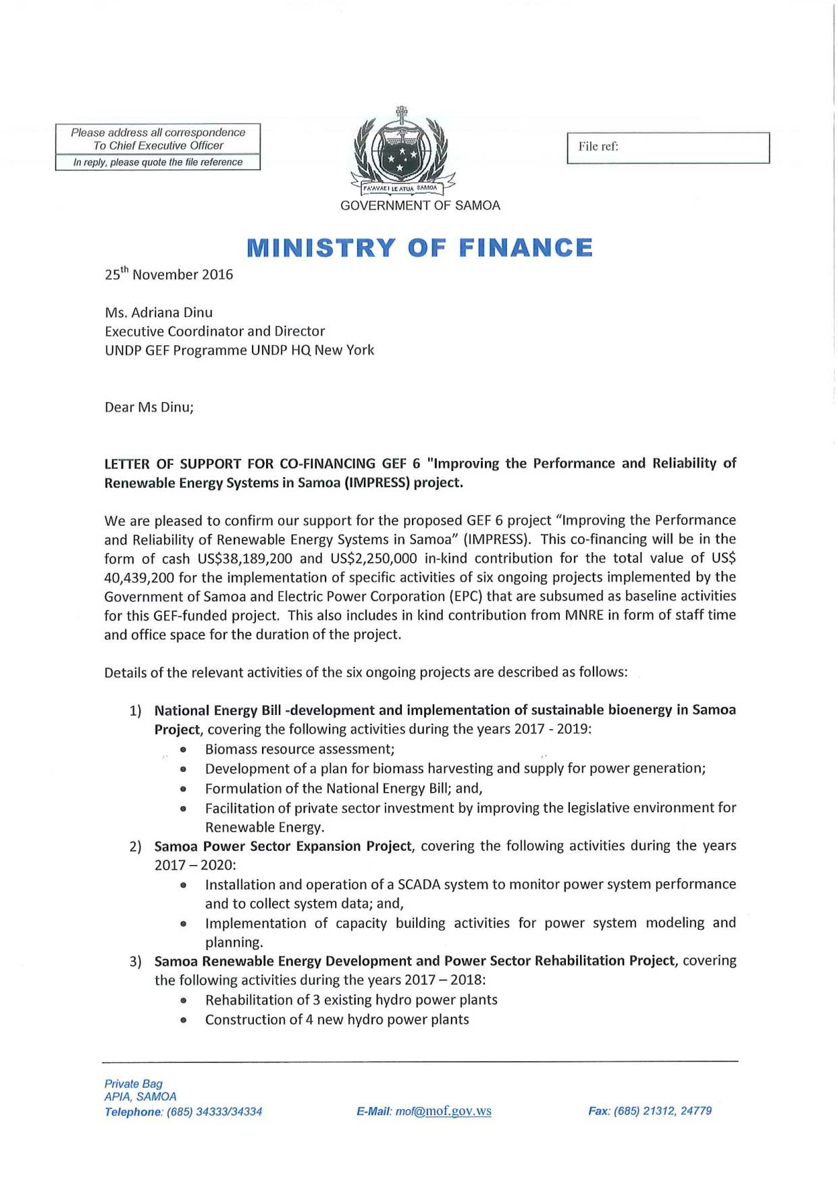
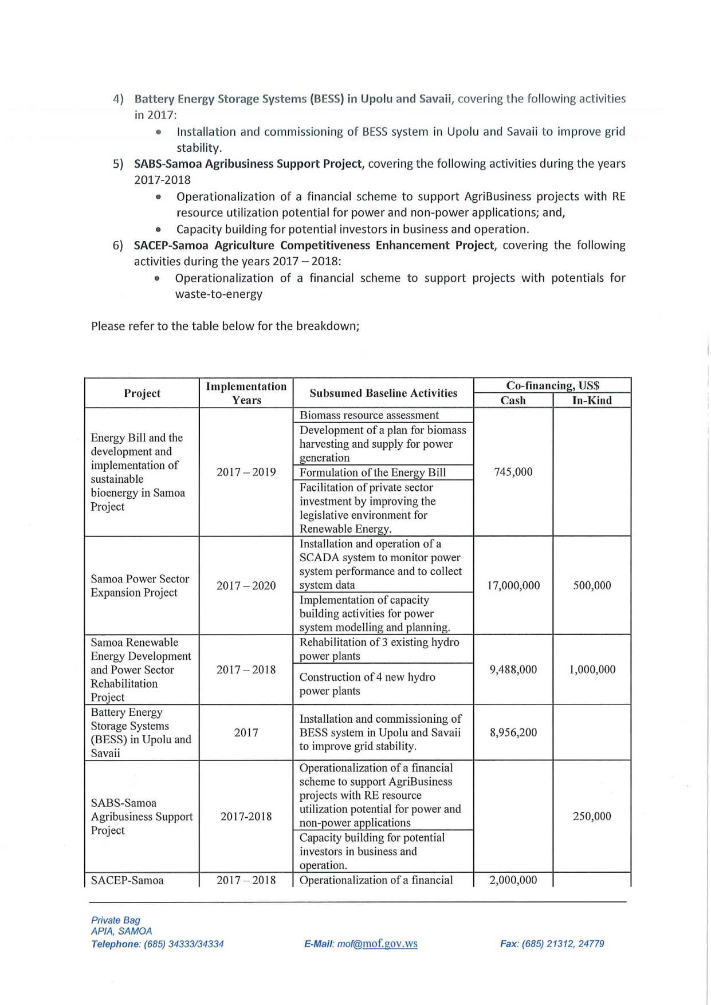

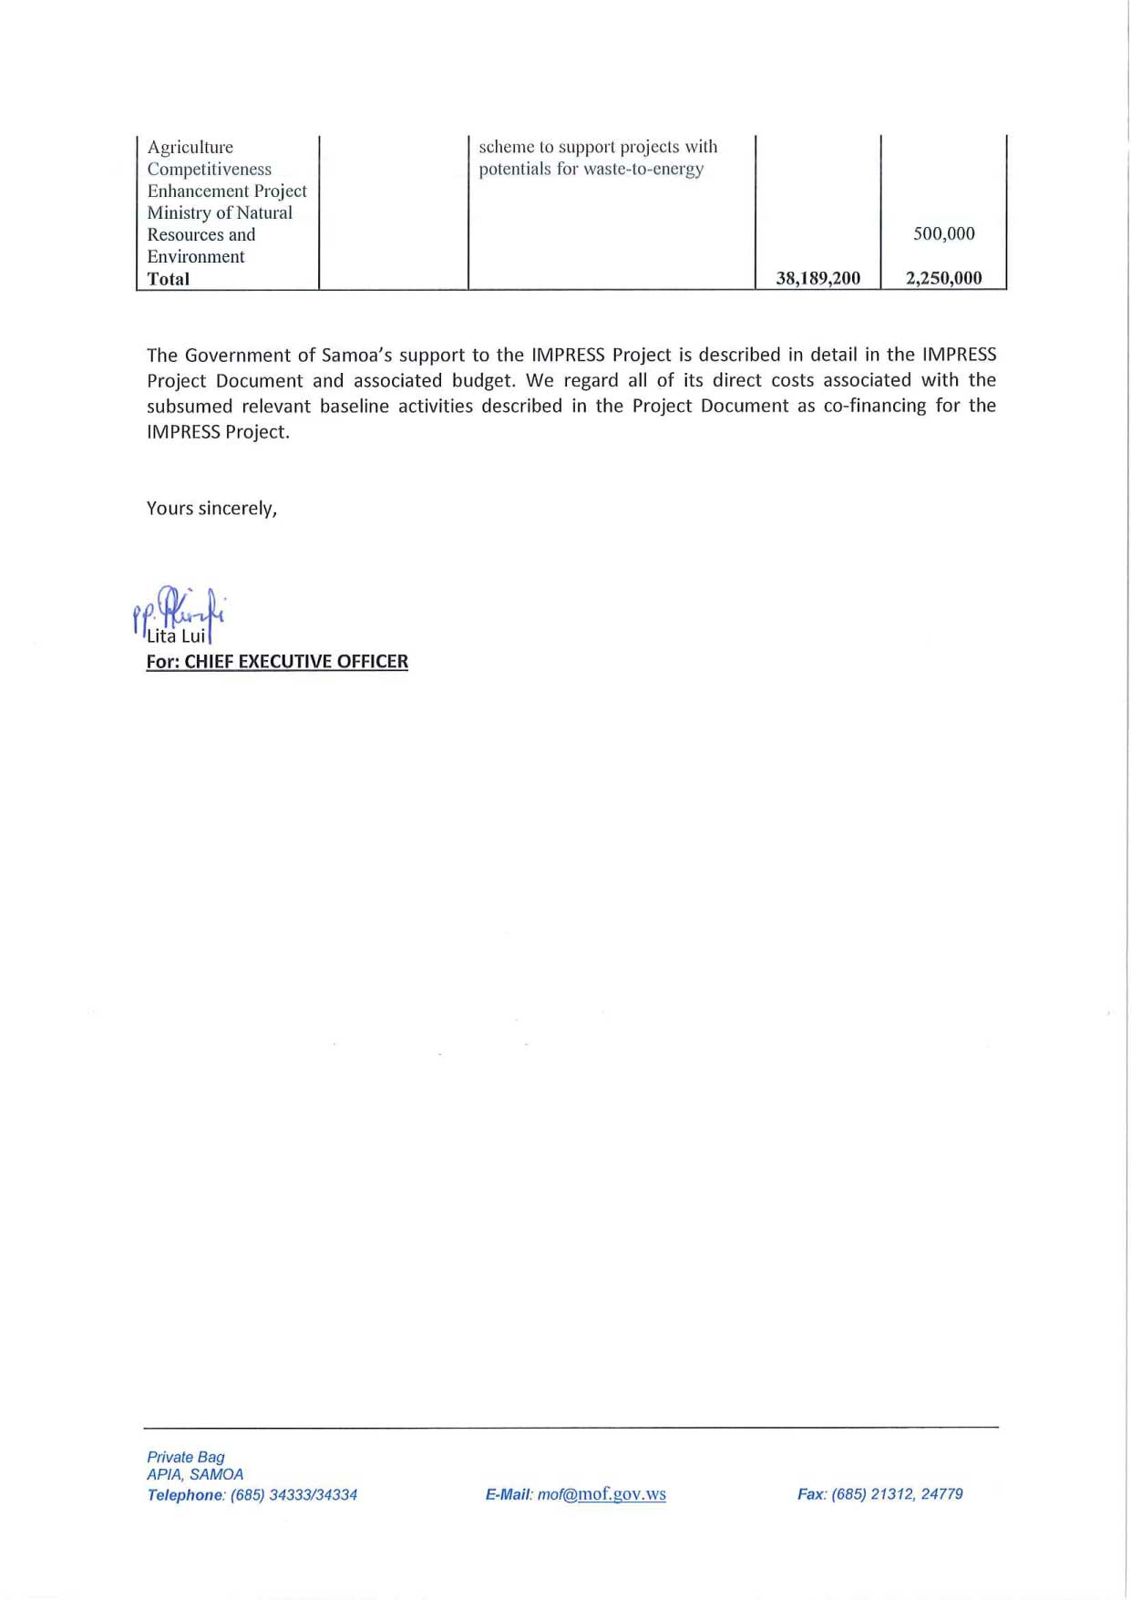

Co-Financing Letter from Samoa Trust Estates Corporation (STEC)
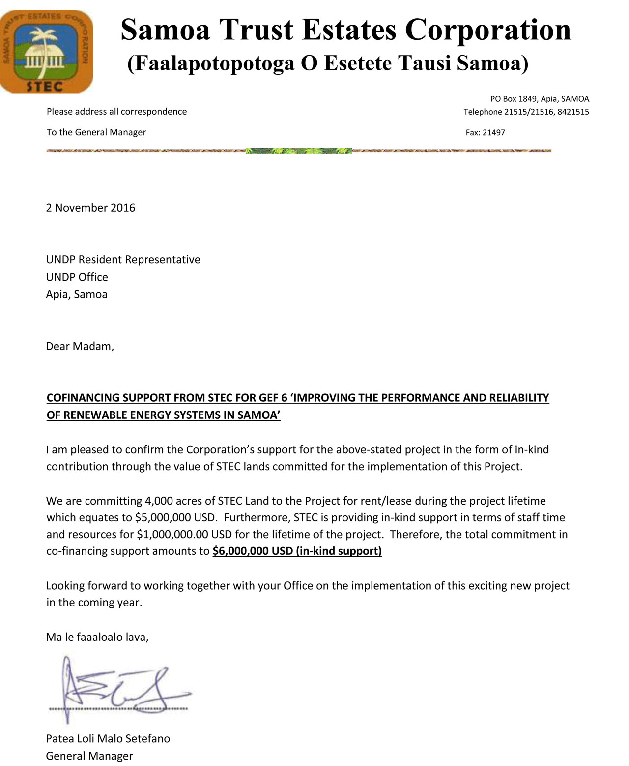

Co-Financing Letter from UNDP for Multi-Country Office for Samoa
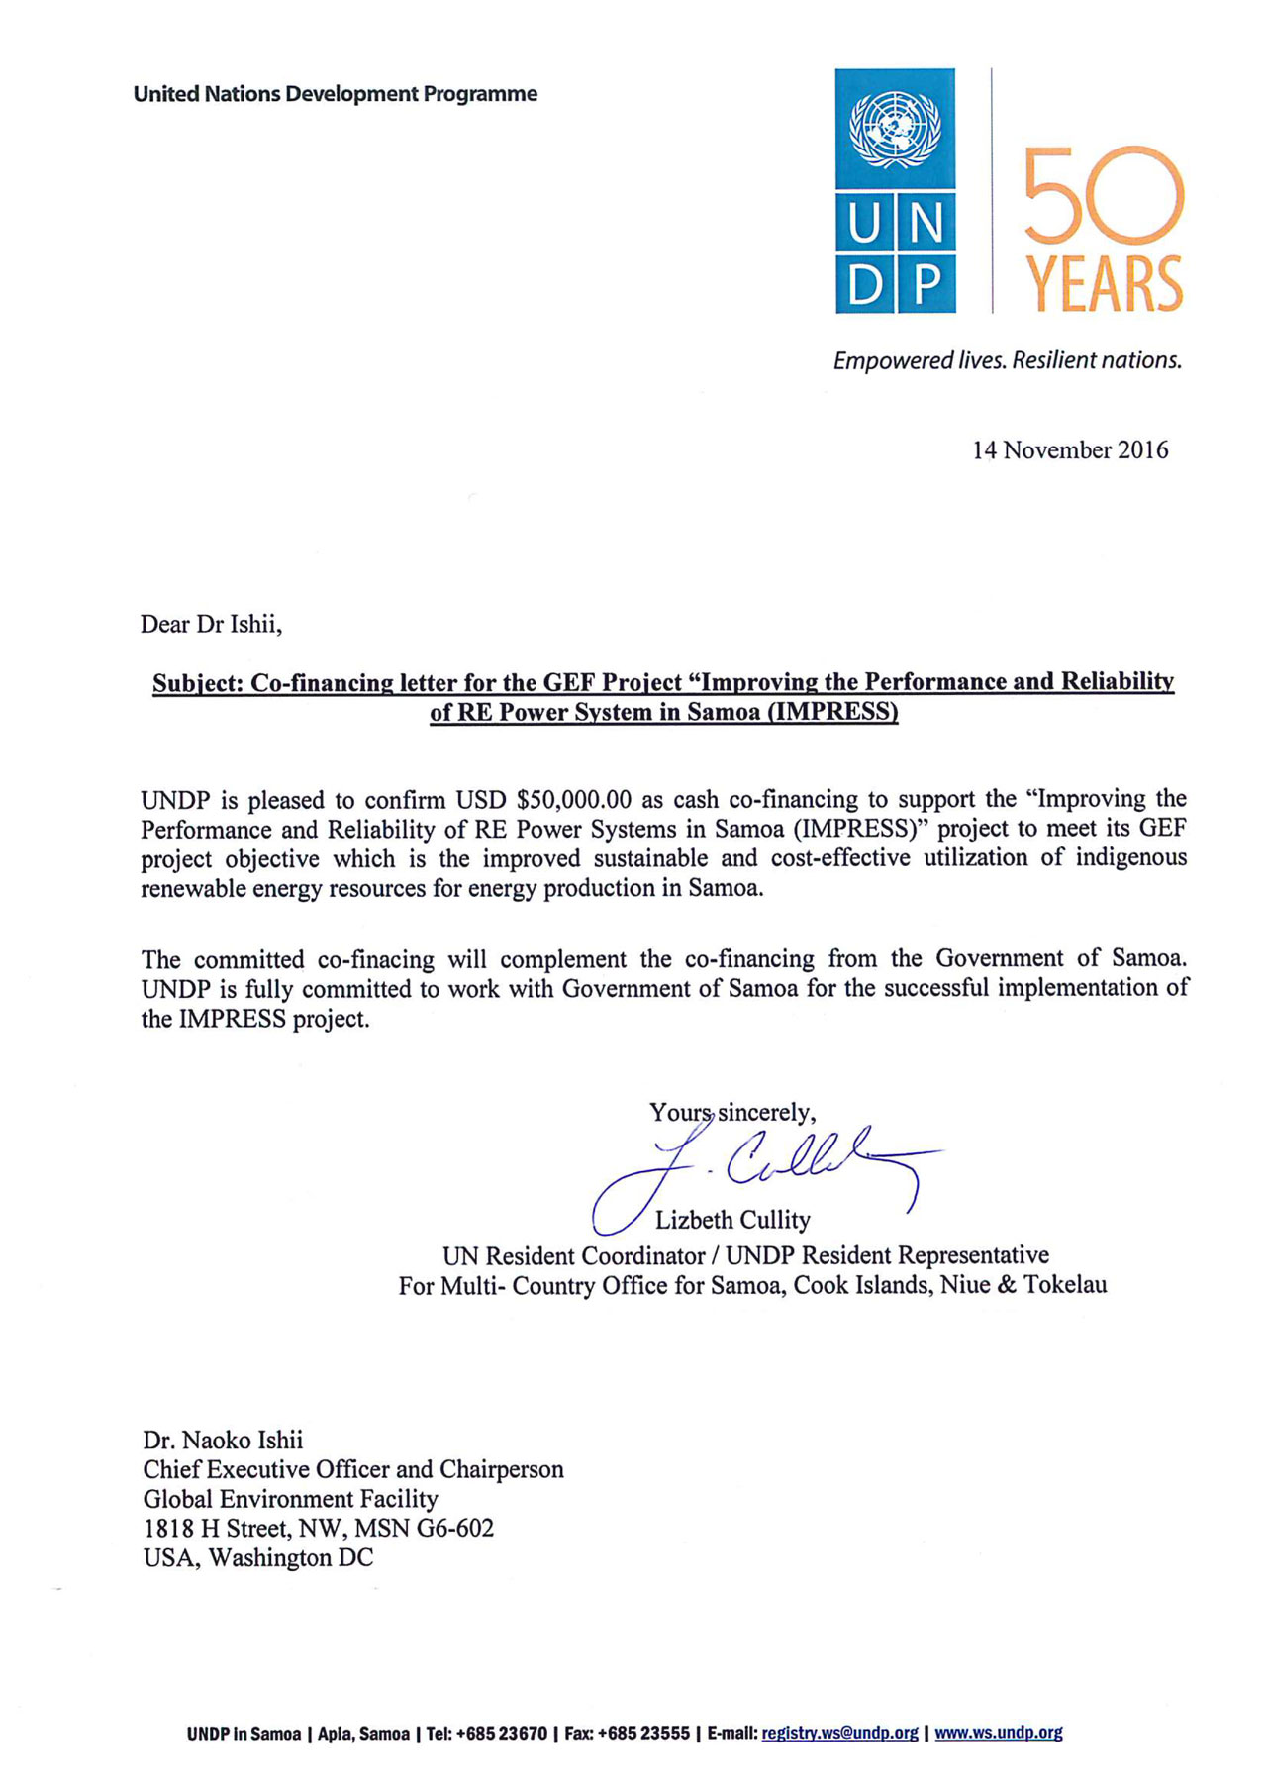

Supporting Letter from ANZ Bank (Samoa)
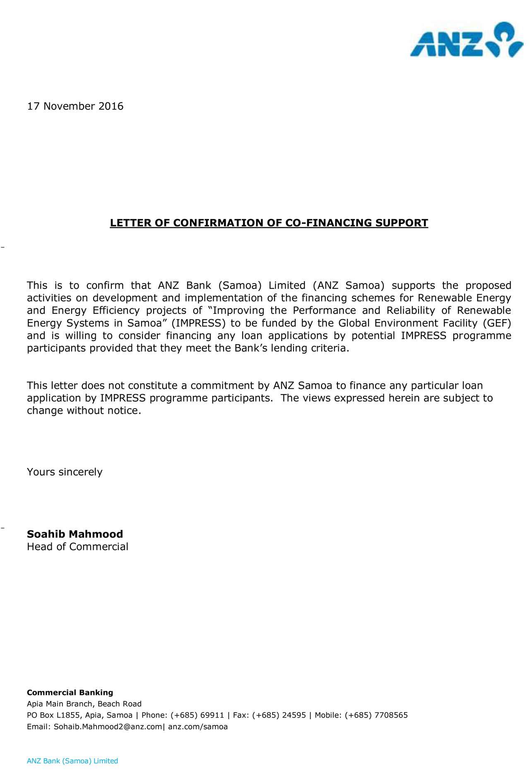

Agreement between UNDP and the Government of Samoa
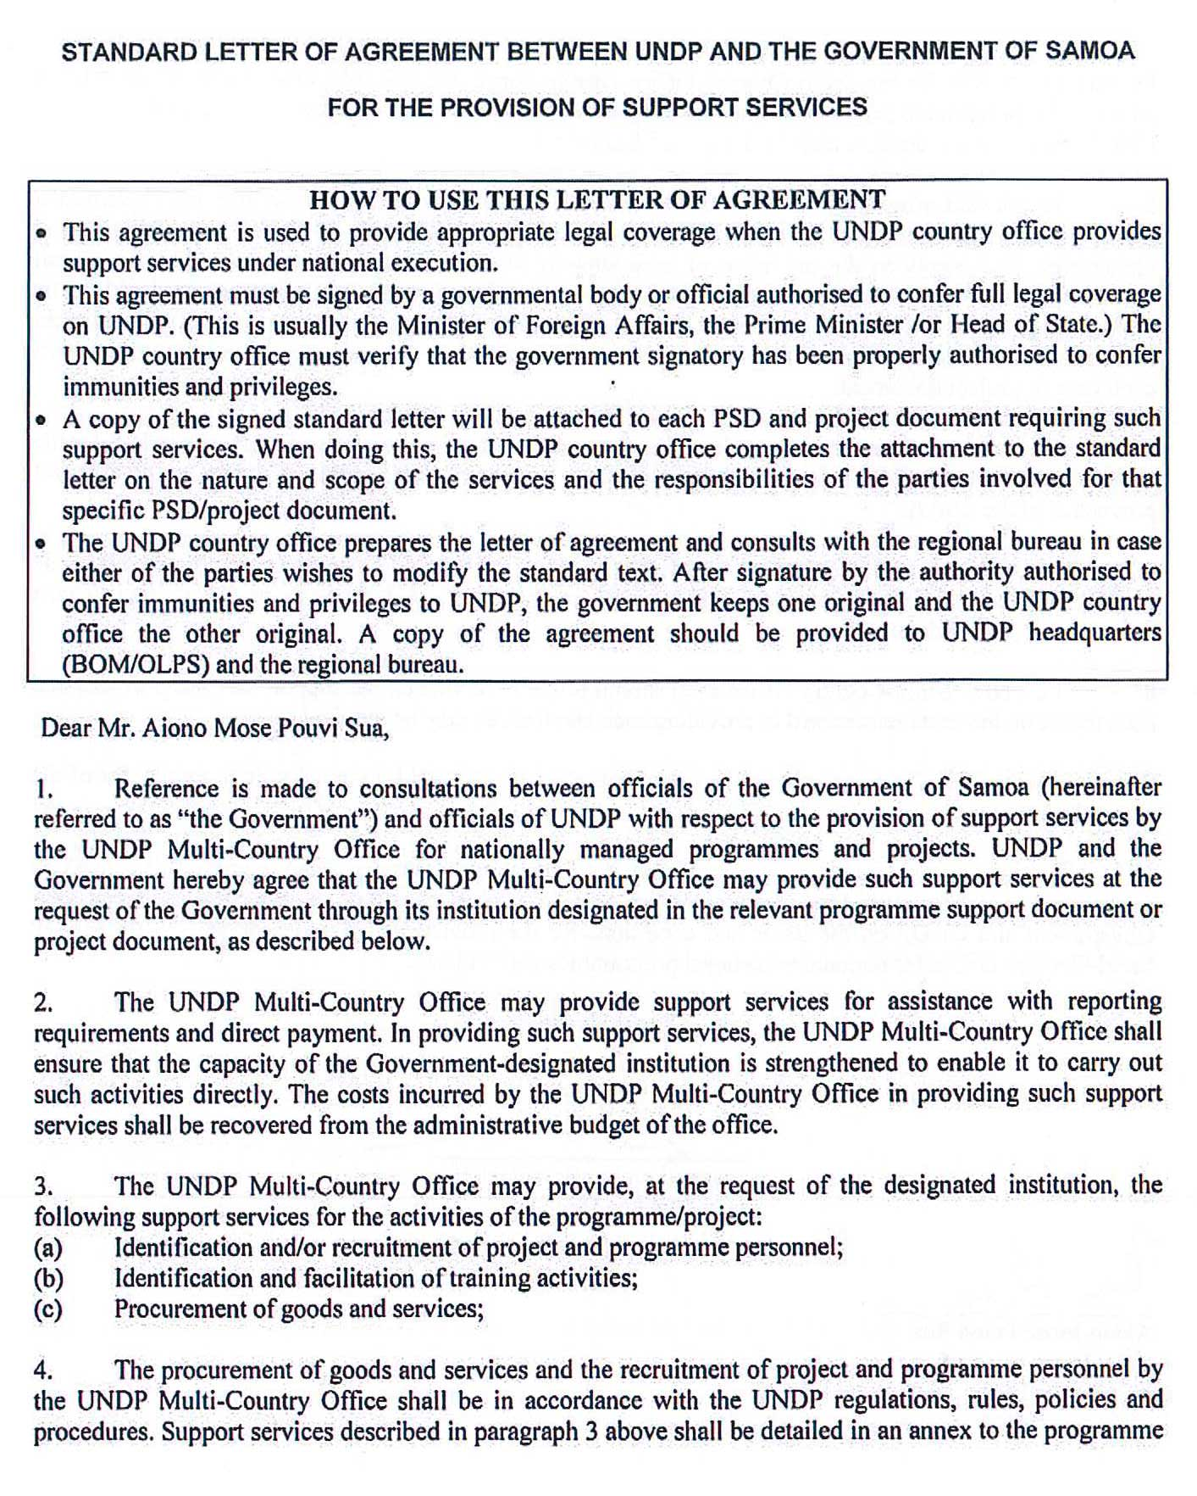

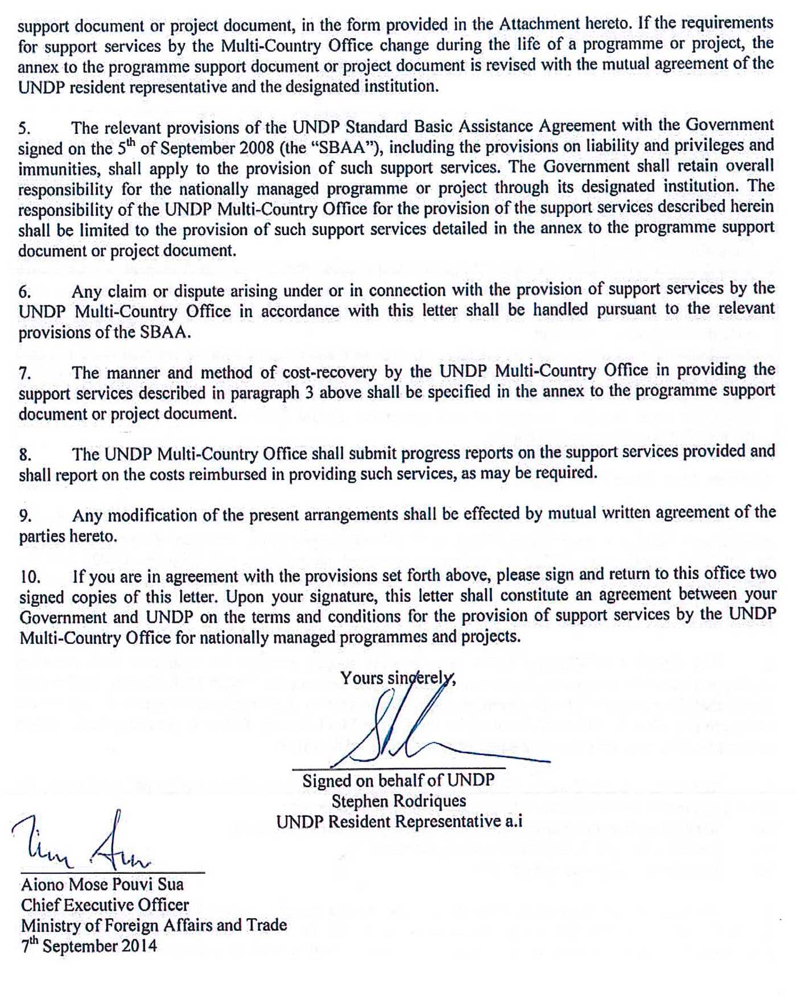

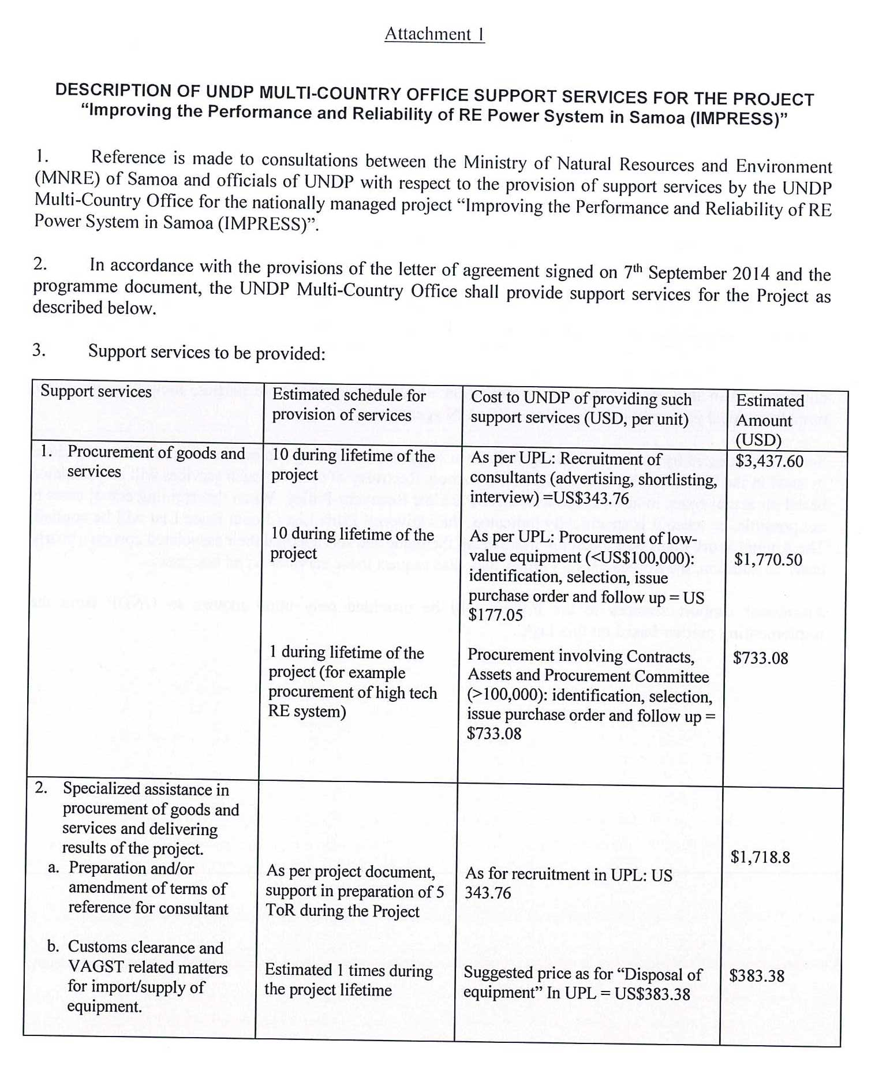

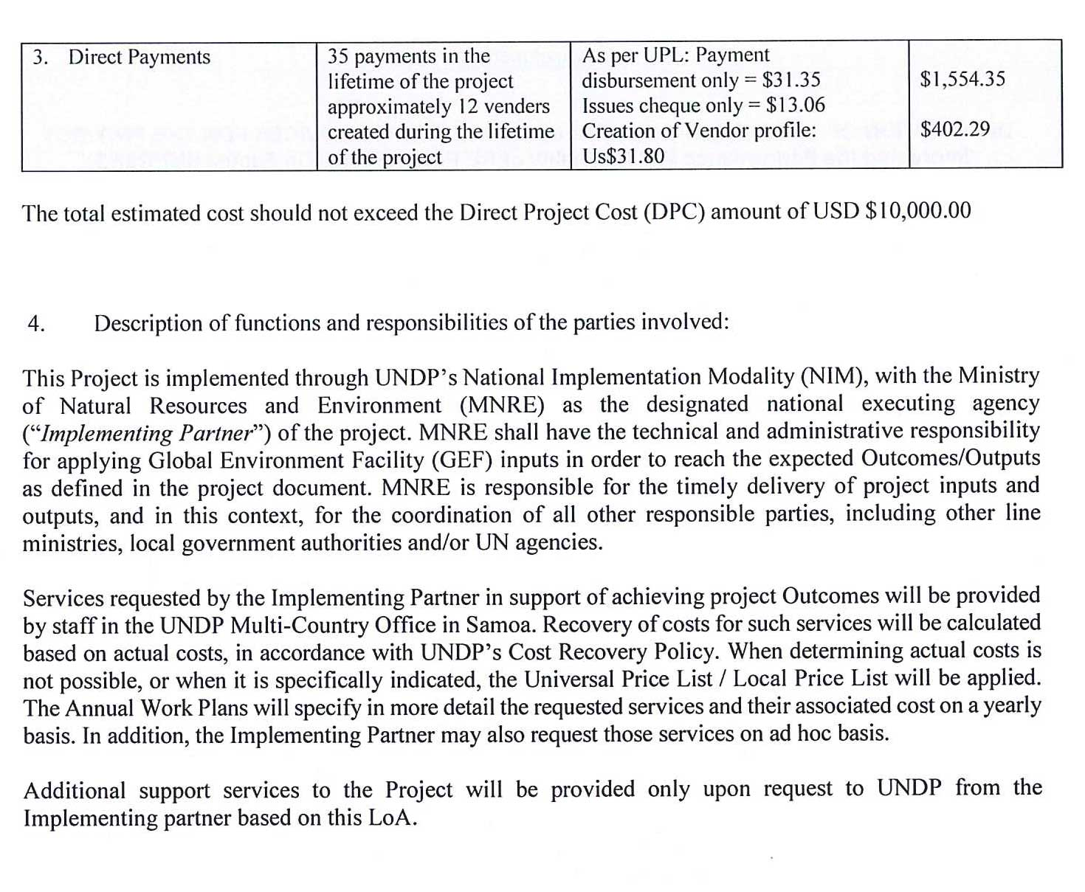

Annex K. Conceptual Designs of Demonstration Projects

Biomass Processing and Gasification for Power Generation
Location | STEC-owned land near the Faleolo International Airport on Upolu Island – This land plot has an area of 2,600 hectares and is partly used as coconut plantation, accounting for about 10% of the total land area. STEC intends to develop this land for a fast-growing tree plantation, and production and utilization of the harvested and processed biomass for generating electricity that will be sold to the EPC power grid.
Description | This demonstration project consists of the following major components.  1. Biomass Production Plant - The plant takes the harvested timber from the STEC’s plantation area to produce the feedstock for the power plant. Initially the feedback will rely on various overgrown invasive species within the plantation area. The fresh timber logs are prepared and cut into small pieces. The small timber logs are fed to the wood chipper to reduce the size to around 5-10 cm wide and 2-3 cm thick chips. The woodchip is then dried in the dryer to less than 20% moisture content.  2. Biomass Gasification Power Plant - Two lines of 250 kW biomass gasifiers and gas engine generators will be installed near by the biomass feedstock production plant. The power plant takes the dry woodchip to the gasifiers to convert the biomass to the combustible gas. The gas is cooled down, filtered and directed to the engine driven power generators to produce electricity for selling to the grid. Part of the produced electricity will be used for the power generation and biomass production plant. The power plant will be equipped with the SCADA and instrumentation system for real-time monitoring and automatic control of the biomass production and power plant operation. The plant SCADA will be connected with the central EPC SCADA via the broadband internet for power dispatching coordination.  3. Grid Connection System - The electricity output from the gas engine generators will go through the electrical system and step up transformer to increase the voltage to 22kV. The 22kV will be connected to the EPC grid at the existing 22kV Lafaga distribution line. The synchronization devices and protection relays and switch gears will be installed to the grid connection code for plant safety and grid integrity.  4. Substation Upgrade - The new protection relay system will be added to the existing the EPC 22kV substation near the airport to closely monitor the power quality, power plant and grid conditions. The protection systems at the power plant and substation sides will continuously coordinated and take necessary response to protect the grid when the power conditions are out of control or some faults exist.  The above major components are enclosed with red lines in the below diagram.  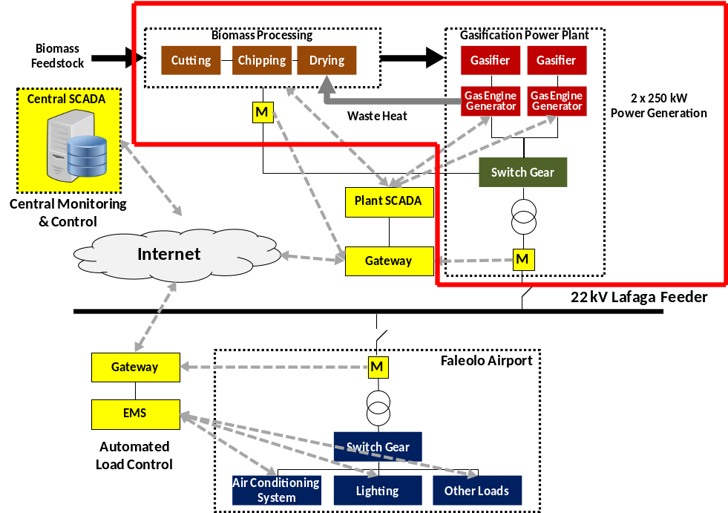
Investment
  Description | Budget
  Biomass production plant | US$ 0.35 million
  Biomass gasification plant | US$ 1.88 million
  Grid connection line | US$ 0.02 million
  Substation upgrade | US$ 0.15 million
  Total investment for design and construction | US$ 2.4 million
  Land cost for biomass plantation (Rent/lease of 4,000 acres) | US$ 6.00 million
  Management and operating cost (in-kind) | US$ 1.00 million
  Total cost for management and operation | US$ 7 million
Revenue and Economic Analysis
  Description | #
  Net electricity export to EPC grid | 2,251,930 kWh/yr
  Annual revenue from electricity export @ US$0.2/kWh | US$ 450,386
  Payback Period | 6.4 yrs
  IRR (15 years) | 13%
  NPV (15 years @ a discount rate of 9%) | US$ 485,271

Power System Performance and Reliability Enhancement Demonstration
Location | Lafaga feeder near Faleolo airport
Description | This demonstration project consists of the following major components.  1. Central SCADA Modification - The new control and input/output modules will be added at the EPC central SCADA to work with the new biomass gasification power plant and the airport EMS. The central SCADA will closely monitor the condition of Lafaga feeder, regulate level of power generation and reactive power flow from the new gasification power plant and adjust the demand of the airport major loads to improve the balance of power supply-demand and grid stability.  2. Energy Management System for Airport Load Control - The new Energy Management System (EMS) to be installed at the new Faleolo airport will control the electricity demand in response to the grid condition. The EMS consists of demand metering and automatic control of the major electricity loads including air conditioning, lighting, large motors and pumps. The airport EMS links with the EPC SCADA via the internet to take the command for load adjustment. Based on the set criteria, the EMS will manage the demand to help balance the grid stability. For example some of the loads can be shifted a few hours before the evening to lessen the grid burden due to the unavailability of solar power plants.  The above major components are enclosed with red lines in the below diagram.  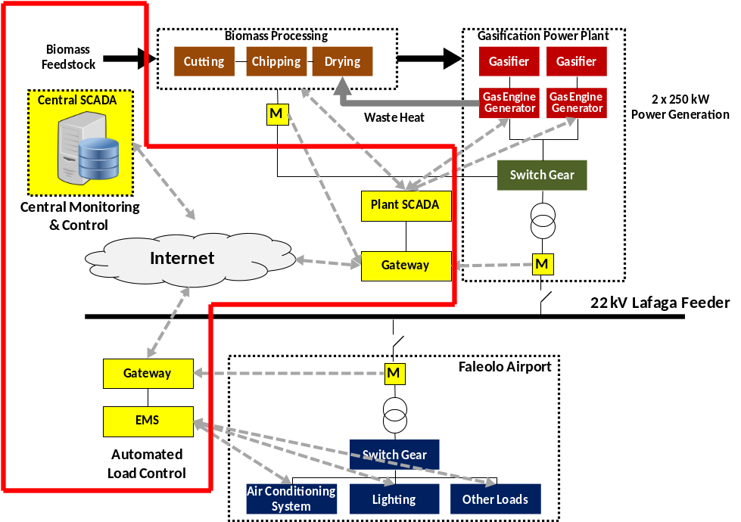
Investment
  Description | Budget
  SCADA System | US$ 0.35 million
  EMS for Airport Load Control | US$ 0.04 million
  Total | US$ 0.39 million
Revenue and Economic Analysis | There are no revenues directly generated by the power system performance and reliability enhancement demonstration project. However, the project will result in additional integration of RE electricity power generation into the EPC’s grid. Based on the generation data in May 2016, diesel generation of about 70 MWh is required to supplement RE electricity generation by hydro and solar PV during 7.30am to 5.30pm on weekdays. Based on a conservative estimation, about 50% of 70 MWh diesel generation during weekdays (or about 30 MWh) could be displaced by solar and other types of RE electricity generation. With the EPC’s diesel generation efficiency of 3.79 kWh/liter, about 8,000 liters of diesel for electricity generation can be avoided on a weekday or about 2 million liters can be avoided per year.

Biogas for Power and Non-Power Applications Demonstration

Location | Salu’a Village, Manono Island, and Nursing Home, Sisters of the Poor, Upolu Island
Description | The demonstration of biogas plants aims to show case the use of renewable energy for productive use and social services. This concept design is a part of the Component 2 of the IMPRESS project.  Salu’a Village  There are 52 households in Salu’a village. About 20 households raise pigs with an average of 3-4 pigs per household. According to the village rule, pigs are penned and are not allowed to roaming around. Some of the pig pens are closed together that a single biogas digester can be used for these 3-4 pens. Sizing of the digester depends on the available feedstock. For single pig sty with 3-4 pigs, the digester size is 2 - 4 m³. For combined 3-4 pig sties with total 10 - 12 pigs, the digester size is around 12 – 16 m³. Salu’a village is on Manono Island and is situated right next to the water. The water table is high and fixed dome is not recommended. Modular plastic digesters can be used and installation can be finished within 3 days. The cost of the modular plastic digester became lower when the size is larger. Therefore, it is recommended to group pig pens together when feasible. Septic waste may be added to the digester. For households that do not have pigs, old septic waste can be used for biogas production. However, the new waste generation would be only around 2 kg per day from 4-5 persons per household. Gas production from new faces has very low gas yield. Once these households used up old waste, the new waste system will not be sufficient for gas production. Therefore, the demonstration will target to households that have pigs.  Nursing Home  The Nursing home has 10 pigs and about 45 residents. The potential gas production is around 12 m³ per day. The pig sty is approximately 150 meters from the septic tank and the septic tank is around 20 meters to the kitchen. Considering the distance between pig sty and septic tank, there should be 2 digesters, one for the pig sty and another for the septic waste. The digester size for 10 pigs is around 12 m³. It is recommended that this digester use fixed dome so that gas can be send with sufficient pressure. A modular plastic digester can be used but it would require a pump or a blower to send gas through pipe. A 20 m³ digester is recommended for the septic waste.
Investment
  Description | Budget
  Salu’a village, Manono Island
  10 of very small modular digesters (4 - 6 m³) @ US$ 3,000 each | US$ 30,000
  2 of small digesters (10 – 12 m³) @ US$ 4,500 each | US$ 9,000
  Total for Salu’a village | US$ 39,000
  Nursing home, Sisters of the poor, Upolu Island
  1 Fixed dome 15 m³ for pig sty | US$ 5,000
  1 Balloon digesters (20 m³) for domestic waste | US$ 9,000
  Total for Nursing home | US$ 14,000
Revenue and Economic Analysis | Note: Estimated lifetime: small modular digester = 7 years, fixed dome = 15 years; balloon digester = 5 years
  Description | #
  Salu’a village, Manono Island
  Annual fuel cost savings | US$ 5,854
  Payback Period | 6.7 yrs
  IRR (7 years) ^{see note} | 1%
  NPV (7 years @ a discount rate of 9%) | US$ -8,750
  Nursing home, Sisters of the poor, Upolu Island
  Annual fuel cost savings | US$ 3,415
  Payback Period | 4.1 yrs
  IRR (15 years) | 13%
  NPV (15 years @ a discount rate of 9%) | US$ 2,694

Annex L. Proposed Facilitation to Access Financing and Capacity Building in Financing EE/ RE Projects

There are no existing funds or financing schemes dedicated to support RE/EE investment in Samoa. But there are financial mechanisms in Samoa from which micro, small medium enterprises (MSMEs) and households financing for RE/ EE projects can be sourced provided perceived risk and barriers are addressed and capacity building in developing financially viable EE/ RE projects with livelihood/ income generating component is given.

The incremental GEF funding will be used to support the provision of financial consultancy services that would assist/facilitate qualified MSMEs, households or individuals in Samoa to access available commercial financing schemes to support the RE and EE initiatives with livelihood component and financial institutions to assess viability of such initiatives .

The financial advisory will gear towards developing partnership schemes such that qualified households/ borrowers with RE/EE projects that have livelihood components are able to access:

- Existing financing programs of the government such as the Guarantee Program of Small Business Enterprise Center (SBEC), and the Small Business Incubator Program under the Youth Employment program of Ministry of Women, Community and Social Development (MWCSD);

- Samoa Agri-Business Support (SABS) Project of the Asian Development Bank (ADB).

The financial advisory will also cover the capacity building of financial institutions on small RE/ EE technologies with potential for livelihood and income generation for small businesses, households and individuals.

Partnership with Existing Financing Programs to Facilitate Financing of Income Generating RE/EE Projects

Small Business Enterprise Center (SBEC)

SBEC is a quasi- government agency that has been existing for 23 years, having been set up in 1994. Its mandate is to support and grow small businesses in Samoa. It provides guarantee mechanism for business loan applications of Small Medium Enterprises (SMEs) or individuals who would like to go into business. But to qualify for guarantee, potential beneficiaries including all family members will have to undergo training on business and financial management. Since 1994 SBEC has already guaranteed 800 clients of which about 300 are partial guarantee and 500 are provided with full guarantee.

With the SBEC guarantee, the Development Bank of Samoa has already generated 200 loans, the Samoa Commercial Bank for 110 loans. There are also other loans generated in other commercial banks which availed of the SBEC guarantee.

At present SBEC has enough capitalization for the guarantee fund but has limited funding support for its operating expenses. The one-time fee of 3%-5% of the guarantee is used to support SBEC’s operating expenses. This includes assessment of client, conduct of business training, assisting clients in business planning and continuous monitoring of clients. Thus SBEC’s resources and training facilities for operational activities are currently stretched and pressured. Potential loan beneficiaries are required to pay training fees to avail of the training. The current accommodations and training facilities are limited. The financial advisory services will work towards partnering with SBEC to support the development, training and access to commercial finance of small businesses that would adopt RE/ EE technologies for its start- up businesses including export oriented businesses and those that are export ready.

Ministry of Women, Community and Social Development (MWCSD)

MWCSD, under its Youth Employment Program, which is supported by UNDP, will be implementing a program to assist youth to start-up a business by providing grant of ST$1000 for capacity development ST$2500 as seed capital for business. The start-up business will be guided until it is strong enough to be on its own. Then it will be referred to SBEC for further business advisory and assistance in obtaining commercial loan to expand its business. The financial advisory services will look into potential partnership with MWCSD to facilitate the sourcing of financing for a start-up business for youth with RE/ EE component.

Samoa Agri-Business Support (SABS) Project of the Asian Development Bank (ADB)

SABs is a financing program of ADB in partnership with commercial banks to provide financial assistance targeted for export oriented or import substituting agri-businesses. It provides financing scheme such that project cost could be funded with minimum 25% equity, maximum 25% ADB (short term equity), and maximum 50% from a participating commercial bank which is guaranteed by ADB. To qualify, the business must have been in operation for at least one year. The financial advisory services will look into the scheme that will enable qualified potential borrowers to access this financing program for agribusiness projects with EE/RE component.

The provision of financial advisory to enable EE/ RE projects with livelihood component to access commercial financing will include assistance in developing business plans, specialized technical support and training in financial management.

The provision of the financial advisory would allow leveraging not only the cost of investments but also the capacity building components of the other existing financing mechanisms /programs to which RE/ EE projects can access provided it has a livelihood/ income generating component.

Capacity Building of Financial Institutions

The financial advisory will also cover the training of financial institutions to increase their capacity and support in financing RE/EE technologies with potential for livelihood and income generation. Initial findings indicate the need of financial institutions including commercial banks to be trained on the technical evaluation of RE/EE projects and collateral valuation RE/EE equipment or facilities. The financial advisory will include the conduct of a training needs assessment on the financial institutions, preparation of the training materials and the conduct of the training.

Annex M. CO2 Calculation and Assumptions

Summary

The IMPRESS project aims to improve sustainable and cost-effective utilization of indigenous renewable energy resources for energy production in Samoa. The implementation of project activities that will facilitate and influence the formulation and enforcement of suitable RE/EE policies and regulatory frameworks, financing and investments in RE and DSM/EE projects will bring about CO₂ emission reductions from the anticipated displacement of diesel electricity generation and energy savings. The implementation of the IMPRESS project will lead to a potential direct and direct post project CO₂ emissions reduction of about 699.6 ktCO₂. The long-term CO₂ emissions reductions will be much greater ranging from 285 ktCO₂ to 2,099 ktCO₂. Deviation from the initial project target of 900 kilo tCO₂ (indirect top-down estimation) is primarily due to the outdated data on CO2 emission from power generation in Samoa obtained from the World Bank website and referenced during the preparation of PIF.

Assumptions

Key assumptions used in estimation of potential CO₂ emission reduction as the results of IMPRESS project implementation are summarized in the following table.

Table 15: Assumptions used in Estimation of CO2 Emission Reduction

Parameters | BAU Scenario | IMPRESS Scenario
Electricity Sub-Sector
Annual electricity consumption in Samoa in 2016 (est. MWh) | 133,155
Annual growth rate of the total electricity consumption in Samoa during and after the end of project | 0.25%
Electricity generation mix | Based on EPC’s annual reports and projections in the power development plan
Annual generation per 1MW of grid-connected solar PV power plant (MWh) ¹ | 1,900
Annual generation per 1MW of grid-connected wind power plant (MWh) ² | 300
Annual generation of hydro power plant (MWh) | Based on estimation per power plant by EPC’s power development plan
Annual generation of 1MW of biomass gasification power plant (MWh) ³ | N/A | 4,500
Financing Schemes for EE Refrigerators
Annual electricity savings per US$1,000 | 0.35 MWh
Total EE investment during the project period (US$1,000) | N/A | 195
Useful lifetime of investment | N/A | 15 years
Other Parameters
Biomass resources | Based on previous studies (see Annex K)
Operating lifetime of biomass production and gasification power plant | N/A | 20 years
CO₂ Emission Factor (EF) of diesel electricity generation in Samoa | 0.7133 t/MWh
Note: ¹ Estimation based on actual generation data from 30 April 2016 to 14 June 2016 reported by EPC.
² Estimation based on actual generation data from 30 April 2016 to 14 June 2016 reported by EPC.
³ Calculation of electricity generation potential for a biomass gasification plant operating at 6,000 hours/year

Calculation of the emission factor for diesel electricity generation in Samoa is shown in the table below.

Table 16: Emission Factor for Diesel Electricity Generation in Samoa

Description | Value | Reference
Electricity generated (net in kWh) per liter of diesel | 3.79 | EPC’s diesel generation efficiency (kWh/liter) based on 2011 generation data
Emission coefficient of diesel (tCO2/liter) | 0.0027* | Calculated based on IPCC default values of diesel properties
Emission coefficient per MWh | 0.7133 | Calculated based on IPCC default values and EPC’s generation data
*Based on IPCC 2006 default values for DFO

Direct CO₂ Emission Reductions

The IMPRESS project includes the implementation of demonstrations of a biomass gasification power plant and at least three RE-based (biomass and biogas) energy generation units for power and non-power application. Based on the initial estimation of biomass resource at STEC’s plantation, a 500 kW biomass gasification power plant can be installed with annual electricity generation of 2,250 MWh or 45,000 MWh over its lifetime of 20 years. The biomass gasification power plant will be connected to the EPC’s grid, and the biomass power generation will displace electricity generated by EPC’s diesel power plant. Electricity generation from the other three RE projects will be minimal due to the sizes of the installations. Benefits from integration of additional RE electricity as a result of the grid stability improvement demonstration are detailed in the calculation of Direct Post Project CO2 emission reductions.

In addition, the project will catalyze a minimum total investment of US$195,000 to finance replacement of low efficiency refrigerators in Samoan households with high efficiency refrigerators. The project preparation studies have estimated that US$ 1,000 of investment in high efficiency 5-star refrigerators will yield on average around 0.35 kWh per year in energy savings. The total investment of the fund will then correspond to 68.25 MWh saved per year or 1,024 MWh over the 15-year lifetime of refrigerators.

Based on the GEF manual for calculating GHG benefits of GEF RE projects, direct CO₂ emission reductions (CO₂ _{direct}) will be calculated using the following formula:

CO₂ _{direct} = E*C; where:
E = cumulative energy saved or substituted of the lifetime
C = CO₂ intensity of the diesel electricity generation in Samoa

During IMPRESS Project Implementation (assuming last 3 years):

CO₂ _{direct} (Bio-gasification) = 2,250 MWh * 3 years * 0.7133 tCO₂/MWh = 4,814.7 tons
CO₂ _{direct} (EE refrigerators) = 68.25 MWh * 3 years * 0.7133 tCO₂/MWh = 146.1 tons
CO₂ _{direct} (Total) = 4,814.7 + 146.1 = 4,960.8 tons

CO₂ _{direct} (Lifetime) = (45,000 MWh + 1,024 MWh) * 0.7133 tCO₂/MWh = 32,828.9 tons

Direct Post Project CO₂ Emission Reductions

The project activities include providing assistance to prospective RE and DSM/EE developers and investors in project development, financing and implementation. It is envisioned that, the introduction of new financing models/tools, implementation of demonstration projects and dissemination of demonstration project results to be undertaken by the IMPRESS project, will assist two replications of the 250kW biomass gasification power plant after the project’s implementation period, within the STEC plantation area. Based on the preliminary estimation, available biomass resources in Savaii should be able to support two biomass gasification power plants with a capacity of about 250 kW each. Considering this, a total generation capacity of 1 MW will be added to the system, and the annual electricity generation from these biomass gasification power plants will be 4,500 MWh or 90,000 MWh over a period of 20 years.

The IMPRESS project will also improve stability of the EPC’s grid allowing additional integration of solar PV power plants and other RE electricity generation which will totally displace the projected diesel electricity of 42,184 MWh in 2025.

Direct post project CO₂ emission reductions (CO₂ _{direct post project}) are calculated as following:

- 4 x 250 kW biomass-gasification facility: Equivalent annual power generation = 4,500 MWh @ Net Capacity Factor (NCF) = 0.514;
CO₂ _{direct post project} (Biomass-gasification replication) = 4,500 MWh * 20 years * 0.7133 tCO₂/MWh = 64,197 tons

- Solar PV and other RE power generations: Equivalent annual power generation = 42,184 MWh by 2025
CO₂ _{direct post project} (Solar PV and other RE power generations) = 42,184 MWh * 20 years * 0.7133 tCO₂/MWh = 601,797 tons

- No. of EE appliance financed through IMPRESS financing scheme is the same as that for EE refrigerators during the demo period
CO₂ _{direct post project} (EE refrigerators) = 68.25 MWh * 15 years * 0.7133 tCO₂/MWh = 730 tons

CO₂ _{direct post project} (Lifetime) = 64,197 + 601,797 + 730 = 666,724 tons

Consequential CO₂ Emission Reductions

The IMPRESS project creates the enabling environment that will facilitate the widespread applications of RE and DSM/EE technologies in Samoa. Capacity development and awareness activities that will be conducted under the project are expected to influence the relevant stakeholder entities in the promotion, support, design and installation, financing, operation and maintenance of RE for power and non-power projects. The project will also involve interventions that will bring about the necessary fiscal and non-fiscal policies, financing tools and schemes that would enhance the investments in RE and DSM/EE technologies in various target groups.

Bottom-Up Approach
The bottom-up approach is calculated based on the following formula:

CO₂ _{consequential BU} = (CO₂ _{direct} + CO₂ _{direct post project}) * RF; where:

CO₂ _{consequential BU} = emission reductions following the project close, calculated using the bottom-up methodology.
CO₂ _{direct} = estimate for total direct emission reductions (direct + direct post project emission reduction)
RF = replication factor

The project will implementation demonstration projects with capacity building programs, and the default replication factor suggested for these activities is 3. The project will also design and implement credit and/or guarantee facilities which would have strong replication effects concurrent with a default replication factor of 4. However, in order to be conservative, a replication factor of 3 shall be assumed here.

CO₂ _{consequential BU} = (32,829 t CO₂ + 666,724 t CO₂)* 3
CO₂ _{consequential BU} = 2,098,659 t CO₂

Top-Down Approach
The top-down approach estimates CO₂ emission reductions caused by the GEF project using the following formula:

CO₂ _{consequential TD} = CO₂ _{TM} * CF; with
CO₂ _{consequential TD} = emission reductions following the project close, calculated using the top-down methodology.
CO₂ _{TM} = total market potential for CO₂ emission reductions
CF = causality factor

It is estimated that Samoa would still require around 50,000 MWh per year from diesel electricity generation to meet the country’s total annual energy demand. So the total market potential for CO₂ emission reductions from diesel generation displacement during the 10 year post project influence period is:

CO₂ _{TM} = 50,000 MWh * 0.7133 t/MWh * 10 year post project influence period
= 356,650 tCO₂

The IMPRESS project is the only major initiative on biomass-based power generation Samoa over the next 5 years. Hence, it would be fair to assume that any subsequent RE-based power generation initiatives in the country will be influenced by this project. In that regard, a Level 4 Causality Factor = 0.8, (The GEF contribution is dominant, but some of this reduction can be attributed to the baseline) will be applied to come up with the consequential emission reductions that can be attributed to the IMPRESS project.

CO₂ _{consequential} TD = 356,650 tCO₂ * 80%
CO₂ _{consequential} TD = 285,320 tCO₂

Total CO₂ Emission Reductions
The total CO₂ emission reductions estimated based on different approaches are summarized in the table below.

Table 17: Total CO2 Emission Reduction attributed to the IMPRESS Project

Particulars | Quantity  (tCO₂) | Remarks
Direct CO₂ | 32,829 | Cumulative CO₂ emission reductions from the demonstration projects throughout their lifetimes.
Direct Post Project | 666,724 | Cumulative CO₂ emission reductions from the replication of biomass gasification projects in Upolu and Savaii islands assisted by the IMPRESS project and from the replication of the EE appliance financing scheme throughout the lifetimes of the gasification projects and EE appliances.,
Consequential CO₂ | 285,320 - 2,098,659 | For the Bottom Up approach, assuming a Replication Factor of 3 and the IMPRESS project’s influence period is 2023-2032. For the Top-Down approach, using the GEF Causality Factor (CF) of 0.8 and the IMPRESS project’s influence period is 2023-2032

Annex N. Annual Target Table

Strategy | Indicator | Baseline | Targets
Strategy | Indicator | Baseline | Year 1 | Year 2 |  | Year 3 | Year 4 | Year 5
OBJECTIVE: Improved sustainable and cost-effective utilization of indigenous renewable energy resources for energy production in Samoa | - Cumulative electricity generation using RE resources, GWh | - 82 | - 82 | - 170 |  | - 259 | - 349 | - 438
 | - Cumulative GHG emission reduction, tCO2. | - 7,832 | - 7,832 | - 11,291 |  | - 12,944 | - 14,598 | - 16,251
 | - Cumulative Number of people employed by new RE-based power generation facilities and by productive and social use activities powered by RE-based energy systems | - 3 | - 3 | - 6 |  | - 9 | - At least 15 | - At least 15
COMPONENT 1: Enhancement of Renewable Energy Policy Formulation and Implementation
OUTCOME 1: Enforcement of clear and consistent policies and regulations that are supportive of the development and implementation of RE-based power generation in support of national economic development | - Cumulative number of approved and enforced policies that support and incentivize investments in RE development and utilization. | - 0 | - 0 | - 1 |  | - 1 | - 1 | - 1
 | - Cumulative number of approved and enforced regulations that support EE implementation in Samoa under the Energy Bill | - 0 | - 0 | - 0 |  | - 1 | - 2 | - 3
COMPONENT 2: RE-based Energy System Improvements
OUTCOME 2.1: Enhanced operating performance and reliability of RE power systems (generation and distribution) in major islands | - SAIDI target, minutes | - 2,565 | - 2,565 | - 2,565 |  | - 2,430 | - 2,430 | - 2,430
 | - SAIFI target, number of occurrences | - 36 | - 36 | - 36 |  | - 34 | - 34 | - 34
OUTCOME 2.2: Increased application of biomass-based energy for power and non-power uses | - Number of biomass-based power generation units integrated into the EPC grid system. | - 0 | - 0 | - 0 |  | - 0 | - 1 | - At least 2
 | - Cumulative number of operational off-grid community biomass-based energy projects | - 0 | - 0 | - 1 |  | - 2 | - 3 | - 4
OUTCOME 2.3: Increased application of power system performance and reliability enhancement technologies | - Cumulative number of grid systems with increased reliability due to the effective application of system reliability enhancement technologies | - 0 | - 0 | - 0 |  | - 0 | - 1 | - 1
COMPONENT 3: Financing of Initiatives for Electricity Saving, Productive and Social Uses of RE Electricity, and Electricity System Performance Improvement
OUTCOME 3.1: Improved availability of, and access to, financing for electricity DSM, power/non-power RE application and electricity system performance improvement projects | - Number of banks/ financial institutions that implemented and funded the designed and endorsed financing models and schemes | - 0 | - 0 |  | - 0 | - 2 | - 2 | - 2
OUTCOME 3.2: GoS & financial sector providing financing for EE, and productive uses of RE | - Cumulative total investments (in US$) mobilized through the implemented financing schemes | - 0 | - 0 |  | - 180,000 | - 355,000 | - 535,000 | - 710,000
 | - Cumulative number of RE/EE projects supported by the implemented financing models | - 0 | - 0 |  | - 0 | - 25 (RE Projects)  - 165 (EE refrigerators) | - 80 (RE Projects)  - 230 (EE refrigerators) | - 164 (RE Projects)  - 330 (EE refrigerators)
COMPONENT 4: Productive & Social Uses of RE
OUTCOME 4: Increased demand and utilization of RE for productive and social use | - Cumulative number of businesses utilizing biomass-based energy for productive and social uses | - 0 | - 0 | - 0 |  | - 0 | - 3 | - 3
 | - Percentage of household expenses on fuel in pilot communities | - 5% | - 5% | - 5% |  | - 5% | - 4% | - 4%
COMPONENT 5: Enhancement of Awareness on the Applications and Benefits of RE/EE
OUTCOME 5: Improved awareness about RE and EE technology applications to support national economic development | - % of households utilizing low carbon (RE & EE) technologies | - N/A | - N/A | - N/A |  | - N/A | - 60% | - 60%
 | - Number of trained local authorities, i.e., local government officials) that are capable of developing, planning and implementing RE, DSM/EE and PURE/SURE projects. | - 0 | - 0 | - 5 |  | - 10 | - 15 | - 20

Annex O. Gender and Youth Analysis

Submitted as a separate file.

Annex P. Knowledge Management Strategy

Submitted as a separate file.

Population and Housing Census, Samoa Bureau of Statistics (SBS), 2011
World Economic Outlook Database, October 2015, International Monetary Fund (IMF)
Samoa Energy Review Report, 2013, Ministry of Finance
Source: Energy sector plan status report for cabinet development committee, MOF, February 2015
Samoa’s Intended Nationally Determined Contribution (INDC), September 2015
Other Acts that deal directly or indirectly with grid-connected IPPs include: i) The Foreign Investment Act (2012) – reservation of some businesses for Samoans; ii) The Public Bodies (Performance and Accountability) Act (2001) – requirements for state owned enterprises to meet community service obligations, including universal access to a necessary good or service; iii) The Planning and Urban Management (PUMA) Act (2004) - regulating the development, regulation, sustainable use, and management of land, requiring environmental impact assessments and management plans for a range of activities; and iv) The Samoa Forestry Management Act (2011) - regulating management of forest resources including biomass.
List of IPPs that have high potential in actual operation by 2020
Least-cost planning framework and toolset for the Samoan electricity sector ver. 11, Prepared for NZMFAT and GOS by Concept Consulting Group
Source: Evaluation of Renewable Energy Potential, IPA Samoa, Draft Report, May 2016
Productive uses of renewable energy (PURE) refer to production activities that make use of RE as energy source (e.g., food processing activities that make use of RE for food production like solar dryers and heaters, wood-fired ovens, and RE-based electricity generation units). Social uses of renewable energy (SURE) refer to activities that make use of RE as energy source for the delivery of social services (e.g., water supply using solar PV water pumps, solar PV powered telecommunications, etc.).
Household Income and Expense Survey (HIES) 2013/2014
Second National Greenhouse Gas Inventory, Samoa's Greenhouse Gas Emissions: 1994-2007, Final Report, March 2008
Estimates of GHG emissions were based on methodologies used in 2nd GHG Inventory, Second National Communication and IPCC 2006 Guidelines
Samoa’s Intended Nationally Determined Contribution, September 2015
These include generation from hydro, solar and wind.
The SCADA system will be connected with all generating plants, including hydro plants in Taelefaga, Lalomauga, Samsoni, Fale ole Fee and Alaoa; Wind farm in Vailoa Aleipata; Diesel stations in Tanugamanono, Fiaga and Salelologa; three solar PV systems in Faleolo airport; three solar PV systems inside race course in Tuanaimato; solar PV rooftop of Gymn 3; solar PV in Vaitele EPC yard; solar PV in Tanugamanono; and two solar PV systems in Salelologa.
The hydro power plants in Samasoni, Fale ole Fee and Alaoa were damaged by Cyclone Evan in December 2012.
The SACEP project provides 50% matching grant for the approved applications. Farmers are responsible for the remaining 50% financing.
The new Energy Sector Plan for 2017-2021 is under preparation and scheduled for dissemination in December 2016.
These may focus on: (1) Poorest performing feeder; (2) Multiple device activation; (3) Service interruption; (4) Customers experiencing multiple interruptions; and, (5) System equipment inspections. This can involve assessments and planning for implementation of system reliability initiatives such as pole replacements, selective undergrounding of cables, distribution automation, sectioning, feeder reconfiguration, circuit re-conductoring cable replacements, etc.
With 24/7 operation, refrigerators are the main electricity consumers in the residential sector and have been identified as the primary target for EE after lighting end-use in most countries. According to the Samoa National Survey on Household Lighting and Electrical Appliances conducted by the Promoting Energy Efficiency in the Pacific – Phase 2 (PEEP2) in 2014, about 51% of Samoan households have at least one refrigerator. The ownership of refrigerators is the third highest after lighting products and televisions.
Review of various secondary resources such as Business Activity Survey reports and Household Income and Expense Survey (HIES) reports during the project preparation phase revealed that food and beverage manufacturing in Samoa includes beer, cigarettes, tobacco, soft drinks, ice cream, sausages, coconut oil, fruit juices, coconut cream, salted beef, snacks (banana and taro chips), and honey. However, there is insufficient information of the quantity of production, in-country consumption and export and import materials.
Efficient utilization of non-power RE applications (e.g. RE for cooking and heating applications) has not been properly addressed in the national energy policy and planning. The pilot demonstrations by YWAM and PIGGAREP have encountered several constraints in scaling up. It should be noted that the pilot biogas system is used for household cooking, and has not been exemplified for other productive purposes.
Common practices of banana, taro, yam and breadfruits plantations are that some households have their own small plantations for self-sustenance. Only when there are excess, they will make chips for sale. There are a couple of medium scale plantations of taro and banana for Apia market.
SBEC has a list of its clients which include small businesses of food and beverage and cook stove manufacturers.
Women in Business Development Inc., works to support villages in sustainable development and has been providing micro finance to maximize farm-based resources and to promote sustainable businesses.
SQA has accreditations for 7 trade area; Plumbing, Refrigeration, Tourism, Carpentry, Automotive engineering, Electrical Engineering, Welding & Fabrication & Fitting and Machining.
To qualify SQA non-formal learning, the curriculum shall have 10-39 credits or 100-399 hours duration.
The main service providers for capacity development in technical and vocational skills and knowledge are the vocational schools and universities, particularly the National University of Samoa (NUS) and the Samoa campus of the University of the South Pacific (USP). The planned technical capacity building on RE/EE technologies will build on the ongoing activities of these schools in these areas and other related areas. The NUS has existing research program on renewable energy applications, and the USP has an existing Vocational Training Centre in Samoa that can provide the necessary training on the operation and maintenance of equipment used in RE-based energy systems.
From RE-based energy systems that are assisted with GEF resources during the IMPRESS Project implementation period.
Per 2016 estimated population of Samoa (194,523), the total number of households is 27,378 @ 7 people per HH (ADB, Samoa National Survey of Household Lighting and Electrical Appliances, March 2014.
SAIDI = System Average Interruption Duration Index (in minutes); baseline and target indicators estimated based on 5% and 10% improvement of 2016 target of Upolu: SAIDI- 1300mins; Savaii: SAIDI –1400mins.
SAIFI = System Average Interruption Frequency Index (number of occurrences); baseline and target indicators estimated based on 5% and 10% improvement of 2016 target of Upolu: SAIFI –22 times, Savaii: SAIFI – 16 times.
40 electoral districts and 3 potential projects per district
Average value from Household Income and Expenditure Survey 2013/2014, Samoa Bureau of Statistics
20% reduction from the baseline value
See guidance here: https://info.undp.org/global/popp/frm/pages/financial-management-and-execution-modalities.aspx
Excluding project team staff time and UNDP staff time and travel expenses.
The costs of UNDP Country Office and UNDP-GEF Unit’s participation and time are charged to the GEF Agency Fee.
The costs of UNDP Country Office and UNDP-GEF Unit’s participation and time are charged to the GEF Agency Fee.
[1] See http://www.undp.org/content/undp/en/home/operations/transparency/information_disclosurepolicy/
[2] See https://www.thegef.org/gef/policies_guidelines
Prohibited grounds of discrimination include race, ethnicity, gender, age, language, disability, sexual orientation, religion, political or other opinion, national or social or geographical origin, property, birth or other status including as an indigenous person or as a member of a minority. References to “women and men” or similar is understood to include women and men, boys and girls, and other groups discriminated against based on their gender identities, such as transgender people and transsexuals.
In regards to CO_{2,} ‘significant emissions’ corresponds generally to more than 25,000 tons per year (from both direct and indirect sources). [The Guidance Note on Climate Change Mitigation and Adaptation provides additional information on GHG emissions.]
Forced evictions include acts and/or omissions involving the coerced or involuntary displacement of individuals, groups, or communities from homes and/or lands and common property resources that were occupied or depended upon, thus eliminating the ability of an individual, group, or community to reside or work in a particular dwelling, residence, or location without the provision of, and access to, appropriate forms of legal or other protections.
From the biomass assessment in the STEC plantation area reported by MNRE/STEC in September 2016, about 1,835 hectares of the STEC land is covered by forest, 599 hectares is used for coconut plantation and 161 hectares is covered by shrub vegetation. The majority of the trees in the forest area are from seven known invasive species. The conservative estimate of the timber volume in the STEC land is around 247.9 m3 per hectare with the total mass of around 60 tons (at 40% moisture content) per hectare, respectively. Excluding coconut plantation and shrub vegetation, the forest area of the STEC land would have almost 110,000 tons of timber available. For a 15 year rotation, around 7,300 ton of biomass could be harvested per year.
Source: http://data.worldbank.org/country/samoa
The calculation of direct and indirect GHG emission reductions follows the methodology issued by GEF in “Manual for Calculating GHG Benefits of GEF Projects: Energy Efficiency and Renewable Energy Projects” 2008, http://www.thegef.org/gef/sites/thegef.org/files/documents/C.33.Inf_.18%20Climate%20Manual.pdf
With 24/7 operation, refrigerators are the main electricity consumers in the residential sector and have been identified as the primary target for EE after lighting end-use in most countries. According to the Samoa National Survey on Household Lighting and Electrical Appliances conducted by the Promoting Energy Efficiency in the Pacific – Phase 2 (PEEP2) in 2014, about 51% of Samoan households have at least one refrigerator. The ownership of refrigerators is the third highest after lighting products and televisions.
RE resources include hydro, solar, wind, biomass and others.
People employed by the new company established by YWAM
People employed by STEC, EPC and community-based RE projects for productive and social uses
SAIDI = System Average Interruption Duration Index (in minutes); baseline and target indicators estimated based on 5% and 10% improvement of 2016 target of Upolu: SAIDI- 1300mins; Savaii: SAIDI –1400mins.
SAIFI = System Average Interruption Frequency Index (number of occurrences); baseline and target indicators estimated based on 5% and 10% improvement of 2016 target of Upolu: SAIFI –22 times, Savaii: SAIFI – 16 times.
41 electoral districts and 4 potential projects per district
Average value from Household Income and Expenditure Survey 2013/2014, Samoa Bureau of Statistics
20% reduction from the baseline value

